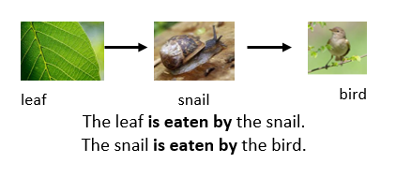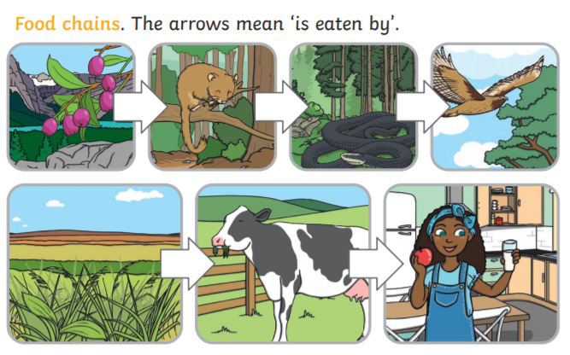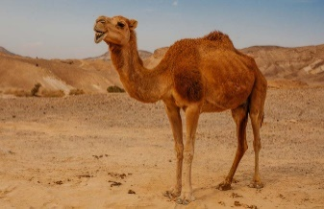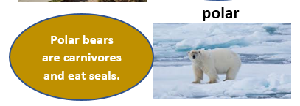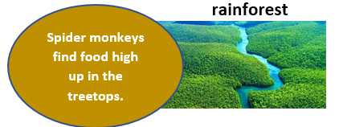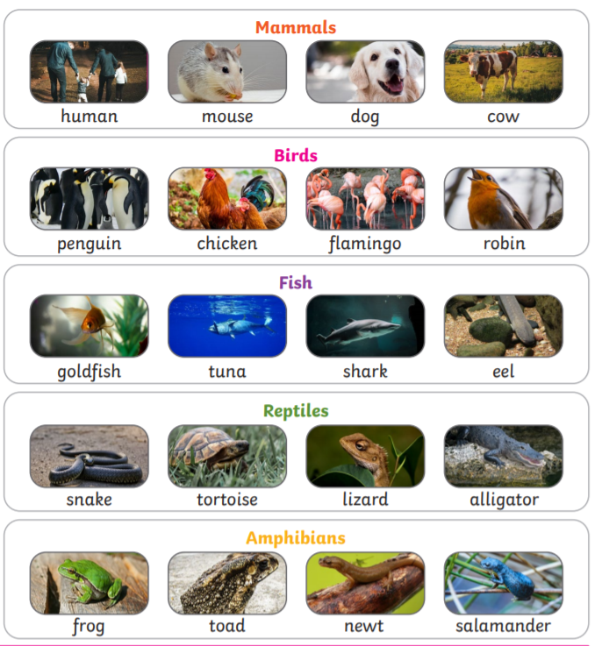

**FACTOID**

Camels have long eyelashes to keep sand out of their eyes.

**desert**

**FACTOID**

Polar bear hairs are hollow like straws to trap warm air inside.

**Different types of habitat**

**FACTOID**

Howler Monkeys search high up in the trees for food.

**Vocabulary**

|  |  |
| --- | --- |
| habitat | A place that an animal lives. It provides the animal with food, water and shelter. |
| fish | An animal that lives in water and has fins for swimming and gills for breathing. Most fish lay eggs. |
| amphibian | Animals that need water or a moist environment to live. All can breath and absorb water through their skin. Lays eggs. |
| reptile | A cold-blooded animal that breathes air and usually has the skin covered with scales or bony plates. Most reptiles lay eggs. |
| bird | An animal that lays eggs and has wings and a body covered with feathers. |
| mammal | Mammals are animals that breathe air, grow hair or fur and feed on their mother’s milk as a baby. |
| carnivore | Animals that mostly eat other animals (meat) are carnivores. |
| herbivore | Animals that only eat plants are herbivores. |
| omnivore | Animals that eat both plants and other animals are omnivores. |

Super Scientist Investigates: Do all offspring look like their parents?

**FPS SCIENCE**

**KNOWLEDGE ORGANISER**

**Year 1/2 Animals and their habitats – Can a camel live in the Arctic?**