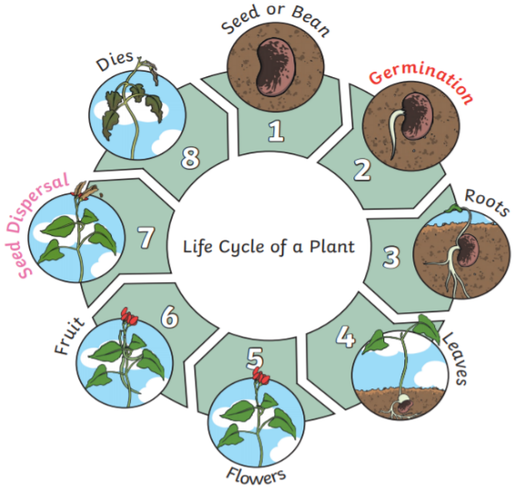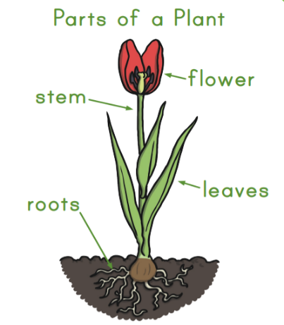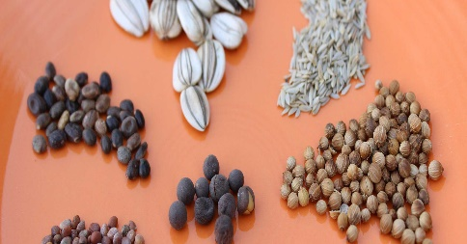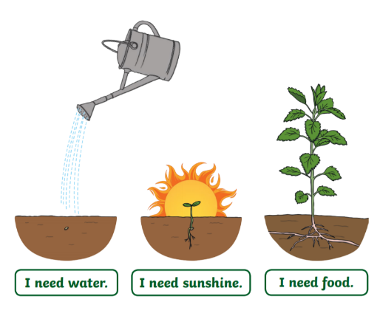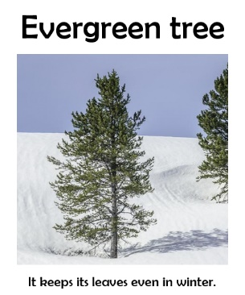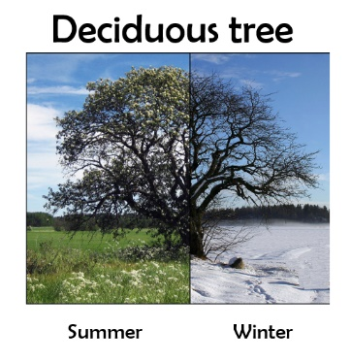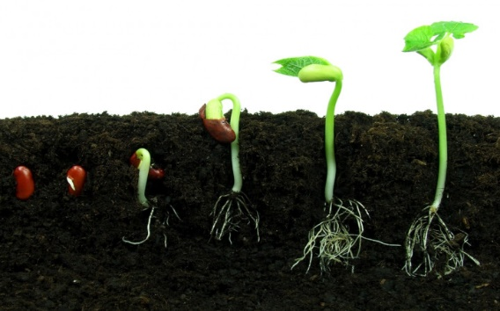 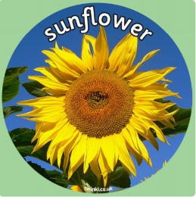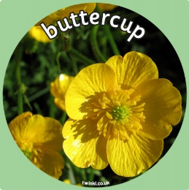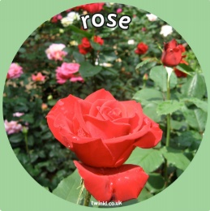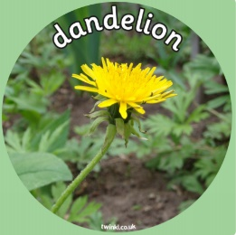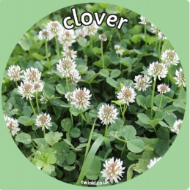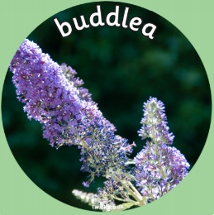

**What plants need to grow**

**FACTOID**

A plant makes its own food. It makes it in it’s leaves.

**I can identify and name some common plants.**

**How a plant grows**

**FACTOID**

Did you know the root of the seed starts to grow first?

**Seeds can be different shapes, sizes and colours.**

**Vocabulary**

|  |  |
| --- | --- |
| deciduous trees | Deciduous means to fall off. Every year these trees loose their leaves in Autumn. |
| evergreen | A plant that has leaves throughout the year, always green. They keep their leaves all year round. |
| flower | A flower is the. part of a plant that blossoms. Flowers  produce the seeds that can become new plants. Most plants, including many trees, grow some kind of flower |
| roots | A part of a plant that is usually hidden underground. They hold the plant in the ground and keep it upright. They take water and food from the soil. They also store food for the plant. |
| stem, stalk trunk | The stem is the main structure that supports leaves and flowers. |
| leaf | The leaf is one of the most important parts of a [plant](https://kids.britannica.com/kids/article/plant/353639). Leaves produce food for the plant |
| bud | a small growth at the tip or on the side of a stem that later develops into a flower, leaf, or branch |
| seed | A part of a plant which can grow into a new plant. |

Super Scientist Investigates:

Does a brown seed grow a brown plant?

**FPS SCIENCE**

**KNOWLEDGE ORGANISER**

**Year 1/2 Plants – Does a big seed grow into a big plant?**