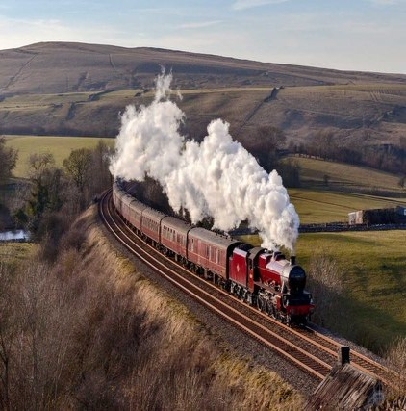
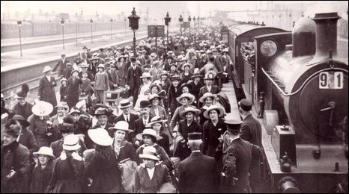
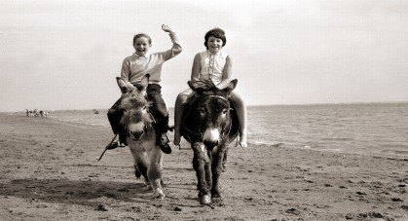
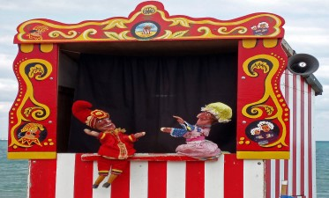
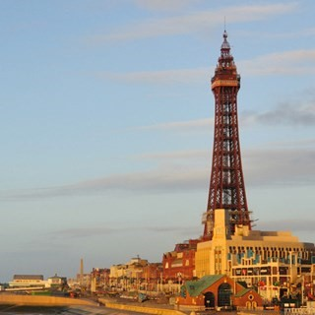
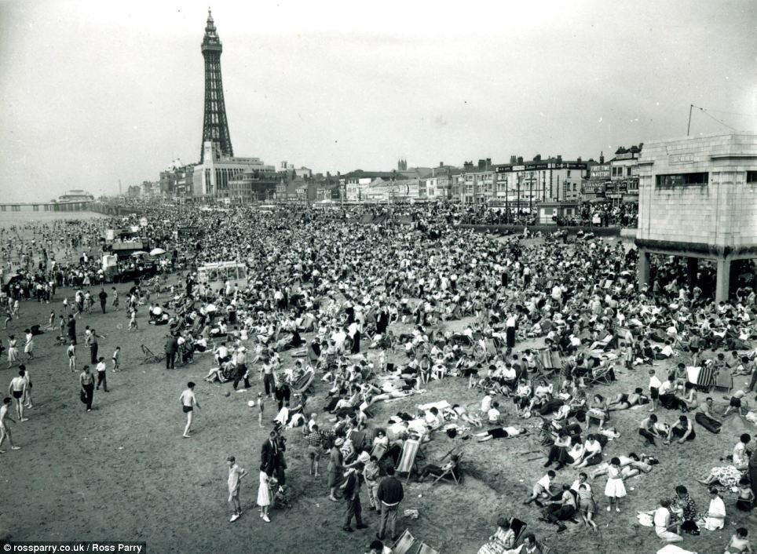
FPS HISTORY
Knowledge Organiser

History Detectives -were holidays better in the past?
Year 1/2 Seasides in the Past

Key Vocabulary

Key Knowledge |  |  | Key Vocabulary
Knowledge and understanding of the past events, people and changes in the past. | Seaside holidays | People have been going on seaside holidays for over a hundred years. | seaside A place by the sea, especially a beach area or holiday resort.  coast Where the sea meets the land.  beaches A pebbly or sandy shore by the sea.  pier A raised platform supported by pillars that rises above the water and juts out from its shore.  amusement An indoor area containing coin- arcades operated game machines. promenade A paved public walk along the  seafront.  railways A network of tracks for trains to travel on.  circus A special kind of entertainment that can be enjoyed by everyone
 | Railways | Rail travel made it cheaper and easier for people and their families to travel to the seaside.
 | Wakes Week | Wakes Weeks became a tradition in northern towns. All the cotton mills,  factories and shops in the towns would close for two weeks.
 | Seaside holiday activities | Many things we see at the seaside now such as donkey rides, fairgrounds and buckets and spades have been enjoyed by people for over a hundred years.
 |  |  |  | History Skills and Enquiry
 | Blackpool Tower | A tourist attraction in Blackpool, which  was opened on 14 May 1894. Blackpool  Tower was the Tallest man-made structure  in the British Empire.
 |  |  |  |  | 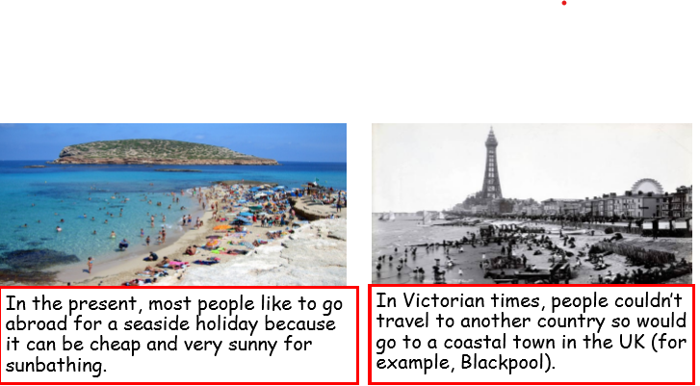
 | Punch and  Judy | Punch and Judy was a popular puppet  Show with Mr Punch, his wife, a crocodile and some sausages.
Timeline of Historical Events
