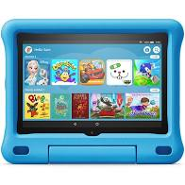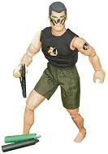

21st Century

Toys: Games

consoles, Tablets,

Virtual reality, X-box.

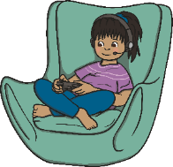

20th Century

Toys: Teddy bears,

Barbie dolls, Action Man, electronic toys, computers, games consoles.

History Detectives:

**What was the first ever toy?**

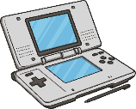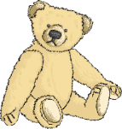

**Year 1/2 Are childern’s toys now better than those from the past?**

19th Century

Toys: wooden dolls, wooden doll houses, tea sets, ball and cup, spinning top, toys soldiers, footballs.



**Timeline: Key Events**

**Key Vocabulary**

|  |  |
| --- | --- |
|  | **Key Vocabulary** |
| Victorian | The time of **Queen Victoria’s** reign. 1837-1901. |
| 20th century | The **20th century** was 1900-1999. |
| 21st century | We are in the **21st century**. It started in the year **2000** and will end in **2099.** |
| Metal toys | Toy soldiers and some spinning tops were made out of metal. |
| Plastic toys | Most modern toys are made of plastic. Toy soldiers, dolls, ride-on cars are often made of plastic. |

|  |  |
| --- | --- |
| **Key Facts** |  |
| How long have toys existed? | Toys have existed for **thousands** of years. Even stones and string have been made into toys. |
| What were toys made of in the Victorian age? | Toys were mainly made of **wood**, **paper** and **metal** during the **Victorian** age. |
| What toys did Victorian children play with? | **Rich** **Victorian** children played with clockwork trains, rocking horses and dolls. **Poorer** children played with homemade toys like peg dolls and wooden boats. |
| What are modern toys made of? | Modern toys are mainly made of plastic. This is because it is usually safer and easier to make things with. |
| How are modern toys different? | Many modern toys use electricity to work. Computers and consoles were invented in the **20th century**. |

**FPS HISTORY**

**Knowledge Organiser**