Key Question: What is ‘mummification’ and why did the A.E. believe about it?
To know that the A.E. believed in life after death. To know the process of mummification and items the dead were buried with.

Key learning: Who were the Main A.E. gods and goddesses?

Key learning:

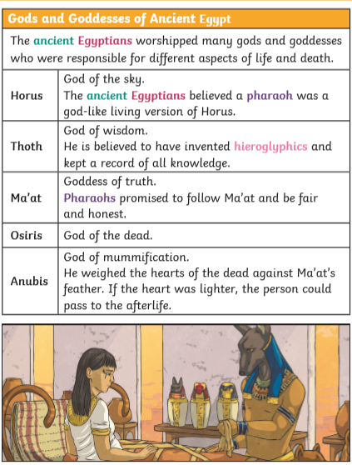

Key Question: Who were the Ancient Egyptians?
Key Learning: Locate A.E. in time and place and understand terms ‘ chronological’, ‘ancient’ and ‘modern’ and ‘BC’ and ‘AD’. To know why people lived close to the river Nile. 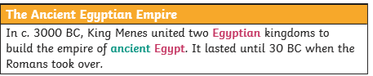

Key Vocabulary
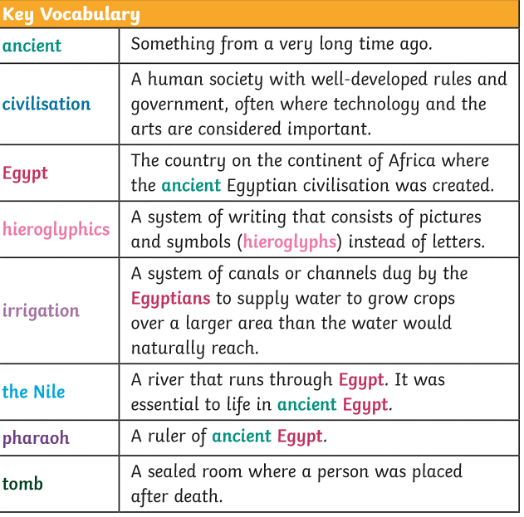

Year 3/4 What do we know about Ancient Egypt?
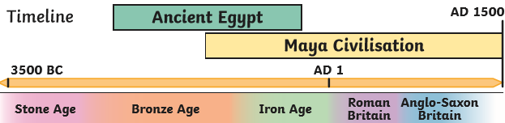

History Detectives:
How could a British archeologist come face to face with an Egyptian mummy?
FPS HISTORY
Knowledge Organiser

Key Question: Where did the Ancient Egyptians live?

3. To complete a map of A.E. and give reasons as to why most places are so close to the River Nile.
- To appreciate the importance of the River Nile.
Key Learning: The jobs local children may have done and other jobs in Nottinghamshire such as textile mills, mines and lace factories.

Key Question: What can we find out about Ancient Egyptian life?
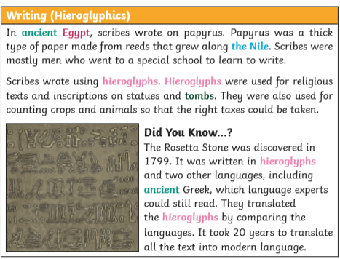

1842 The mine act means children under 10 can no longer work in coal mines

1838 Slavery abolished in the British Empire and QV crowned queen

1901 Queen Victoria dies, aged 81 and Edward vii becomes king

1840 Queen Victoria marries Prince Albert

1851 The Great Exhibition takes place from May and October in London

1870 Schools start being built for 5-10 year olds

1864 Children under 10 can no longer work as chimney sweeps

1861 Prince Albert dies of typhoid

1837 Queen Victoria becomes queen

1880 The Education Act makes school compulsory for all children

