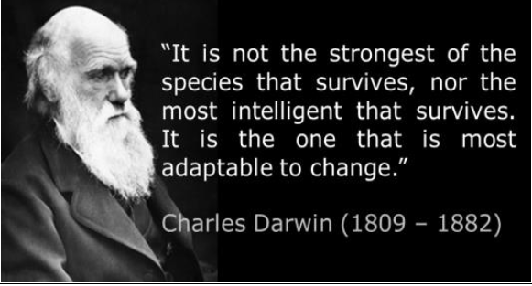

**Key Question:**Why is Charles Darwin such a controversial figure? Charles Darwin sailed to the Galapagos Islands to research into how animals had adapted to their environment. He developed a theory of evolution that stated that animals evolved and adapted over time. This went against the teachings of the church and caused controversy around the world.

**Key Question:**What can fossils tell us about adaptation and evolution?

**Key Learning: Living things change over time and fossils provide evidence of this. Anthropologists study fossils to investigate how humans evolved and from which species.**

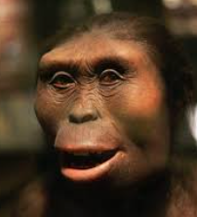

**Key Question:**How do animals adapt and survive in hostile environemnts?

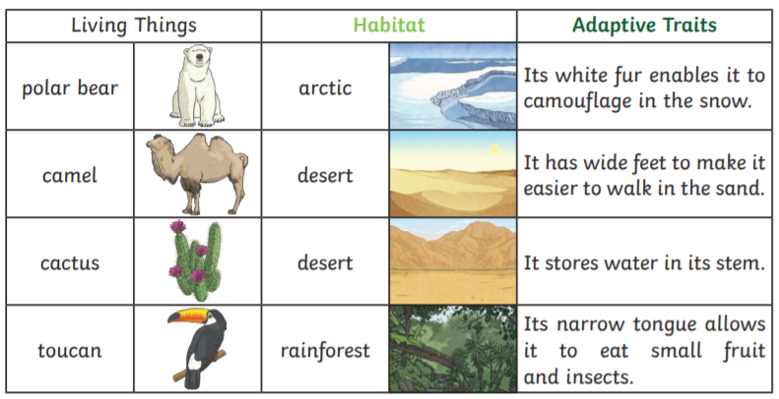

**Key Question:**Why was the discovery of ‘Lucy’ so important?

**Key Learning:Lucy was the name given to a fossilised skeleton that was found in Ethiopia in 1974 and believed to be over 3 million years old. Some anthropologists believe she is proof that we evolved from primates.**

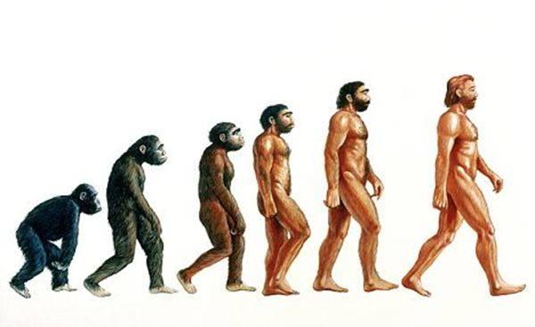

**Vocabulary**

|  |  |
| --- | --- |
| evolution | the process of changing and adapting to an environment over time |
| natural selection | a process of evolution in which the organisms that are best adapted to their environment survive and reproduce, while those that are weak leave fewer or no offspring |
| variation | the amount of change or difference in something |
| species | a group of living things that can mate with one another but not with those of other groups |
| adaptation | the way by which an organism or species becomes better suited to its environment |
| theory | an idea, based on research that can be used to explain something |
| inheritance | the process of passing characteristics to later generations by genes |
| genes | The code in our bodies that has our characteristics in (ie eye colour) |

Super Scientist Investigates:

Why was Charles Darwin disliked by religious groups?

**Key Question:**Could we possibly be evolved from apes, monkeys and other primates?

**Key Learning: Humans are one type of several living species of great apes. Humans evolved alongside orangutans, chimpanzees, bonobos, and gorillas. All of these share a common ancestor before about 7 million years ago**

**FPS SCIENCE**

**KNOWLEDGE ORGANISER**

**Year 5/6 Evolution: Changing over time**