Year 3 and 4 New mixed age planning overview

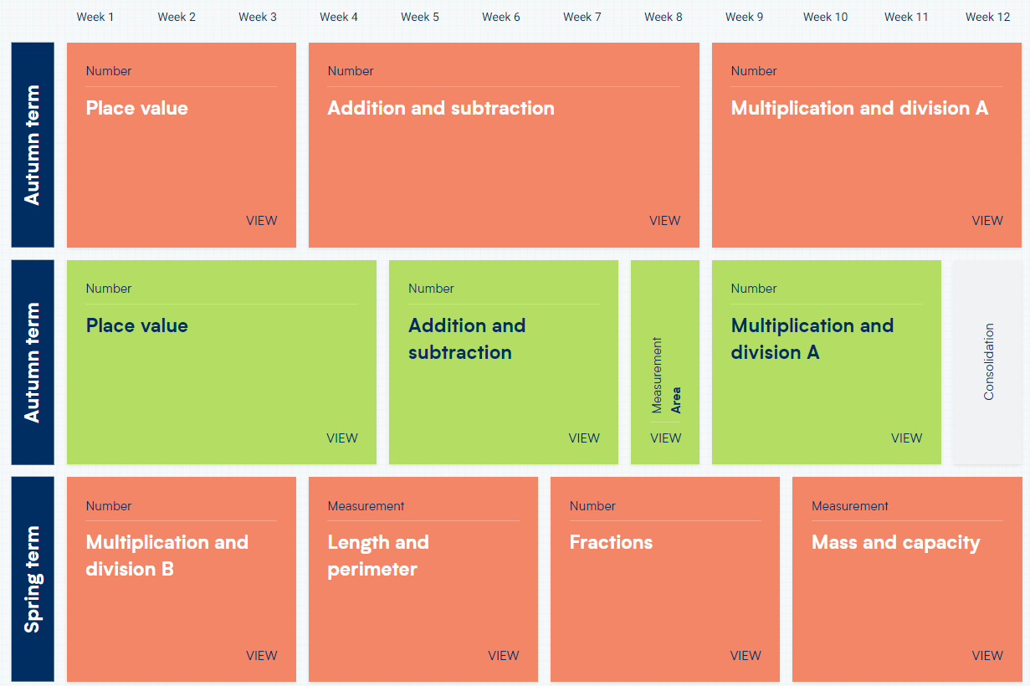

Year 5 and 6 New mixed age planning overview

