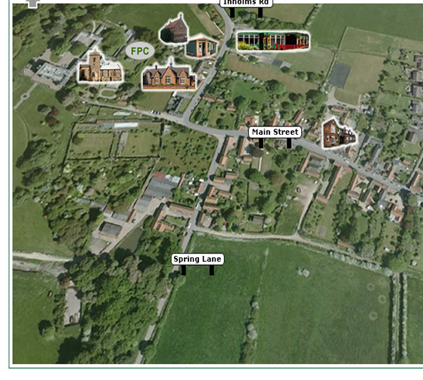

**Vocabulary**

|  |  |  |
| --- | --- | --- |
| **aerial view** |  | A view from above |
| **human geography** |  | Things that have been made by people |
| **physical geography** |  | Natural things- not made by people |
| **route** |  | A way from one place to another |
| **village** |  | A small group of houses, maybe with a shop, that are often in the countryside. |
| **key** |  | Tells you what the symbols on the map mean |
| **landmarks** |  | A well-known building in a place that is easily seen and recognised |

**What is the difference between physical and human geography?**

**Flintham**

**Year 1/2 Can you describe where we live?**



Geography Investigators: Where did the name Flintham come from?

**FPS Geography**

**KNOWLEDGE ORGANISER**

***My Address:***

***______________________________***

***______________________________***

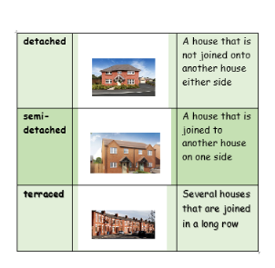

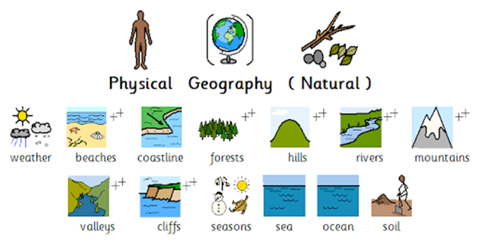

**Flintham**



**Flintham**

**Flintham**

**Flintham**