FPS HISTORY
Knowledge Organiser

History Detectives:
How do we know about the Fire?
Year 1/2 The Great Fire of London
2nd Sept 1666: 1am – The fire starts in a bakery in Pudding Lane
1677 – A monument to The Great Fire of London is finished.
6th Sept 1666: 8am – The fire is put out.
22nd Jan 1667: The committee finds that the fire was an accident.
10th Oct 1666: A day of fasting is held to remember the fire.
7am – 300 houses have already been destroyed.
3rd Sept 1666: 9pm – Houses are pulled down to stop the fire reaching the Tower of London
4th Sept 1666: 8pm – St. Paul’s Cathedral catches fire.
5th Sept 1666: 2am – Buildings along the strand are blown up to stop the fire spreading.
Summary  Map showing the spread of the fire, between 2nd and 5th September 1666. |  |  | Key Questions
The Great Fire of London was a major fire that swept through London from Sunday 2nd September to Thursday 6th September 1666.  The fire destroyed:  -13200 houses (homes of 70,000 people)  -87 churches  -St. Paul’s Cathedral  -Many government buildings  Only 6 deaths were reported: But many historians think that there were lots more deaths. The temperature of the fire may have reached 1,600˚C! | 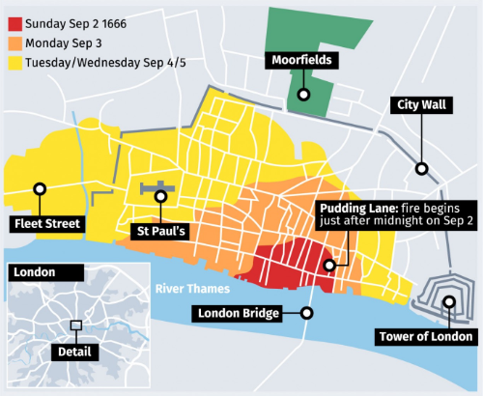 |  | HOW DID THE FIRE START? |  |  | The fire started around 1am in Thomas Farriner’s bakery on pudding lane. The flames spread through the house, down Pudding Lane, and into the nearby streets. |  |  |  |  |  | Did you know?  Thomas Farriner always said that the fire was not his fault.
 |  |  | WHY DID THE FIRE SPREAD SO QUICKLY? |  | 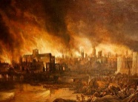 | Lots of things caused the fire to spread. It had been a long, dry summer. Most houses were made of wood and built very close - a strong wind helped to blow the fire across them. |  |  |  |  |  | Did you know?  In 1979, 20 barrels of tar were found in a cellar on Pudding Lane.
 |  |  | DID MANY PEOPLE DIE? |  |  | Records show that only 6 people died in The Great Fire of London, although there might be more. The deaths of the poor were unlikely to have been recorded. |  |  |  |  |  | Did you know?  Some historians believe that hundreds of people actually died in the Great Fire.
 |  |  | WHO PUT THE FIRE OUT? |  | 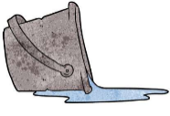 | There was no fire brigade in London at the time, so Londoners had to try and put out the fire themselves, helped by soldiers. They used leather buckets, water squirts, and fire hooks, to pull buildings down. |  |  |  |  |  | Did you know?  From the 3rd day, gunpowder was used to bring down houses quicker.
 |  |  | WHAT HAPPENED AFTERWARDS? |  |  | The city began to be rebuilt, (King Charles gave Christopher Wren control of this) but this took around 50 years to rebuild. |  |  |  |  |  | Did you know?  Houses were mostly rebuilt using brick and built further apart. Streets were widened.
Key People
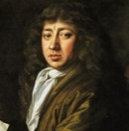  Samuel Pepys (1633-1703)  Samuel Pepys was a diary writer. He was in the city during the fire and was an eyewitness. He wrote in his diary about the fire. | Thomas Farriner (1615-1670)  Thomas Farriner was the owner of the bakery on Pudding Lane where the fire started. Thomas Farriner and his children escaped the fire, but his maid died. |  | HOW DO WE KNOW ABOUT ALL OF THIS? |  | 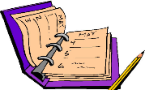 | We know about what happened at the time because people wrote about it in newspapers and in letters (Samuel Pepys’ diary). Also, artists who were around at the time painted pictures of the fire as they remembered it. |  |  |  |  |  | Did you know?  The most famous painting of the fire was by Jan Griffier in 1666.
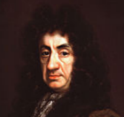  King Charles II  (1630-1685)  Charles II was the King of England at the time of the fire. He helped put the fire out and feed the homeless. | 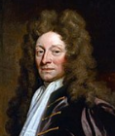  Sir Christopher Wren  (1632-1723)  Sir Christopher Wren was one of the best architects at the time of The Great Fire. He re-built 52 of the churches that were destroyed by the fire. He redesigned St Paul’s cathedral, which became the tallest building in London. Wren was a talented man, who was also a mathematician and scientist.
 |  |  | Top Facts |  |  |  |  | Key Vocabulary
 |  |  | - Before the fire began, there had been a drought that had lasted for over 10 months!  - People whose homes had burnt lived in tents in London until their houses were rebuilt.  - Sir Christopher Wren designed a monument for the Great Fire, which still stands today.  - The Fire helped wipe out the Plague. |  |  |  |  | Architect |  |  | Someone who designs a building.
 |  |  |  |  |  |  |  | Drought |  |  | A long period of time when it doesn’t rain.
 |  |  |  |  |  |  |  | Eyewitness |  |  | Someone who sees an event happening.
 |  |  |  |  |  |  |  | Monument |  |  | Usually a statue built to help remember something.
 |  |  |  |  |  |  |  | Plague |  |  | A deadly disease that  spreads quickly.

