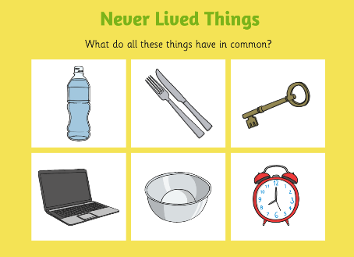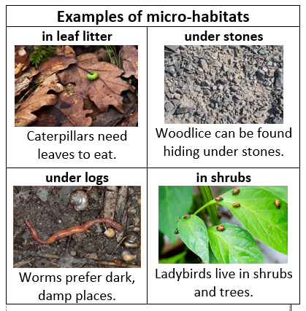

**FACTOID**

A rotting log may become home to a number of different insect species.

**Food Chain**

The Leaf is **eaten by** the snail.

The snail is **eaten by** the bird

**Vocabulary**

|  |  |
| --- | --- |
| microhabitat | A small home environment for plants, animals and insects. Examples include: ponds. individual trees. |
| reproduction | The process by which living things produce offspring. |
| living | Things that are living, grow, move eat, reproduce, breathe, go to the toilet. |
| Non-living | Things are things that are not alive. They do not need air, food or water. They do not move. They do not grow and do not reproduce. |
| dead | No longer alive – was living. |
| consume | To eat. |
| decay | To rot or decompose, to slowly waste away. |
| food chain | A food chain describes how different organisms eat each other, usually starting out with a plant and ending with an animal. |

Super Scientist Investigates: Do all offspring look like their parents?

**FPS SCIENCE**

**KNOWLEDGE ORGANISER**

**Year 1/2 Minibeasts – Do minibeast babies look like their parents?**