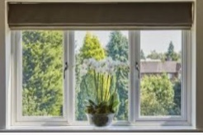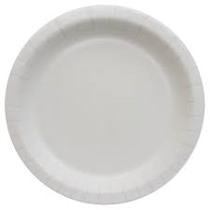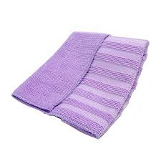

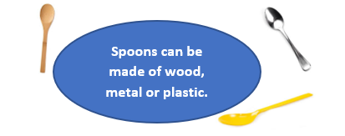

**FACTOID**

The same object can be made out of different materials.

Glass is a good materials for windows because it is transparent. You can see through it.

This paper plate is good for a party because it is stiff.

This towel is absorbant. It soaks up water well.

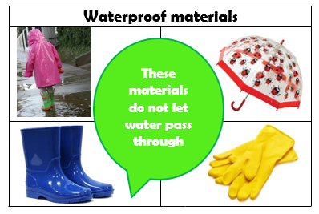

**Key Question:** Can you think of materials that are waterproof?

**Key Learning:** A material that is waterproof does not let water in. Materials like plastic, rubber and wax are waterproof.

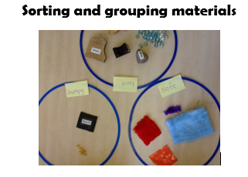

**Key Question:** Can you sort objects

by the material they are made from?

**Key Learning:**

We can use our senses and what we

know about a materials properties to

help us to identify different materials.

**Vocabulary**

|  |  |
| --- | --- |
| absorbtion | The process of drawing in or soaking up. |
| transparent | An object that is transparent can be seen through. |
| property | What a material is like or how it behaves. |
| waterproof | A material that does not let water in. |
| maluable | A material which can be shaped. |

Names of materials – brick, glass, metal. wood, plastic, foil, rubber.

Properties of materials – dull, shiny, stretchy, elastic, hard, rough, smooth, strong, not transparent, not waterproof.

Plastic

**FACTOID**

An object can be made of more than one material.

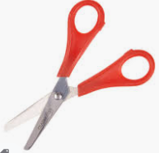

Metal

**Materials and their uses**

|  |  |  |
| --- | --- | --- |
| **Material** | **Properties** | **Uses** |
| **wood** | opaque  hard  strong | **table** |
| **metal** | shiny  smooth  reflective | **fork** |
| **plastic** | waterproof  bendy  translucent | **water bottle** |
| **glass** | transparent  waterpoof  hard | **window** |
| **brick** | hard  rough  dull | **wall** |
| **rock** | strong  hard  rigid | **fireplace** |
| **paper** | tears easily  translucent  flexible | **book** |
| **cardboard** | dull  non-reflective  opaque | **boxes** |
| **fabric** | flexible  Soft  absorbent | **clothes** |

**FPS SCIENCE**

**KNOWLEDGE ORGANISER**

**Year 1/2 Which material is the best?**

Super Scientist Investigates: