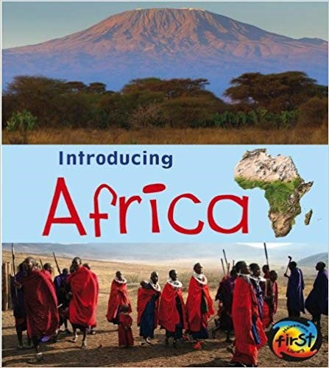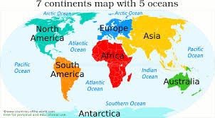

**FPS Geography**

**KNOWLEDGE ORGANISER**

|  |
| --- |
| **Vocabulary** |
| **Continent**  A big area of continuous land: **Africa, Europe, Australia, Asia, North**  **America, South America, Antarctica.** |
| **Equator**  An imaginary line that splits the Earth into the North and South. The closer you are, the warmer it is. |
| **Ocean**  A huge body of salt water. It covers 71% of the world. **Pacific, Atlantic, Indian, Southern, Arctic.** |
| **Physical Feature**  Something that is put there because of  nature– it is **natural**. |
| **Human Feature**  Something that has been put on the Earth by a **human**– it has been built. |

Geography Investigators: Where in the world is Africa?

**Year 1/2 How Hot is Africa?**

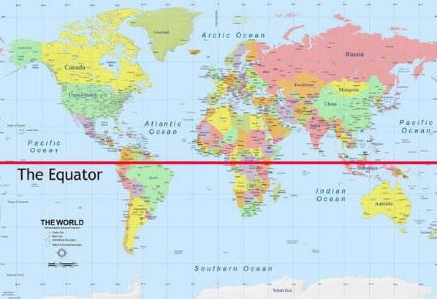

|  |
| --- |
| **Key Facts about Africa:** |
| Africa is a **continent** with **55 countries.** It is the **hottest** **continent**. |
| Africa is near the **equator**. |
| The **weather** in Africa is mostly **hot** and **dry**. |
| **Sahara** is a large **desert** in Africa. |
| Africa has **extreme** weather which can be **dangerous**. |

