**Tourism, employment, fertile land for crops, geothermal energy**

**Poisonous gases, burning hot lava, falling rocks, suffocating ash**

**Destruction of homes and livelihoods, poor health, fires, landslides**

**Physical Geography**

**What natural features are linked to volcanoes, earthquakes and tsunamis?**

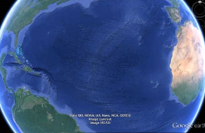tectonic plates 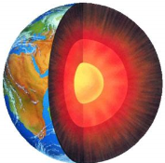 earth's core

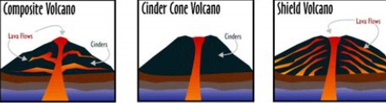

**Human Geography**

**How do volcanoes, earthquakes and tsunami affect people?**

**Negative**

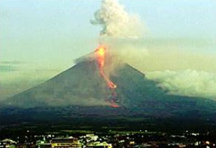

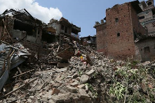

Positive (volcanoes only)

**Vocabulary**

|  |  |  |
| --- | --- | --- |
| eruption | Molten lava erupts from the ground | To send out lava,rocks and ash in a sudden explosion |
| tectonic plates |  | the rocky outer layer of the earth (crust) broken into pieces |
| geothermal |  | heat made by the earth |
| magnitude |  | Strength of an earthquake |
| aftershocks |  | A minor shock following the main shock of an earthquake |
| tsunami |  | A large ocean wave usually caused by an earthquake or volcanic eruption |

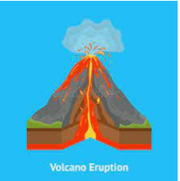

|  |  |
| --- | --- |
| magna chamber | a reservoir of magnain the earth’s crust under a volcano |
| layers of lava and ash | hardened lava and ash forming rocks |
| conduit | a channel lava passes |
| ash cloud | bits of rock and volcanic glass blasted into the sky |
| crater | A large bowl shaped hole in the ground |
| vent |  |

Geography investigators: Why do we have volcanoes and earthquakes?

**FPS Geography**

**KNOWLEDGE ORGANISER**

**Year 3/4 Why is the earth angry?**

**Key questions**

1. What is the role of tectonic plates in the the creation of volcanoes?
2. Why do volcanoes erupt?
3. What are the dangers of living in the foothills of a volcano?
4. Why is the volcanic landscape important for crops, energy and tourism?
5. Where in the world are the world’s most dangerous volcanoes?