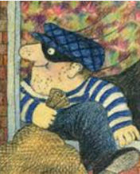

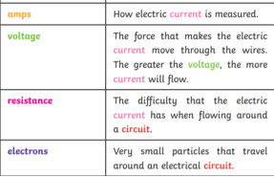

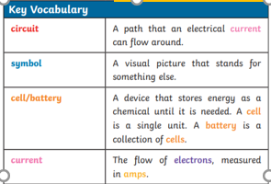

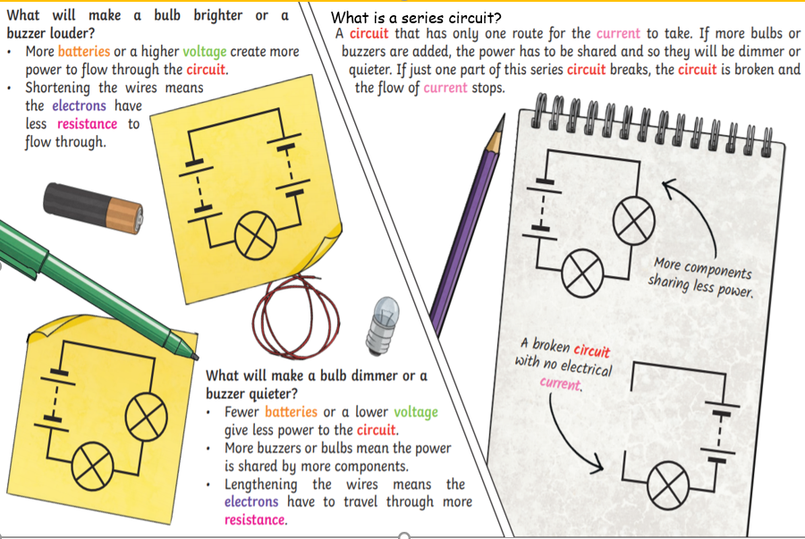

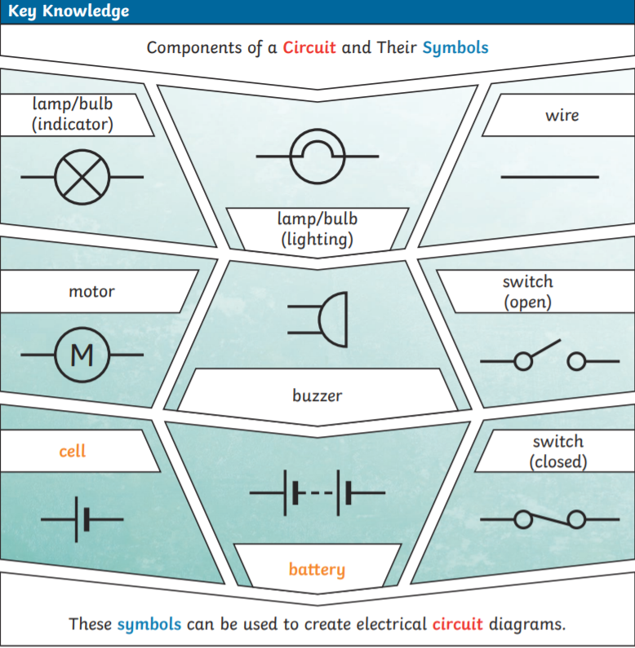

Super Scientist Investigates:

What is the best circuit for a hall light?

**How can my knowledge of a switch help me catch a thief?**

**Pressure pads are used as switches to complete circuits that are otherwise broken.When this happens,**

**other components have**

**power to alert the**

**presence of an intruder!**

**FPS SCIENCE**

**KNOWLEDGE ORGANISER**

**Year 5/6 Electricity**