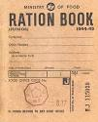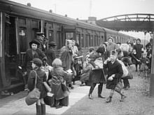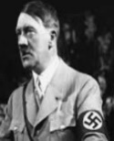

History Detectives:

How did Hitler become leader?

**Key Question:** What types of evidence can we find about the war?

**Key Learning:**We have much evidence from the time of the war (primary evidence) including film, peoples’ accounts and original documents. There is also secondary evidence which includes people’s research and views.

Adolf Hitler

Nazis leader

of Germany

1933 - 1945

**Key Question:**Why was the ‘Kindertransport’ so important to the lives of Jewish children?

**Key Learning:**The Kindertransport was an organised rescue effort of children from Nazi-controlled countries that took place during the nine months before the outbreak of the Second World War.

**Key Question:**How did Hitler persuade the German people that his views were the right ones to follow?

**Key Learning:** Hitler used his own version of history, that was based on rumour an d lies, to convince the German people that what he was doing was necessary. He used propaganda to convince them that Jews were evil and greedy. Often cartoons would have been drawn to make jokes about them, depicting them as dirty animals.

**Key Question:**Why was rationing introduced?

**Key Learning:** Before the War, Britain imported 55 million tons of food food a year from abroad. During the war German submarines attacked British supply ships. There was less food so the British government introduced rationing. Rationing made sure that people got an equal amount of food every week.. Rationing of food lasted for 14 years and ended on July 4, 1954.

**Key Question:**What was the Blitz?

How did it affect daily lives?

**Key Learning:** The German Luftwaffe was used to target and bomb British industrial cities This bombing was especially intense during 1940-1941 and referred to as the 'Blitz' in the British press.

* Anderson aid raid shelters were built.
* Blackouts were enforced after dusk
* Many people were killed or injured

**Key Question:**What was the Holcaust?

**Key Learning:** This was the systematic murder of 6 million Jew and other ‘undesirable’ others. They were kept in concentration camps and starved or killed.

**Key Question:**Why were children evacuated?

**Key Learning:**People expected cities to be bombed, as

enemy planes tries to hit targets, for examples waregouses and

factories.This would have put city children in grave danger, and

so about 800,00 from Spetember 1939 onwards were evaccuated to the countryside.

**Key Question:** Who were the main participating countries?

**Key Learning: Allies = friends Axis = enemies**

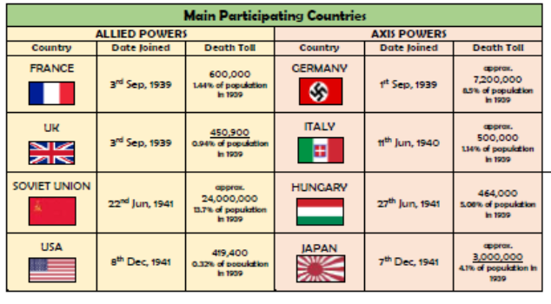

**Timeline: Key Events****e**

**Key Vocabulary**

|  |  |
| --- | --- |
| **allies** | Countries who fought against the Nazis |
| **axis powers** | Germany, Japan and initially Italy |
| **blitz** | The mass bombing of a town or city |
| **evacuation** | Moving somewhere to avoid a danger |
| **holocaust** | The mass murder of people |
| **kindertransport** | Special trains and boats that moved jewish children out of Germany to Britain |
| **luftwaffe** | The Germany airforce |
| **propaganda** | The use of media (radio, newspapers,film) to persuade people ato believe in something. |
| **rationing** | Limiting how much you can have. |
|  |  |

**FPS HISTORY**

**Knowledge Organiser**

**Year 5/6 Childhood during the Second World War**

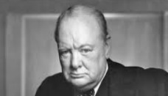

Winston Churchill

Prime Minister of Britain 1940 - 1945

**Previous Historical Thinking**

* Events in history have causes and consquences
* There are a range of sources to find out about the past

**Deepening Historical Thinking**

1. Explain how and why different versions of the past exist
2. Identify the different ranges of historical evidence including primary and secondary
3. Explain causes and consequences of a significant world event

**New Learning**

1. World War Two began on September 3rd 1939 and ended in Europe on 8th May 1945
2. Nazi Germany persecuted minorities including Jews and disabled people
3. Rationing was introduced to control the supply of food
4. Children were evacuated from dangerous places into the countryside
5. The German airforce bombed many areas of Britain which was called the Blitz
6. Countries who fought agiast the Nazis were called The Allies and included Russia, USA, Canada and s

**Lesson Sequence**