Key question; How can we hear?
Key learning: Sound is a type of energy. Sound is created by vibrations.

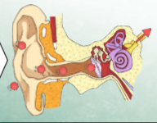

Key question: What is soundproofing, why is it important and which materials are the best at soundproofing?
Key learning: Prevents sound from passing through

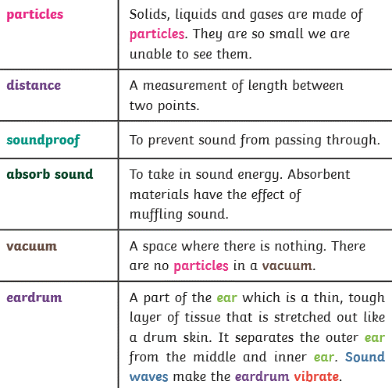

Key question: How can I make different sounds using musical in struments? (pitch and loudness) 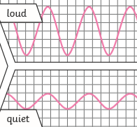
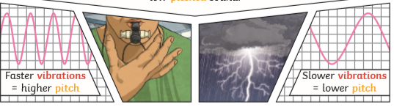

Key question: How does sound travel?

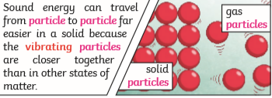
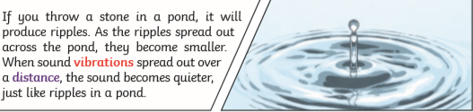

Super Scientist Investigates:
How are shadows and sound created and changed?
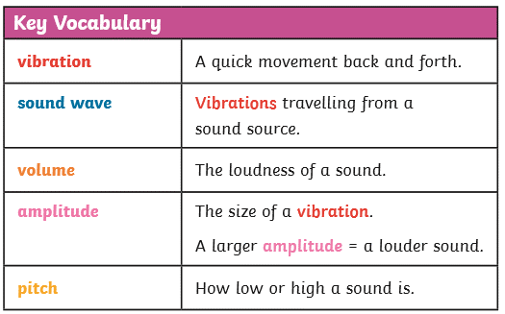
Sound Year 3 and 4

FPS SCIENCE: Physics
KNOWLEDGE ORGANISER

Key question: What is soundproofing, why is it important and which materials are the best at soundproofing?

