Knowledge Bank – Understanding the World
Reception – Spring 1 2023
Chinese New Year
Where is China?
China is a very big country a long way from the UK, where we live, on almost the other side of the world.
Every year during spring time, many people in China and other people from around the world, celebrate Chinese New Year.
Every year, a different animal is chosen. This year, it is the Year of the Rabbit.
Things you might see happening during Chinese New Year…
People decorate their houses with lanterns. | People set of fireworks. | Children are given red envelopes filled with money and sweets. Red is a lucky colour! | There are parades in the streets with dragon and lion dances. | People spend time with their families and eat nice food. These are dumplings.
Some other animals have the years named after them…

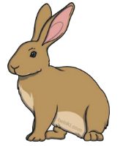

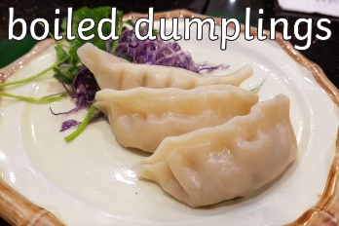
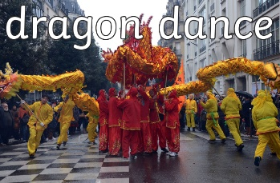
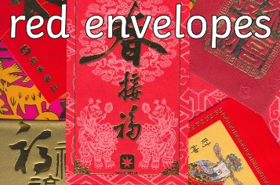
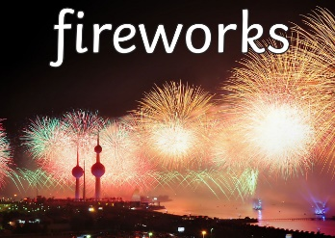
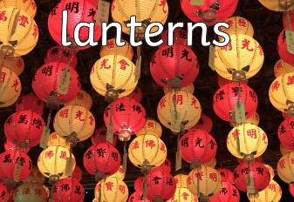

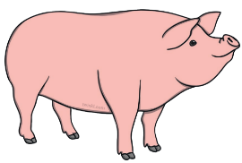
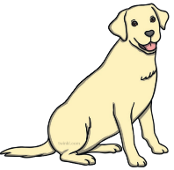
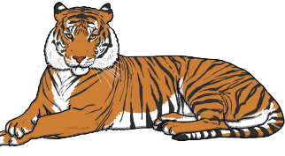

Key Questions…
Where is China? How do people celebrate Chinese New Year? What might you see happening at Chinese New Year?
Can you name some of the animals that have the years named after them? What animals is it this year?

Materials
Everything is made up of a material. Some materials we might know are;
Wood | Plastic | Glass | Card and paper | Metal
 |  |  |  | 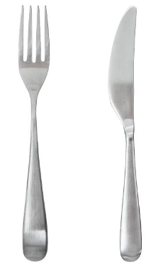

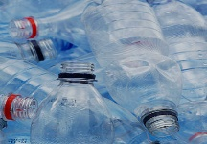
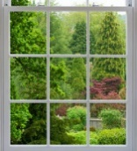


Key Questions…
What is this made out of? What will happen if…? Which material might you choose for…?

Worms

Did you know?
- Worms have no eyes or ears
- There are lots of different types of worms.
- Worms do not like being out in the light for too long.
- Worms mainly eat soil. They also eat dead leaves and plants.
- Worms are very good for your garden and for your soil.

How can materials change?

Some materials change when we heat them up. Sometimes they can melt.

Some materials can change when we cool them down. Sometimes they can freeze.

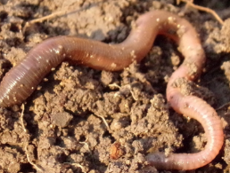
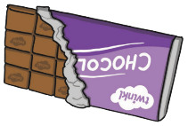
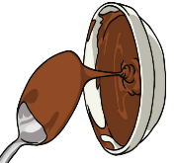

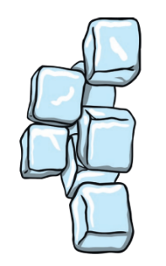
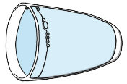

Key Questions…
Can you tell me three special facts about worms?
Key Questions…
What happens to water when we put it in the freezer?
What happens to chocolate when we heat it up? What do you notice?

Who might help me if….?

Sometimes more than one person might have to help you if you have a problem. Here are some people who might help us if….

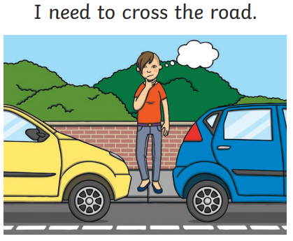 | 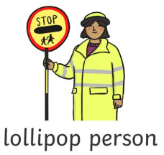
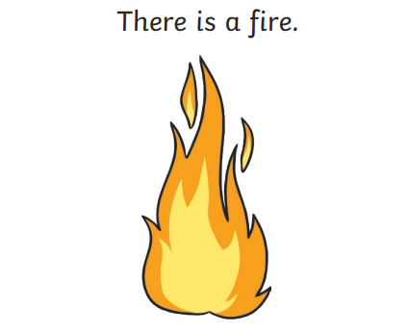 | 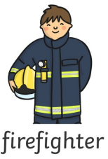
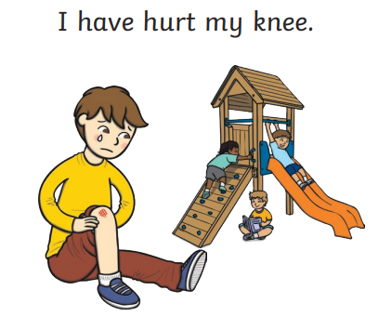 | 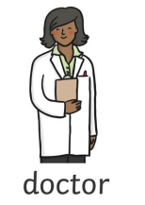
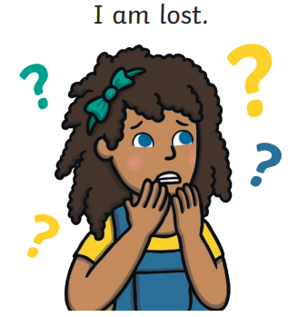 | 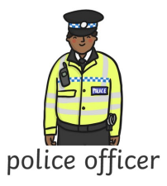

People Who Help Us

There are lots of people in our village and town that can help us if we ever need it and are there to keep us safe. Here are some of the people who you might see.
People who help us and the transport they use…
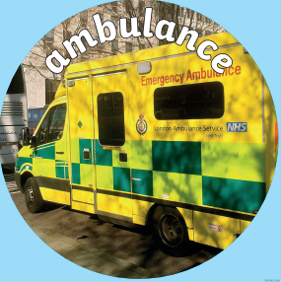 | 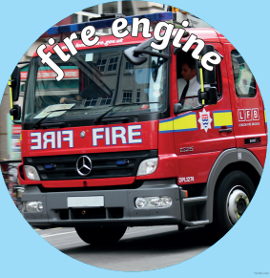 | 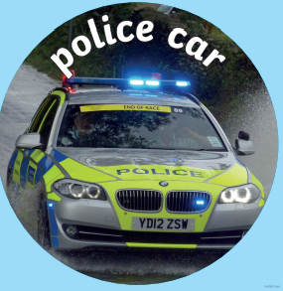
Our nearest hospital is in Newark.
Our nearest police station is in Newark.
Our nearest fire station is in Newark.

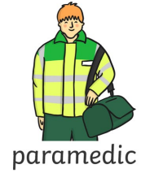

Key Questions…
Can you tell me who might help you if….?

Key Questions…
Can you name some people in the community might help us? What transport might they use?

How have the emergency services changed?
There have been many changes over the years to people who help us, especially the fire and rescue service, the police and the ambulance service.

- Their uniform has changed (the clothes that they wear)
- Transport has changed (what they use o get from one place to another)
- Equipment has changed (the things they use to help them do their job)

Who? | In the past | Now
The Police | 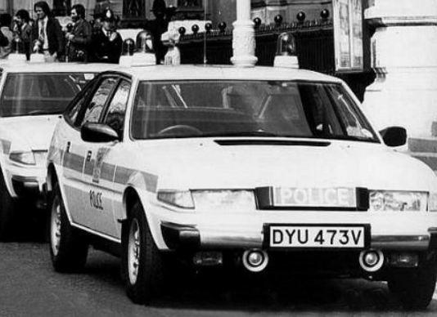 | 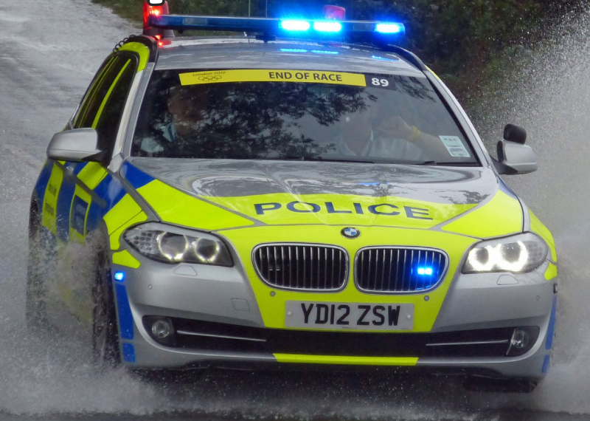
Fire and Rescue Service | 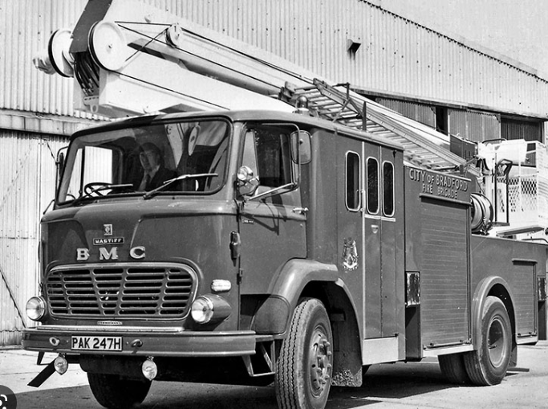 | 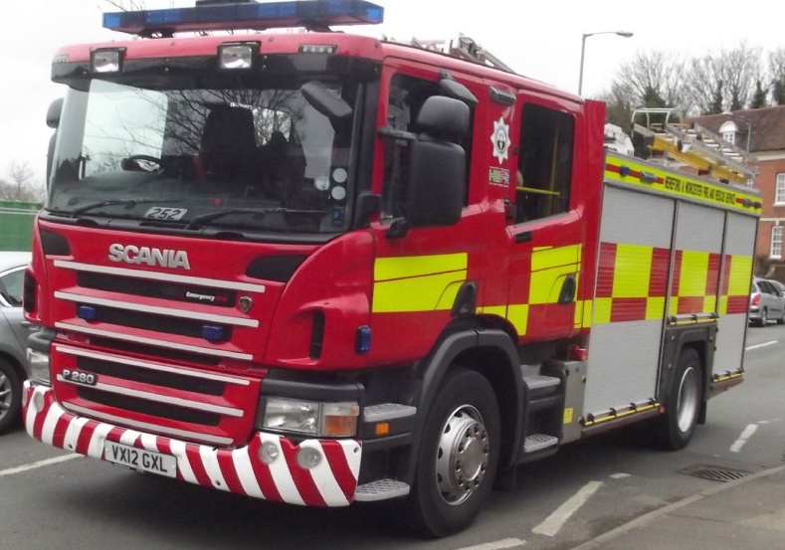
Ambulance Service | 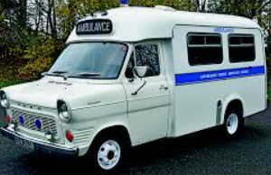 | 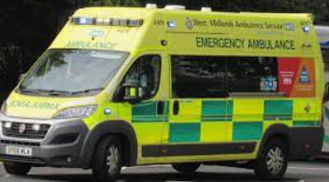
In the past or now?

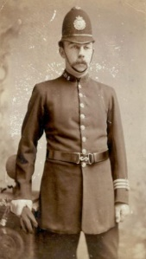
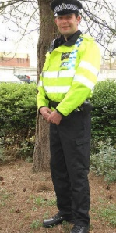
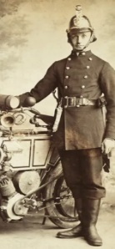
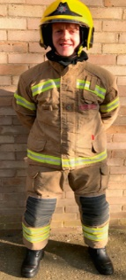
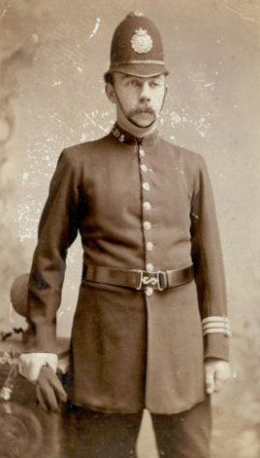
Key Questions…
What is the same? What is different? How and why might it have changed?
Which photos are old, which are new? How can you tell?

Key Questions…
What number do we call in an emergency? What is an emergency?
When might somebody call 999?
What to do when we need help in an emergency…
If we have an emergency and need help, we need to call the emergency services. The emergency services are the police, fire brigade and ambulance service.
We call…
999

