**School**

**Early Years Provision Admissions Policy**

**September 2024**

*‘Inspiring A Love Of Learning’*

**Our School Vision is:**

**We aspire to provide everyone with…**

* **an excellent holistic education through an inspiring, creative and ever evolving curriculum.**
* **an understanding that there is no limit to their potential.**
* **the foundations to face the various challenges of life and be respectful, responsible and caring citizens making a positive contribution to their community and wider society.**
* **a love of learning which continues to develop enquiring minds and enrich their lives.**

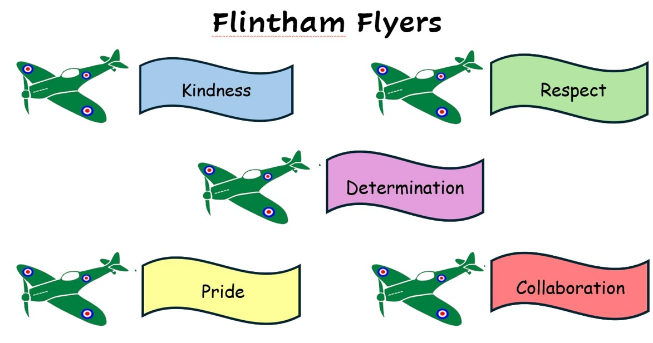

**AIM OF THIS POLICY**

To ensure the admission criteria for Flintham Primary School and Early Years are clear.

The Governing Body is responsible for the Admissions Policy.

**OVERVIEW**

The Early Years Provision within our school is committed to providing excellent quality integrated education and care to children, 3 to 5 years old within the local community.

Your child will learn through play, in structured sessions planned by skilled Early Years teachers and professionals. They will provide play activities suited to your child’s interests and provide a teaching and learning environment that is stimulating and challenging. The school is registered with Ofsted to provide places for children aged 3-5.

**4-5-year-old Reception class places**

At Flintham Primary School we have a PAN of 15. This means that we have 15 school places available in our reception class each year. To find out if you meet the eligibility criteria please contact admissions at Nottinghamshire County Council. Applications for reception should be made through the County Council.

**3-4-year-old Early Years places**

For our early years children (pre-school) we have a PAN of 13. The number of places is determined by Ofsted, staffing ratios and the staff available at school. We have three admissions intakes in September, January and April of each year, applications for which should be submitted by the end of the term prior to starting in the same year. If vacancies arise during the year, we will fill them in accordance with the admissions criteria. All children are eligible for 15 hours of Early Years Free Entitlement from the term following their third birthday. Those who meet the criteria are entitled to 30 hours funding.Children are admitted through the school therefore applications to the school office.Please note that this provision is on offer for Term Time Only.

The following criteria determines which children are offered a place; they are listed in order of priority:

In the event of over subscription, Flintham Primary School use the following set of criteria.

1. Children looked after by a local authority and previously looked after children
2. Children who live in the catchment area and who, at the time of admissions, will have a brother or sister attending the school
3. Children who live in the catchment area at the closing date for applications
4. Children who do not live in the catchment area but do have a brother or sister attending Flintham at the time of admissions
5. Children who live outside the catchment area

Please note: if your child is enrolled at Flintham in early years, they will not automatically continue into the Reception at the school - you must still apply for a Reception place through the local authority.

The **tiebreaker** for all criteria - children living closest to the school measured in a straight line from the post office address point from the child’s home, to the post office address point of the school, supplied by the Royal Mail using a computerised mapping system. The tiebreaker for two or more applications equidistant from the school will be a random allocation using a computerised system.

**Equality Impact Assessment**

Under the Equality Act 2010 we have a duty not to discriminate against people on the basis of their age, disability, gender, gender identity, pregnancy or maternity, race, religion or belief and sexual orientation.

This policy has been equality impact assessed and we believe that it is in line with the Equality Act 2010 as it is fair, it does not prioritise or disadvantage any pupil and it helps to promote equality at this school.

**Monitoring the Effectiveness of the Policy**

The practical application of this policy will be reviewed annually or when the need arises by the coordinator, the Headteacher and the link governor..