 **Flintham **

**Primary School**

**Behaviour Policy**

**October 2024**

*‘Inspiring A Love Of Learning’*

**Our School Vision is**

**We aspire to provide everyone with…**

* **an excellent holistic education through an inspiring, creative and ever evolving curriculum.**
* **an understanding that there is no limit to their potential.**
* **the foundations to face the various challenges of life and be respectful, responsible and caring citizens making a positive contribution to their community and wider society.**
* **a love of learning which continues to develop enquiring minds and enrich their lives.**

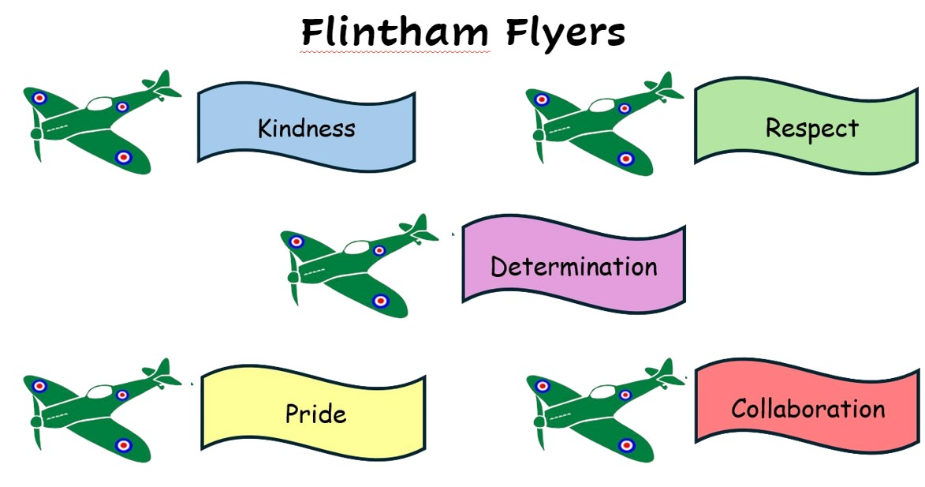

**INTRODUCTION**

At Flintham Primary School every child matters and we work hard in partnership with children and their families to ensure the best possible outcomes for each individual child. We strive for continuously high standards of behaviour, whilst endeavouring to preserve and share important values, in the form our ‘Flintham Flyers’, which are intrinsic to our school and to society in general. Our policy promotes positive behaviours rather than merely deterring unacceptable choices of behaviour. This policy should be read in conjunction with our Child Protection (and the broader safeguarding agenda), SEND policies and Physical Intervention.

We have a consistent and fair approach where the children know what is acceptable and these principles build positive relationships.

Children at Flintham Primary School are made aware when they join our school that they have a choice when it comes to behaviour. They are encouraged to make good choices but it is also made clear that there are consequences for making the wrong choice and choosing unacceptable behaviour.

Every child is an individual and has individual strengths and needs. Where a child has a special educational need or disability (SEND), flexibility is sometimes required in designing and applying the most appropriate strategies for that child through their individual support plan, whilst still recognising that every child is expected to demonstrate the Flintham Flyers. The school acknowledges its responsibilities under the Equality Act 2010 in respect to SEND.

We understand that Adverse Childhood Experiences (ACEs) can have a significant impact on our children. Children who have experienced ACEs may arrive at school in a state of hyper-arousal or hypo-arousal and this can impede a child’s readiness to learn and ability to form positive relationships. If staff recognise any of the signs they will, wherever possible, offer children time to talk and explore their feelings.

**ENCOURAGING POSITIVE RELATIONSHIPS (AND BEHAVIOUR)**

At Flintham, we focus on promoting positive relationships through creating a school ethos that celebrates and rewards the positive choices made by children. Staff model positive relationships through a culture of trust, respect, nurture, encouragement, high expectations and a stimulating curriculum. In order for this policy to succeed it needs to apply to all stakeholders. Parents and Carers are key partners in encouraging and maintaining positive relationship and behaviour. The school work closely with parents and carers to promote the welfare of all children, including early involvement when issues arise to establish the underlying reasons and to develop strategies that can be adopted by both home and school with consistency. All parents are asked to read and sign a copy of the home school agreement once their child has started at the school.

These are a few of the many ways in which we encourage positive behaviour:

* smile with praise
* rewarding positive behaviour and those following the ‘Flintham Flyers’
* giving children responsibilities
* being organised and prepared
* using P.S.H.E. as a tool to discuss and build positive relationships
* promoting good examples which encourage children to make the right choices
* grouping and positioning children within the classroom appropriately
* having access to appropriate resources
* having suitable play equipment during lunch times
* modelling of expectations by all staff members

**REWARDS**

To encourage positive behaviour and good learning outcomes, staff distribute various rewards with each class having their own class reward system appropriate to their age group which focuses on the positive choices. As a whole school, house tokens are used for children showing the Flintham Flyers throughout the school day. Stickers for each of the values are given to children who are demonstrating the Flintham Flyers. A class sticker chart in each class is used when a house token is given (sticker added to house trees in own class as a visual reminder of how many tokens have been given out). This also helps to build a team spirit as tokens are added as a house rather than individual.

Children who demonstrate the Flintham Flyers will be celebrated in our Celebration Assembly at the end of each week. One child from each class is awarded a certificate for the values to take home.

Every half term, class teachers select a ‘Flintham Flyer’, for someone who consistently demonstrates the school values, including a child from Kids Club too. Their behaviour is celebrated and they take home a laminated certificate and trophy. Their photograph and certificate is displayed in the school for the half term. In addition, each term a child in each year group who always shows our school values is invited to have hot chocolate and cake with the Head Teacher.

All of the strategies employed for rewards have been designed to enhance self-esteem and recognition of all skills and aptitudes.



**Our values are our**

**‘Flintham Flyers’**

At Flintham Primary School we all use these values to help us

‘’Inspire a Love of Learning’

and ensure all children are part of the Flintham Family

**Kindness**

‘We share, care, help and play’

**Determination**

‘We keep trying to achieve our best’

**Pride**

‘We are proud of our work, achievements and the community’

**Collaboration**

‘We work together as a team to achieve greatness’

**Respect**

‘We take care of ourselves, other people, our classroom and our environment’

**CONSEQUENCES OF UNACCEPTABLE BEHAVIOUR**

At Flintham Primary School we manage disruptive and negative behaviour with a step by step approach. It is important that children know what will happen if they choose to make an unacceptable behaviour choice and that the consequences are applied consistently and fairly. When responding to any unacceptable behaviour choices, a clear reference to the ‘Flintham Flyers**’** will be used by all staff and a positive approach assumed in all instances.

**Step by Step Approach of Sanctions**

**Step 1** Reminder of Expectations

**Step 2** Verbal warning

**Step 3** Consequence applied at this point – followed by restorative conversation

**Step 4** Child asked to report to the Head Teacher

When a child reaches step 3 a consequence will be applied after they have had a time to reflect on their behaviour. Consequences need to be appropriate to their actions, e.g. if a child has made a mess, the expectation is they will tidy up the mess. For younger children consequences will be applied immediately where possible, for older children consequences will at an appropriate time, such as playtime or lunchtime or moving to another classroom to remove them from the situation.

Possible Steps of Consequence and Restorative Practice

|  |  |  |  |  |
| --- | --- | --- | --- | --- |
| Examples of Behaviours | Low level Disruption | Refusal to Follow an Adult's Instructions | Verbal Aggression | Physical Aggression |
| Examples of Consequences for Step 3 | * 2 minutes missing play * Work completed in own time | * 5 minutes missing play * Removal from classroom to take out of situation | * Straight to Step 4 * Parents informed * Repair relationship with other child | * Straight to Step 4 * Parents informed * Repair relationship with other child |
| Restorative Practice | Restorative conversation with adult who they have disrupted.  Daily or weekly catch up with child to reflect on behaviour. | | Restorative conversation between the children involved in the incident.  Weekly catch up with children involved to ensure situation has improved. | |

After a consequence, the use of restorative questions are used to help the children reflect on their behaviour and to help them identify better ways of dealing with situations. The behaviour system is also a reset, giving the child the opportunity to make a fresh start. If the child persists with unacceptable behaviour they will progress through the steps quicker and the Head Teacher may contact parents to discuss their child’s behaviour.

Although this approach applies to all children in school, in the case of our youngest children in Fire Class, teachers may adopt an additional warning as the children develop an understanding of the school expectations. This supports them in making the positive choices that are desirable.

In addition to strategies stated above it may be felt that a child needs appropriate periods of ‘time out’ from difficult situations.

A partnership between school, parents and the child should ideally prevent the chances of any fixed term exclusion although this will be considered and used when a child presents with extreme unacceptable behaviour, physically injures staff or children or there is no progress following significant intervention. Only the Head Teacher, or in the long term absence of the Head Teacher, an Acting Head Teacher, can exclude a child. All parents are asked to read and sign a copy of the home/school agreement when their child starts at the school.

As a consequence of unacceptable behaviour, no children are denied access to any aspects of the National Curriculum however, sustaining the learning opportunities of all children is a key priority. Any child that prevents this from happening will not be able to participate fully in the curriculum due to the barriers created by their personal choices.

**BREAK AND LUNCH TIMES**

All members of staff on duty at morning break and lunchtime will adopt the principles of the ‘Flintham Flyers’, rewarding children with house tokens. The four steps of sanctions will apply in cases of unacceptable behaviour choices. When an incident is considered serious or is repeated, members of the team feed back to class teachers.

During wet playtimes, activities are available in each class. Supervision is extended during these times to support positive play.

To minimise unacceptable behaviour during break times, some of the older children are given specific responsibilities. For example, organising play equipment, use of a ‘buddy’ system, School Council members helping to ensure equipment is used safely and/or setting up the play equipment in the different zones.

**RESTORATIVE PRACTICE**

When a relationship breaks down restorative practice should be used to address and repair the relationship.

The key questions used for a restorative conversation will be:

* What happened?
* What were you thinking?
* How did this make people feel?
* Who else has been affected?
* What should we do to put things right?
* How can we do things differently in the future?

**What happened?**

The idea is to get a very clear picture of what actually happened. The event is likely to be very different from each person’s perspective. Your job, as facilitator, is to understand how the event unfolded from the perspective of the person you are listening to.

**What were you thinking?**

It can be important to find out what each person was thinking at the time of the incident. If someone hits out they may have been thinking:

* ” I thought he was going to hit me”
* ” I thought she had cheated”
* ” I thought I had been disrespected.”

Once you have clarified the thought you can then go to the “feeling”

**How did you feel?**

This is about how the thought made them feel.

* ” I felt frightened because I thought he was going to hit me.”
* “I felt frustrated because I thought she had cheated.”
* ” I felt hurt because he had disrespected me.”

Identifying the feeling can help all parties understand better the incident. If this happens empathy can develop.

**Who else has been affected by this?**

This is the learning phase for those involved. It helps them to understand the impact their actions have had on others. The student will only feel able to answer this question if he/she feels that the facilitator has both listened to and fully understood the situation first.

**What do you need, and what needs to happen now, so that the harm can be repaired?**

Once someone understands that they have caused harm they now have the opportunity to put things right. Putting in right requires:

* Acknowledgement – that harm has been done.
* Repair – reparation and/or making amends.
* Risk reduction – minimising the risk of a similar event happening again.

**RECORDING, MONITORING AND EVALUATING BEHAVIOUR**

Incidents of persistently disruptive and/or unacceptable behaviour classed as serious are recorded on CPOMs, which details:

Date and time with details of the event

The people involved, including children and staff

Reflecting why an incident happened, including any de-escalation strategies used

Reason for using force and description of force used

Any injuries to staff or children and details of first aid or medical attention given

What can be learnt from it for future practise and any disciplinary procedures taken

Parents and Chair of Governors are informed of the event, recording when and how.

If when recording any incident, a member of staff has concerns over a child’s safety and wellbeing or considers that a child may be at risk of significant harm, child protection procedures must be followed (see Child Protection Policy). The designated safeguarding lead must also be informed.

If any complaints are logged this is added as an action to the incident and the appropriate procedures followed from the complaints policy.

Teachers discuss the ‘Flintham Flyers**’** with their class at the beginning of each term and at regular intervals over the course of the year. These aims are an essential part of our school ethos and through discussion in class, small groups and assembly times, the focus on positive behaviour choices involves all children at Flintham Primary School.

Our school does not tolerate bullying of any kind, including whilst online. If we discover that an act of intimidation has taken place, we act immediately to stop any further occurrences. We aim to ensure that all children attend school happily and free from fear. Related issues are entwined within our curriculum with topics appropriate for each age group and we discuss these issues holistically during shared times, such as in assemblies (See Anti-bullying policy).

All members of the school community are expected to follow the same rules and expectations for behaviour whilst using the internet. Teachers are responsible for ensuring children understand and follow the acceptable use policy and know how to report abuse, misuse and access to inappropriate materials (See online safety policy). The Designated Safeguarding Lead monitors use of the internet through reports provided by our internet security provider.

In specific extreme circumstances the physical restraint of a child may be required to prevent injury to a child that is in danger of hurting him/herself or others. Any physical restraint will only be carried out by a member of staff. The actions that we take are in line with government guidelines on the restraint of children and are only carried out as a last emergency resort. It is likely that in such cases, parents are made aware and will be consulted in ensuring plans are in place to support a specific child, such as a behavioural support plan (BSP) (See Physical Intervention policy).

All paid staff with responsibility for children at Flintham Primary School are trained and authorised by the Head Teacher to manage behaviour and discipline, following the school’s policy and using appropriate and agreed strategies.

Any new members of staff or volunteers will be given a copy of FPS Behaviour Policy. Discussion around the implementation of the policy and procedures will form a key part of the induction process. Regular training and updates on aspects of relationships and behaviour approaches will be provided for all staff members as part of the school’s commitment to providing regular and relevant development.

**BEHAVIOUR OFF SCHOOL SITE**

* Educational Visits, including overnight stays - Where an educational visit takes place off school site, it will be regarded as normal curriculum time and the Head Teacher delegates the same powers and responsibilities to staff as when children are on the school site.
* Members of staff do not have powers to discipline a child outside the school premises, but the member of staff should inform the Head Teacher if dangerous behaviour is witnesses. The Head Teacher will then consider whether appropriate to discuss with the parent/carer.

**THE ROLE OF GOVERNORS**

* The governing body has the responsibility of setting down this general guidance and of reviewing the effectiveness of the policy. The governors support the Head Teacher in carrying out these guidelines.
* The Head Teacher has the day to day authority to implement the school behaviour and discipline policy.

**REVIEW**

The staff and governing body regularly review this policy every two years or earlier if deemed necessary. The governors may review the policy at any point if the government introduces new regulations, or if the governing body receives recommendations on how the policy might be improved.

October 2024