 FPS EYFS Literacy Curriculum and Trackers

|  |  |  |  |  |  |  |  |  |  |  |  |  |  |
| --- | --- | --- | --- | --- | --- | --- | --- | --- | --- | --- | --- | --- | --- |
| **Area of Writing** | **Autumn 1** | **Autumn 2** | | | **Spring 1** | | **Spring 2** | | | **Summer 1** | | **Summer 2** | |
| General Reading and Writing Content | | | | | | | | | | | | | |
| **Topics/Themes** | **I am special, all about me!** | **Traditional Tales and Celebrations** | | | **Superheroes and people who help us** | | **Into the Woods** | | | **Farming and Transport** | | **Around the World** | |
| F1  Curriculum Content  (Genre/Writing stimulus) | Drawing and labelling self (meaning to marks)  First letter of name | Name writing )  Initial sound/Final sounds (to hear) | | | Name writing  Initial and end sound  Oral segmenting and blending  Alliteration  Rhyme | | Name writing  Initial and end sound  Oral segmenting and blending  Alliteration  Rhyme | | | Name writing  Reading simple vc/cvc words  Writing individual letters taught in RWI | | Name writing  Reading simple vc/cvc words  Writing individual letters taught in RWI | |
| F1  Key texts  Reception | Lulu’s first day at school  Where’s Spot  Hug  We are going on a leaf hunt  Autumn | Diwali  We’re going on a bear hunt  Kindness makes us strong  My first nativity  Dear Santa | | | Ten Little Superheroes  Feelings  Hairy Maclary from Donaldson’s Dairy  You Choose  Peace at Last | | Pip and Posey and the Snail  The Gruffalo  Guess how much I love you  Lift the flap – Fruit and vegetables  Hoot Owl  Gruffalo – Where are you? | | | Come on, Daisy  Each peach pear plum  The Train Ride  Pig in the Pond | | Dear Zoo  Brown bear, brown bear Mrs.Pirate  Shark in the Park  First explorers – Sea Creatures | |
| Reception  Curriculum Content  (Genre/Writing stimulus)  *Linked to one or two key texts per week* | Drawing and labelling self Name writing  Reading and writing simple captions (linked to RWI stage)  Simple reading comprehension  Rhyming activities  Simple labelling (own family/family, body parts)  List of people in school  Reading and writing VC/CVC words linked to phonics  Simple lists  Speechbubbles  Simple instructions | Reading and writing CVC words (linked to RWI stage)  Name writing  Rhyming words  Reading and writing simple captions and sentences (linked to RWI stage)  Labelling  Reading and writing lists  Reading and writing simple instructions  Recount/re-telling stories – story maps  Reading comprehension ((linked to RWI stage)  Speechbubbles from characters | | | Reading and writing  CVCC/CCVC words (linked to RWI stage)  Reading and writing sentences (linked to RWI stage)  Recount/re-telling stories – story maps  Recount – Christmas  Reading comprehension (linked to RWI stage)  Difference between fiction and non-fiction  Non-fiction book features | | Reading and writing sentences (linked to RWI stage)  Reading comprehension (linked to RWI stage)  Non-fiction writing linked to mini-beasts, woodlands  Woodland riddle  Easter Poetry | | | Reading and writing sentences (linked to RWI stage)  Reading comprehension (linked to RWI stage)  Write own story opener  Finish of a story that has been started as a class  Fact files linked to farming and transport  Instructions – how to make bread | | Reading and writing sentences (linked to RWI stage)  Plan and write own simple story  Fact files linked to around the world  Under the sea riddle  Summer poetry | |
| Reception  Key texts | Starting School  I’m Special. I’m Me!  My Mum and Dad make me laugh  We are family  Senses books  In every house in every street  The Great Big Book of Families  Love makes a family  All are welcome  Diwali  The Three Little Pigs  Pumpkin Soup | Little Red Riding Hood  Goldilocks and the Three Bears  The Gingerbread Man  The Princess Knight  The Owl and the Star  Ruby’s worry  The Dot | | | Traction Man  Supertato  Superworm  It’s a good thing there are earth worms  Super Daisy  Six Dinner Sid  Whatever Next  Albot Talbot the master of disguise  Mama Panya’s Pancakes | | Owl Babies  Owls and Owlets  The Gruffalo  Stickman  The Very Hungry Caterpillar  Seasons come and seasons go  Jasper and the Beanstalk  One Little Seed  Bumblebear | | | Little Red Hen  Billy Goats Gruff  Farmer Duck  The Scarecrow’s Hat  Mrs. Armitage on wheels  The sky above our eyes  Rosie’s Walk  Goodnight Moon  Naughty Bus  Little people, big dreams – Neil Armstrong  What a waste – recycling book | | Handa’s Surprise  Meerkat Mail  Julian’s a mermaid  Commotion in the Ocean  Here we are  The Snail and the Whale  Harry saves the ocean  The very special dolphin  Little people, big dreams - David Attenborough | |
| Word Reading | | | | | | | | | | | | | |
| F1  Benchmark (December, March, June)  *What we would expect our children to achieve by each point* | Nursery RWI programme - stories and story telling linked to theme books  Reading own name  *If a child is able, they will be assessed against the RWI scheme and put on the programme earlier | | | | | | | | | Reads some individual letters by saying the sounds for them  Fred talk some sounds and blend together | | Reads some individual letters by saying the sounds for them  Fred talk some sounds and blend together | |
| Reception  Benchmark (December, March, June)  *What we would* | Hear general sound discrimination and be able to orally blend and segment. (linked to RWI stage)  Read individual letters by saying the sounds for them  Develop phonological awareness to:   * Spot rhymes in familiar stories * Recognise words with the same initial sound | Read individual letters by saying the sounds for them. (linked to RWI stage)  Blend sounds into words, so that they can read short words made up of known letter-sound correspondences.    Read some common exception words  Develop phonological awareness to:   * Count or clap syllables in words | | | Read individual letters by saying the sounds for them. (linked to RWI stage)  Blend sounds into words, so that they can read short words made up of known letter-sound correspondences.  Read a few common exception words  Develop phonological awareness to:   * Complete a rhyming string * Begin to identify how many sounds are in a word | | Read some letter groups that each represent one sound and say sounds for them. (linked to RWI stage)  Read simple phrases and sentences made up of words with known letter–sound correspondences and, where necessary, a few exception words.  Develop phonological awareness to:   * Recognise and use rhyme in daily conversation * Can identify words containing the same digraph or trigraph | | | Read some letter groups that each represent one sound and say sounds for them. (linked to RWI stage)  Read simple phrases and sentences made up of words with known letter–sound correspondences and, where necessary, a few exception words  Re-read books to build up their confidence in word reading, their fluency and their understanding and enjoyment. Read books consistent with their phonic knowledge. | | Read simple phrases and sentences made up of words with known letter–sound correspondences and, where necessary, a few exception words  Re-read what they have written to check that it makes sense.  **ELG – Say a sound for each letter in the alphabet and at least 10 digraphs, read words consistent with phonic knowledge by sound blending, read aloud simple sentences and books that are consistent with their phonic knowledge, including some common exception words.** | |
| Comprehension | | | | | | | | | | | | | |
| F1  Benchmark (December, March, June)  *What we would expect our children to achieve by each point* | Listens to a range of songs, rhymes, stories. | Repeats familiar phrases from stories  Fills in missing words from well know rhymes | | | Shows a preference for their favourite book/song/rhyme  Understand that print has meaning | | Understands that print can have different purposes  Understands that we read English from left to right | | | Is able to engage in extended conversations about stories  Use some new vocabulary from rhymes/songs/stories in their everyday play | | Holds a book, turing the pages, indicating an understanding of pictures and print  Tells a story to a friend  Talks about the characters in a story  Can make a suggestion for what comes next in a story | |
| Reception  Benchmark (December, March, June)  *What we would expect our children to achieve by each point* | Listens and enjoy sharing a range of books.  Asks questions about stories.  Holds a book correctly, handle with care and turn pages from front to back and recognise front and back cover.  Knows that print carries meaning and in English, is read from left to right and top to bottom.  Knows the difference between text and illustrations.  Enjoys joining in with rhyme, songs and poems.  Joins in with repeated refrains and key phrases during story time. | Engages in conversation and can answer questions when reading wordless fiction and nonfiction books.  Respond to ‘who’, ‘where’ ‘what’ and ‘when’ questions linked to text and illustrations.  Talk about events, feelings, main characters, where a story is set and recognise links to own life experiences.  Re-tells a story very simply using the story book to support. | | | Uses picture clues to help read a simple text and re-tell simple stories.  Predicts and anticipates key events based on illustrations, story content and title.  Understands the structure of a non-fiction book is different to a fiction book.  Play is influenced by experience of books (small world, role play).  Daily storytime to build up their confidence in story structure and sequencing , re-telling stories and narratives and using new vocabulary. | | Retells stories in the correct sequence, draw on language patterns of stories.  Says how they feel about stories and poems, what parts of the story they liked or disliked, can identify favourite characters, events, or settings and why.  Independently accesses the features of a non-fiction book.  Play is influenced by experience of books – using ideas from stories in own play  Innovates a well-known story with support | | | Correctly sequences a story or event using pictures and/or captions.  Responds to questions about how and why something is happening.  Knows the difference between different types of texts (fiction, nonfiction, poetry)  Play is influenced by experience of books - gestures and actions used to act out a story, event or rhyme from text or illustrations.  Use news vocabulary during roleplay activities | | Play is influenced by experience of books - act out stories through role play activities, using simple props (e.g. hats, masks, clothes, etc.) and appropriate vocabulary.  Innovates a known story  .  Recalls the main points in text in the correct sequence, using own words and include new vocabulary.  Talks about themes of simple texts e.g. perseverance, good v evil  **ELG – Comprehension**  **Demonstrate understanding of what has been read to them by retelling stories and narratives using their own words and recently introduced vocabulary. Anticipate (where appropriate) key events in stories.**  **Use and understand recently introduced vocabulary during discussions about stories, non-fiction, rhymes and poems and during role play**. | |
| Phonics – RWI (See separate tracking/assessments linked directly to the RWI programme)  (All children take part in a daily phonics session) | | | | | | | | | | | | | |
| F1 Phonics Phase  Curriculum Content | Phase 1 phonics | Phase 1 phonics | | Phase 1 phonics | | Phase 1 phonics | | | | | RWI programme | | RWI programme |
| F1  Benchmark (December, March, June)  *What we would expect our children to achieve by each point* | RWI Nursery programme - Stories | | | | | | | | | | Reads some individual letters by saying the sounds for them  Fred talk some sounds and blend together | | Reads some individual letters by saying the sounds for them  Fred talk some sounds and blend together |
| Red words | Non – taught at this point (unless put on the RWI programme early) | | | | | | | | | | Red words in line with RWI programme | | Red words in line with RWI programme |
| Reception  Phonics Phase  Curriculum Content | RWI - (See separate planning documents linked to RWI and groupings) | | | | | | | | | | | | |
| Reception  Benchmark (December, March, June)  *What we would expect our children to achieve by each point (steady progress)* | Progression in sounds - Set 1 sounds & Word Time 1 2 3 4 5  Autumn first 4 weeks set 1 sounds and oral blending – mixed ability groups with an adult. Autumn after initial assessment –ability groups with an adult.  Daily speed sound lesson of 10 minutes followed by the word time / reading element of the session (20 minutes) using RWI teaching sequence.  Expected RWI book level by the end of term – Ditty | | Progression in sounds- Set 1 Word Time 6 7, Red ditties  Daily speed sound lesson of 10 minutes followed by the reading element of the session (20 minutes) using RWI teaching sequence.  Children are in ability groups following each 6 weekly assessments.  Expected RWI book level by the end of term – Red | | | | | | Progression in sounds - Set 2, green/purple books  Daily speed sound lesson of 10 minutes followed by the reading element of the session (20 minutes) using RWI teaching sequence.  Children are in ability groups following each 6 weekly assessment.  Expected RWI book level by the end of term – Green/Purple  **ELG – Say a sound for each letter in the alphabet and at least 10 digraphs, read words consistent with phonic knowledge by sound blending, read aloud simple sentences and books that are consistent with their phonic knowledge, including some common exception words.** | | | | |
| Red words | Red words in line with RWI programme | | | | | | | | | | | | |
| Composition (in line with RWI) | | | | | | | | | | | | | |
| F1 Benchmark (December, March, June)  *What we would expect our children to achieve by each point* | Randomly scribbles on the page, sometimes with both hands.    Adds marks to their drawings which they give meaning too e.g. ‘That says Mummy’  Makes marks on their picture to stand for their name | Can distinguish between the different marks they make  Write some of their first name using a capital letter for the first sound | | Write their first name using a name card to support  Turns the pages in a book  Uses some print in their early writing/emergent writing | | Write their first name using a name card to support with a capital letter | | | | | Begins to write individual sounds  Continues to write name | | Tell an adult what I have drawn or painted  Use recognisable letters taught in RWI  Write individual sounds |
| Reception Benchmark (December, March, June)  *What we would expect our children to achieve by each point* | Use talk to link ideas, clarify thinking and feelings.  Understands that thoughts and stories can be written down. | Orally compose a sentence and hold it in memory before attempting to write it.  Write a CVC word. | | Orally compose a sentence and hold it in memory before attempting to write it.  Write CVCC/CCVC words in simple sentences.  Write some red words in line with RWI/ | | Use talk to organise describe events and experiences. Begin to write a simple sentence with support.  Write a simple sentence with a full stop.  Use finger spaces.  Write some red words in line with RWI/ | | | | | Write simple sentences with a full stop and capital letter. | | Write short sentences with known letter-sound correspondences using a capital letter and full stop.  Write different text forms for different purposes (e.g., lists, stories, instructions.)  Begin to discuss features of their own writing e.g., what kind of story have they written.  **ELG: Writing**  **Children at the expected level of development will;**   * **Write recognisable letters, most of which are correctly formed;** * **Spell words by identifying sounds in them and representing sounds with a letter/letters** * **Write simple phrases and sentences that can be read by others** |
| Handwriting/Development of mark making/Scissor Skills – see also fine and gross motor progression  (one stand-alone session a week and daily handwriting in phonics; sound of the day, funky fingers and continuous provision to ensure the practicing of these skills) | | | | | | | | | | | | | |
| F1  Curriculum  Content | Focus on gross motor/fine motor activities  -Imitates circles (whole body, moving to using different media on different scales flags, streamers, with water, in the sand)  -Scissor skills Tears paper in play | Focus on gross motor/fine motor activities  - Imitates lines (whole body, moving to using different media on different scales e.g. flags, streamers, with water, in the sand)  Scissors – Able to hold scissors (sometimes incorrect hand placement) | | | Focus on gross motor/fine motor activities  - Movement games to develop gross motor(waving flags, streamers etc)  -Threading activities for fine motor  -Copy’s circles  Scissors – Able to maintain a correct grip on scissors when positioned by an adult | | | Focus on gross motor/fine motor activities  - Movement games to develop gross motor(waving flags, streamers etc)  -Threading activities for fine motor  -Copy’s lines/crosses  Scissors – Able to hold scissors in a correct grip without assistance | | Focus on gross motor/fine motor activities  -Pencil control activities  Scissors – Begins to open and close scissors | | Focus on gross motor/fine motor activities  -Pencil control activities  Scissors – Hold paper and make small random snips | |
| F1 Benchmark (December, March, June)  *What we would expect our children to achieve by each point* | * Imitates lines and circles (whole body movements) * Use large muscle movements to wave flags and streamers, paint and make marks * Draws self (mark making/emergent writing) | | | | * Is able to thread objects using thumb and finger opposition * Copying shapes e.g. lines, crosses and circles * Holds scissors and moves them using correct fingers | | | | | * Uses one handed tools and equipment e.g. snips in paper * Uses a comfortable grip with good control when holding pens and pencils * Follows over the top of a pattern/line * Shows a preference for a dominant hand * Writes some letters accurately | | | |
| Reception  Curriculum Content | Focus on gross motor/fine motor activities  Draw picture of self  Scissors - Able to open and close scissors using a controlled action (precision of grip begins to develop)  Able to hold paper and make small and random snips | Letter formation session – Curly Caterpillar letters and words including these  Draw picture of self (face)  Scissors - Able to make consecutive cuts with a forward motion of the scissors (first with tearing the paper, then without)  Able to cut straight lines forward across a page, while moving the helper hand forward (moving the paper with the scissors as in raising the shoulders/extending the elbows) | | | Letter formation session – Ladder letters and words including these  Draw picture of self  Scissors - Able to cut straight lines forward without experiencing forward movement of the helper hand | | | Letter formation session – Robot letters and others and words including these  Draw picture of self  Scissors- Able to cut simple curves and angled lines (one direction change) without moving the assisting hand on the paper to re-position | | Consolidation of all letters  Capital letters  Draw picture of self  Scissors - Able to cut circles | | Number formation  Draw picture of self  Scissors - Able to cut complicated shapes with straight and curved lines | |
| Reception  Benchmark (December, March, June)  *What we would expect our children to achieve by each point* | * Draws lines and circles in the air, on the floor or on large sheets of paper, balancing will and using whole arm and body * Uses tools for mark making with control * Grips using five fingers or preferably with two fingers and thumb for control * Uses pincers, tweezers and threading equipment with increasing control and confidence * Copy’s letter and pictures * Shows a preference for a dominant hand * Draws a picture of self (head and legs) * Forms recognisable letters, some of them correctly (handwriting sessions) including their name | | | | * Sits on a chair with a straight back and my feet on the floor (core strength) * Controls finer tools while playing with dough * Forms recognisable letters, some of them correctly (handwriting sessions) * Uses a tripod grasp * Forms most lower case letters and some capital letters correctly (E.g. name) * Draws picture of self (head, body and legs) | | | | | * Holds a pencil effectively to form recognisable letters * Forms lower case letters and capital letters mostly correctly, including clear ascenders and descenders, starting in the correct place and correctly orientated * Forms numbers correctly * Draws a more detailed picture of self   **ELG: Writing**  **Children at the expected level of development will;**   * **Write recognisable letters, most of which are correctly formed;** * **Spell words by identifying sounds in them and representing sounds with a letter/letters** * **Write simple phrases and sentences that can be read by others**   *Handwriting N.B. The letters children can form correctly will relate to their name, RWI and other letters which children have been taught to form correctly* | | | |
| Spelling  (daily writing session in small groups, word/sentence writing in daily phonics session including common exception words – in line with RWI) | | | | | | | | | | | | | |
| F1  Benchmark (December, March, June)  *What we would expect our children to achieve by each point* | * Name writing using name card to support | | | | * Name writing using name card to support | | | | | * In -line with RWI –individual sounds and formation | | | |
| Reception  Benchmark (December, March, June)  *What we would expect our children to achieve by each point* | * Write name copying it from a name card or from memory * Identifies sounds from their own name in other words * Orally segment sounds in words * Ascribes meaning to other marks e.g. signage * Begins to segment and blend the sounds in simple words (VC, CVC words) and writes these words | | | | * Segments and blend the sounds in words (linked to phonics phase) eg. CVCC, CCVC, words with initial and final consonant blends * Spells words by identifying the sounds and then writing the sound with letters * Spells some common exception words (linked to RWI – red words) * Write own name | | | | | * Segments and blend the sounds in polysyllabic words * Write some common exception words (linked to RWI-tricky words)   **ELG: Writing**  **Children at the expected level of development will;**   * **Write recognisable letters, most of which are correctly formed;** * **Spell words by identifying sounds in them and representing sounds with a letter/letters** * **Write simple phrases and sentences that can be read by others** | | | |
| Grammar, Punctuation  (daily writing session in small groups) | | | | | | | | | | | | | |
| F1 Benchmark (December, March, June)  *What we would expect our children to achieve by each point* | * Emergent writing - Add some marks to their drawing which they give mearning to e.g. ‘That says Mummy’ * Make marks on their picture to stand for their name | | | | * Write some of their first name using a capital letter for the first sound | | | | | * Write their first name using a name card to support with a capital letter | | | |
| Reception Benchmark (December, March, June)  *What we would expect our children to achieve by each point* | * Recognise a capital letter at the start of my name | | | | * Talk about sentences and start to write short sentences, orally rehearsing it first * Use a capital letter at the beginning of a sentence and a full stop at the end of a sentence * Knows to continue a sentence on the same line after a full stop | | | | | * Distinguishes between lower case and capital letters * Sometimes uses a capital letter for names, places and at the end of a sentence * Writes a sentence using a capital letter for the beginning, a capital letter for some names/places and a full stop at the end of a sentence   **ELG: Writing**  **Children at the expected level of development will;**   * **Write recognisable letters, most of which are correctly formed;** * **Spell words by identifying sounds in them and representing sounds with a letter/letters** * **Write simple phrases and sentences that can be read by others** | | | |

Ongoing to support literacy/enabling environments;

* Daily story time; texts linked to literacy activities; texts linked to knowledge and understanding areas
* Reading/puppet/story telling area
* Writing area/ongoing phonics display
* Fiction and non-fiction books in other areas of provision e.g family books in home corner, construction books in construction area
* Spelling mats (linked to RWI) around the provision for easy access
* Role play – consistent home corner area and also separate topic related role play area

Stages of Writing Development

Stages of Writing Development

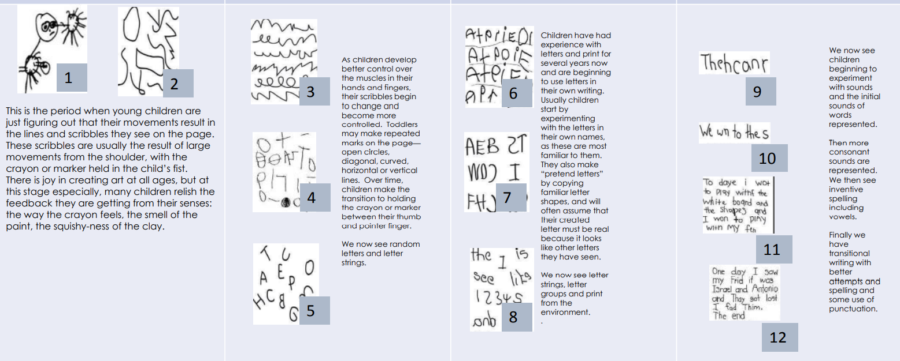

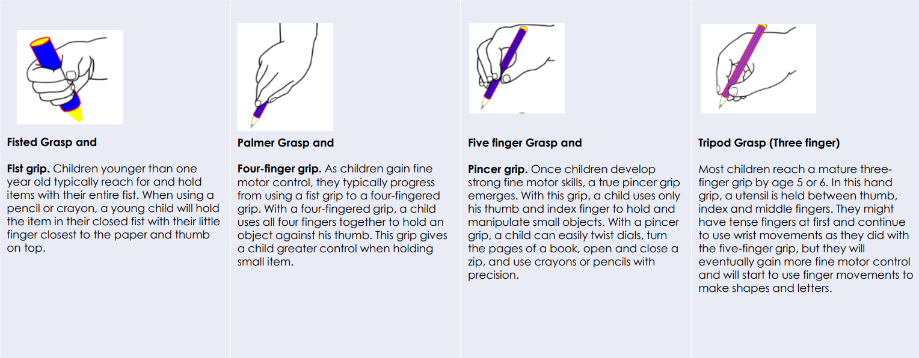

Stages of Grip Development