Flintham Primary School

Mobile Phone & Device Policy

November 2024

*‘Inspiring A Love Of Learning’*

**Our School Vision is**

**We aspire to provide everyone with…**

* **an excellent holistic education through an inspiring, creative and ever evolving curriculum.**
* **an understanding that there is no limit to their potential.**
* **the foundations to face the various challenges of life and be respectful, responsible and caring citizens making a positive contribution to their community and wider society.**
* **a love of learning which continues to develop enquiring minds and enrich their lives.** 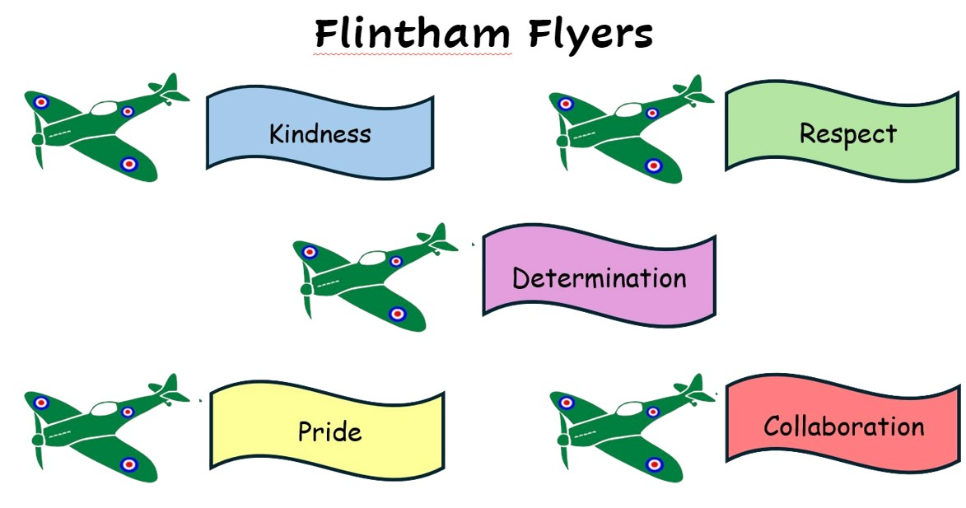



This policy outlines the appropriate use of mobile phones on our school site. Where the policy refers to mobile phones **this also includes smart devices such as watches which can receive messages, calls, access to the internet and take photos.**

We recognise that mobile phones and devices are part of everyday life for many children and young people, and they can be a valuable and important resource. Children learn about the use of mobile technology during online safety lessons and as part of our PSHE curriculum. It is important that children develop sensible habits surrounding their use and also learn about inappropriate use and the impact this can have.

**Mobile Phones**

**Staff**

* During teaching time, while on playground duty and during meetings, mobile phones will be switched off or put on silent or discreet mode and kept in staff’s bags or classroom drawers.
* Except in urgent or exceptional situation, mobile phone use is not permitted during teaching time, while on playground duty and during meetings.
* In accordance with the Staff Code of Conduct, any photographs taken on devices during the school day should be deleted that day.

**Children**

At Flintham Primary School, children should not bring a mobile phone into school, unless this is absolutely necessary – for example, where a child travels to and from school unaccompanied.

Initially, it is the responsibility of the parent/carer to decide:

• Whether the child is responsible enough to look after their phone and use it appropriately.

• Whether the child understands the safety risks involved.

The following rules apply where a child needs to bring their mobile phone to school:

• Mobile phones may only be brought into school with written permission from their parents/carers if there are specific reasons or circumstances. The permission form is available at the end of this policy.

• Phones must not be used anywhere on the school premises. They must be switched off before a child enters the school gates and not switched on until leaving the school gates at the end of the day.

• Phones must be handed in to the **school office** first thing in the morning. Phones will be stored in the school office throughout the day and children need to collect them from the office at the end of the day after they have been dismissed by their teacher (3:15pm).

• Under no circumstances should there be access to phones during the school day or for phones to be left in children’s bags or pockets.

• All phones are brought to school at the owner’s own risk - school accepts no responsibility for any loss or damage whilst on school premises.

• Children are not allowed to take mobile phones on school trips or residential visits.

• Where a child is attending an after-school activity, mobile phones must remain turned off and kept in the child’s bag.

Parents/Carers are reminded that in cases of emergency the school office remains the vital and appropriate point of contact and can ensure your child is reached quickly and assisted in any appropriate way. Your child does not need access to a mobile phone during the school day.

**Parents/Carers**

During sporting events or other special events, such as Christmas plays, church services, parents are asked not to take photos of any child other than their own and not to share on social media.

**Sanctions**

Where these rules are not followed, the following sanctions will be applied:

On the first infringement, the mobile phone will be confiscated and kept secure in the school office. The child will be able to collect the mobile phone at the end of the school day. A record will be made of the incident and parents/carers will be made aware.

On the second infringement the mobile phone will be confiscated and kept secure in the school office. A record will be made of the incident, parents/carers will be notified and asked to collect the phone.

If there is a third infringement, or in the event of a serious breach of the rules, school may withdraw the agreement to allow the student to bring a mobile telephone to school.

**Inappropriate Use of Mobile Phones and the Internet**

If we are made aware that a mobile phone or device is being used inappropriately, incidents will be dealt with in line with other relevant policies (eg: Behaviour, Anti-Bullying, E-Safety, Child Protection, Child-on-Child Abuse) and parents/carers will be notified.

Examples of inappropriate use:

• Taking/using photos or videos – of staff, pupils or members of the school community - without consent

• Using mobile technology (eg: use of messaging apps and social media) to share inappropriate content (including indecent images consensually and non-consensually), cause upset, threaten, intimidate

• Accessing inappropriate content online

* Viewing and sharing pornographic and other harmful content. This type of abuse will be dealt with under the E-Safety and Anti-Bullying Policies.
* Is in breach of any law

It should be noted that it is a criminal offence to use a mobile phone to menace, harass or offend another person. The school may consider it appropriate to involve external agencies – eg: Police, MASH (Multi-Agency Safeguarding Hub), CEOP (Child Exploitation and Online Protection).

**Related Technology**

The procedures applying to inappropriate use and security of mobile phones, apply equally to the inappropriate use of portable computer games, ipods, tablets, smartwatches and similar devices.

Children are not permitted to wear any form of smart device (FitBit/Apple watch) during school hours. If a child wears such a device to school, teachers will collect the device, keep it safe in the school office until the end of the day and the child can collect it at the end of the day. If a device is worn repeatedly, the child’s parents/carers will be asked to collect the device.

Further information for parents about mobile phones and devices, can be found on our school website: [E-Safety – Flintham Primary School.](https://view.officeapps.live.com/op/view.aspx?src=https%3A%2F%2Fwww.flintham.notts.sch.uk%2Fattachments%2Fdownload.asp%3Ffile%3D259%26type%3Ddocx&wdOrigin=BROWSELINK)

To be reviewed in November 2025

Flintham Primary School

Inholms Road

Flintham

Nottinghamshire

***‘Inspiring a Love of Learning’***

NG23 5LF

Tel: 01636 525371

Head Teacher: Mrs J Dunderdale Email: head@flintham.notts.sch.uk

Dear Parents/Carers,

**Children’s Mobile Phone Permission**

Rules and expectations around the use of mobile phones at Flintham Primary School can be found in the Mobile Phone and Device Policy, which is published on the school website. Parents must read this policy and provide permission before their child is allowed to bring a phone to school.

Children should only bring their phone into school if they are walking to or from school unaccompanied and/or they need it in case of emergency. If your child fits this criteria, you need to complete the permission form to indicate that, due to safety reasons, you wish your child to bring a phone into school.

Your child will need to switch their phone off completely before entering the playground and hand it to the school office as soon as they arrive at school.

All phones will be kept in the school office during the day, to ensure that they are kept safe.

Kind regards,

Mrs J Dunderdale

Please provide consent via this [link](https://forms.office.com/e/ur3DNSbEAw) or QR code:

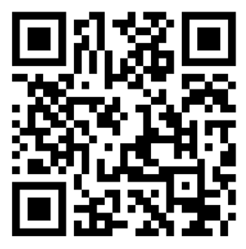

If you require a paper copy of the form, please contact the school office – office@flintham.notts.sch.uk.

Consent will apply throughout your child’s time at Flintham Primary School. You can withdraw consent and the school reserves the right to withdraw consent at any time.