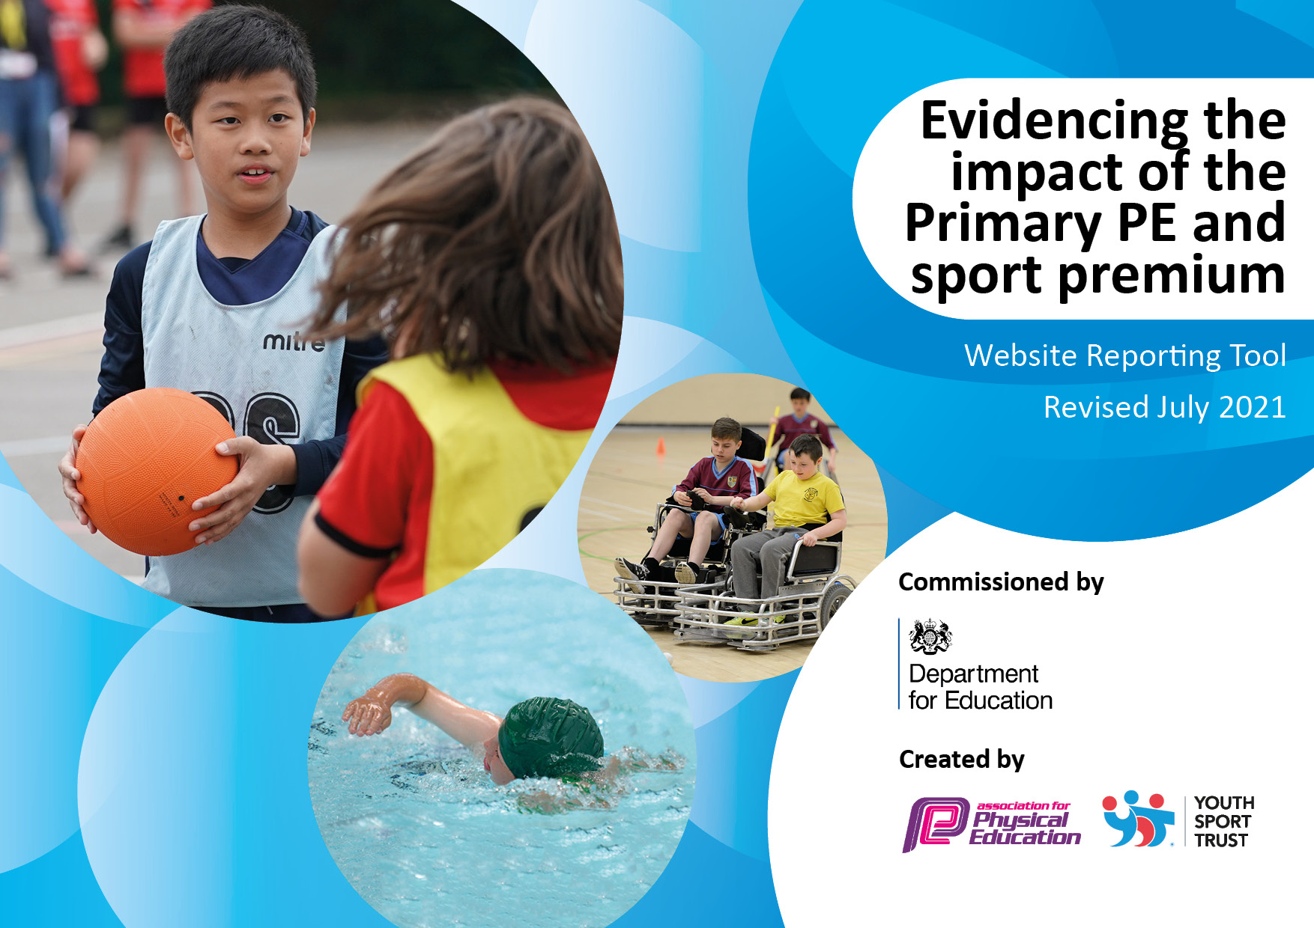

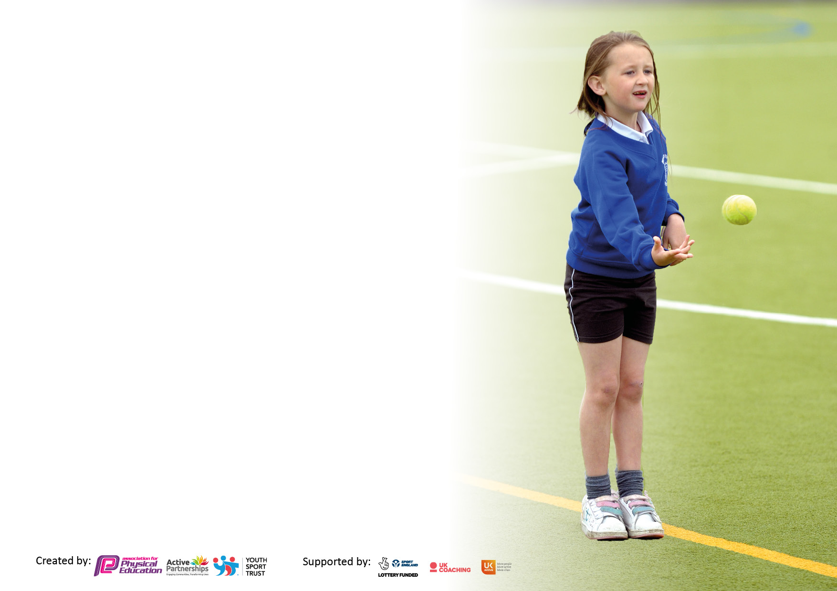It is important that your grant is used effectively and based on school need. The Education Inspection Framework makes clear there will be a focus on **‘whether leaders and those responsible for governors all understand their respective roles and perform these in a way that enhances the effectiveness of the school’**.

Under the Quality of Education Ofsted inspectors consider:

**Intent** - Curriculum design, coverage and appropriateness

**Implementation** - Curriculum delivery, Teaching (pedagogy) and Assessment

**Impact** - Attainment and progress

To assist schools with common transferable language this template has been developed to utilise the same three headings which should make your plans easily transferable between working documents.

Schools must use the funding to make **additional and sustainable** improvements to the quality of Physical Education, School Sport and Physical Activity (PESSPA) they offer. This means that you should use the Primary PE and sport premium to:

* Develop or add to the PESSPA activities that your school already offer,
* Build capacity and capability within the school to ensure that improvements made now will benefit pupils joining the school in future years,
* The Primary PE and sport premium should not be used to fund capital spend projects; the school’s budget should fund these.

Please visit gov.uk for the revised DfE guidance including the 5 key indicators across which schools should demonstrate an improvement. This document will help you to review your provision and to report your spend. DfE encourages schools to use this template as an effective way of meeting the reporting requirements of the Primary PE and sport premium.

We recommend you start by reflecting on the impact of current provision and reviewing the previous spend.

Schools are required to publish details of how they spend this funding, including any under-spend from 2019/2020, as well as on the impact it has on pupils’ PE and sport participation and attainment. **All funding must be spent by 31st July 2022.**

We recommend regularly updating the table and publishing it on your website throughout the year. This evidences your ongoing self-evaluation of how you are using the funding to secure maximum, sustainable impact. Final copy must be posted on your website by the end of the academic year and no later than the 31st July 2021. To see an example of how to complete the table please click HERE.

Created by: Supported by:



**Evidence of the Impact of Primary**

**PE and Sports Premium**

**2022 - 23**

**Details with regard to funding**

Please complete the table below.

|  |  |
| --- | --- |
| Total amount carried over from 2020/21 | £2,824 |
| Total amount allocated for 2021/22 | £16,800 |
| How much (if any) do you intend to carry over from this total fund into 2021/22? | £4,207 |
| Total amount allocated for 2022/23 | £16,800 |
| Total amount of funding for 2022/23. To be spent and reported on by 31st July 2022. | £9,890 |

**Swimming Data**

Please report on your Swimming Data below.

|  |  |
| --- | --- |
| Meeting national curriculum requirements for swimming and water safety.  N.B. Complete this section to your best ability. For example you might have practised safe self-rescue techniques on dry land which you can then transfer to the pool when school swimming restarts.  **Due to exceptional circumstances priority should be given to ensuring that pupils can perform safe self rescue even if they do not fully meet the first two requirements of the NC programme of study** | YES |
| What percentage of your current Year 6 cohort swim competently, confidently and proficiently over a distance of at least 25 metres?  **N.B.** Even though your pupils may swim in another year please report on their attainment on leaving primary school at the end of the summer term 2023.  Please see note above | 75% |
| What percentage of your current Year 6 cohort use a range of strokes effectively [for example, front crawl, backstroke and breaststroke]?  Please see note above | 92% |
| **What percentage of your current Year 6 cohort perform safe self-rescue in different water-based situations?** | 92% |
| Schools can choose to use the Primary PE and sport premium to provide additional provision for swimming but this must be for activity **over and above** the national curriculum requirements. Have you used it in this way? | No |

**Action Plan and Budget Tracking**

Capture your intended annual spend against the 5 key indicators. Clarify the success criteria and evidence of impact that you intend to measure to evaluate for pupils today and for the future.

|  |  |  |  |  |
| --- | --- | --- | --- | --- |
| **Academic Year:** 2022/23 | **Total fund allocated:** | **Date Updated:** | |  |
| **Key indicator 1:** The engagement of all pupils in regular physical activity – Chief Medical Officers guidelines recommend that primary school pupils undertake at least 30 minutes of physical activity a day in school | | | | Percentage of total allocation: |
| 14% (£2,300) |
| **Intent** | **Implementation** | | **Impact** |  |
| Your school focus should be clear what you want the pupils to know and be able to do and about  what they need to learn and to  consolidate through practice: | Make sure your actions to achieve are linked to your intentions: | Funding allocated: | Evidence of impact: what do pupils now know and what can they now do? What has changed?: | Sustainability and suggested next steps: |
| Increase leadership by children – children to help plan, organise and run sporting events and playground games alongside the school council and staff. | Provide children with opportunities to learn new skills through training delivered by school.  Encouraging the house captains and school council to be involved in playground activities with the other year groups. | £0 | House captains and school council are leading games at playtimes.  Groups of children feel confident to represent the school at different sporting events. | Current house captains train children from next year group to take the lead on activities.  Introduce coaching and umpiring to PE lessons. |
| To encourage all children to be active by incorporating active lessons into the week.  Lessons linked to the curriculum that are active and engaging based on research.  To deliver outdoor learning/forest type lessons on a weekly basis in EYFS. | Provide staff with an understanding of active lessons and the research behind them.  To use active blasts within the week.  Timetable outdoor learning/forest type lessons for EYFS on a weekly basis. | £300  Equipment for outdoor learning and active lessons | Children are engaged in their learning whilst being active on days when they haven’t got PE lessons, increasing the number of minutes they are active in a day. | Continue to develop resources for active lessons across the whole curriculum.  Continue to develop and deliver outdoor learning/forest type lessons weekly. |
| To ensure children have access to a range of equipment during PE lessons, playtimes and lunchtimes to help develop their agility, balance, co-ordination and skills. | PE and playtime equipment audit up to date  Replace and replenish equipment  Questionnaire to staff and children regarding games and equipment.  List of games for children to lead on. | £1000 for equipment and resources | More children are engaged in physical activity during playtimes. Equipment is safe and exciting to the children.  A wide range of PE lessons can be taught.  Engagement and behaviour is improved as children have a range of activities to keep them engaged. | Audit to be kept up to date and equipment replenished and added to as required. |
| To ensure children have the opportunities to manage risks in a safe environment and further develop their physical needs throughout the school day. | Continue to develop outdoor learning area, including use of outdoor learning resources throughout the year. | £0 | More children are engaged in physical activity throughout the day. Equipment is safe and exciting to the children.  Outdoor learning is used as part of the curriculum. | Research options for developing the outdoor learning area and making more accessible. |
| To increase the amount of physical activity carried out by our children, to improve knowledge and understanding of mental health and wellbeing, leadership and challenge and to develop links to improving physical activity and diet at home. | House captains to raise awareness of sports and ways to be healthy and active.  Workshops on sleep and positive mental health and wellbeing by MHWT. | £0 | Children are showing a broader awareness of ways to stay healthy and what they can do in order to change their lifestyle choices based on workshops. | Continue to research different methods to support children’s mental health and wellbeing, leadership and challenge. |
| Provide a range of activities and enhancements in the EYFS outdoor area so children continue to make progress. | Review equipment and resources available in the EYFS area and purchase new equipment as required. | £1000 | Children are able to continue to make progress and extend their learning through the use of equipment. | Maintain the EYFS outdoor area through replenishing the resources available. |
| **Key indicator 2:** The profile of PESSPA being raised across the school as a tool for whole school improvement | | | | Percentage of total allocation: |
| 17% (£2,910) |
| **Intent** | **Implementation** | | **Impact** |  |
| Your school focus should be clear what you want the pupils to know and be able to do and about  what they need to learn and to  consolidate through practice: | Make sure your actions to achieve are linked to your intentions: | Funding allocated: | Evidence of impact: what do pupils now know and what can they now do? What has changed?: | Sustainability and suggested next steps: |
| Ongoing PE updates throughout the year through CPD. | PE lead is confident to lead PE and is up to date with the current national picture for PE.  PE lead champions sport and exercise across the school. | £175 per day release for PE lead. (2 days)  £100 for courses | PE lead is able to select and share new aspects of PE with staff to boost its profile and improve the experience for all pupils. | Continue to attend CPD sessions as available. |
| To ensure all pupils are taught the main fundamentals of PE and sport, how it impacts on their physical as well as mental performance in school. | Weekly PE sessions – KS1&2 2 hours / FS 1 hour  Yearly overview completed to show coverage of a range of skills or sports. |  | Children are having the opportunity to revisit and progress in each area of PE as they progress through the school. Children are being provided with the opportunities to learn how exercise impacts their bodies as they grow through a range of activities.  Fundamentals skills are taught in PE lessons. | Continue to review the planning and progression of PE across the school. |
| Children are motivated to try new activities to keep healthy and active. To ensure children access good quality equipment and equipment is available to access new sports. | Equipment audit up to date  Replace and replenish  Questionnaire to staff and children regarding new sports and equipment. | Resources costed in section 1 | Sports equipment purchased to enhance and replenish resources to ensure a range of sports can be delivered. | Audit to be kept up to date and equipment replenished and added to as required. |
| Up-skill and develop teaching and learning with both staff and children. | Coaches from Excel to deliver PE lessons (1 afternoon a week) in new areas or areas staff don’t feel as confident in teaching.  Staff attend CPD as required. | £2,160/year (£60/week)  Excel coaching | Excel coaches liaise with PE lead to deliver PE lessons based on school plan.  Planning from Get set 4 PE is used by school staff to demonstrate to staff how to implement effective PE. | Continue to organise coaches to deliver sports with classes to engage children and upskill teachers. |
| Provide children with more opportunities to be active during the day and to encourage them to think about being active and ways to stay healthy. | Continue to participate in the daily mile and active blasts on a regular basis.  Excel coach to deliver lunchtime and after school sports clubs. | Part of weekly cost above. | Children encourage one another to take part in active blasts/daily mile.  Number of children being active daily is increased. | Continue to promote the daily mile or active blasts as a daily activity. |
| Make the children aware of the range of sports they can take part in locally.  Raise the awareness of what it takes to progress in a sport and those enjoying their sports.  Ensure children know what they can achieve regardless of injury or disability. | Advertise in school newsletters out of school clubs available locally.  Coaching from local sportsman/woman encourage children to take part in new sports (Rugby).  Celebrate sports out of school in assembly and on notice boards. | £200 for Rugby coach  £100 for football association | Encourage a greater number of children to take part in sport outside of school.  Children are encouraged to take part in sports from the local sportsman/woman visit (rugby tournament) | To continue to promote a range of out of school clubs using the children who already attend to promote them.  To arrange for sportsmen/women to visit the school for assemblies and/or workshops. |

|  |  |  |  |  |
| --- | --- | --- | --- | --- |
| **Key indicator 3:** Increased confidence, knowledge and skills of all staff in teaching PE and sport | | | | Percentage of total allocation: |
| 3% (£475) |
| **Intent** | **Implementation** | | **Impact** |  |
| Your school focus should be clear  what you want the pupils to know  and be able to do and about  what they need to learn and to  consolidate through practice: | Make sure your actions to  achieve are linked to your  intentions: | Funding  allocated: | Evidence of impact: what do  pupils now know and what  can they now do? What has  changed?: | Sustainability and suggested  next steps: |
| Ensure all staff are confident in delivering all aspects of PE, including fundamentals/ ABCs and follow the school planned curriculum. | Get set 4 PE planning with all curriculum areas for staff to teach from. | £200 for Get Set 4 PE resources | Staff are confident to deliver a wide range of sports, as a result children experience a wider range of sports. | Continue to use Get Set 4 PE planning to match the school curriculum. |
| Improve the delivery of PE and to increase the confidence of staff to deliver new sports. | CPD sessions available for all staff.  Coaching sessions through Excel and other external coaches.  Planning accessed for new equipment. | £175 per day for release of teachers  £100 for courses | All staff understand the PE curriculum and feel more confident delivering or supporting in PE lessons  Staff are upskilled from sessions taught by specialist coaches. | Continue to explore further CPD opportunities for staff.  Maintain links are established between school and clubs. |
| To understand the areas of support teachers require in order to put actions in place. | Provide CPD for staff following attendance on courses.  Sharing of new PE planning with all staff.  PE lead available for advice. | N/A – staff CPD time | Teachers overall are happy with the structure of PE across the school.  A range of CPD for PE is available for staff. | Continue to provide CPD for staff as requested |
| Raise the profile of PE, SS and PA and to make staff aware of new initiatives.  Deliver CPD session for all staff on PE, the intent, implementation and impact as well as other opportunities. | Staff training on changes or new initiatives.  Staff have a better understanding of the resources available to them to encourage children in PE, SS and PA. | N/A – staff CPD time | Staff are kept up to date with changes in PE and PA.  All staff are aware of how to support the new initiatives and how to use them to best support the development of children.  Staff aware of range of ways to incorporate active learning into the day and provided with exemplifications. | PE lead to keep abreast of new initiatives to share with staff. |
| Support and improve delivery of PE and new schemes. | PE lead to work with staff to deliver new initiatives and share new ways to deliver PE sessions.  Discuss areas for development with staff using staff CPD.  Review new PE scheme. | N/A | Sharing of good practice with all staff to enable good quality PE to take place.  Training to take place where necessary. | Staff are confident in their delivery of PE.  High quality PE is being delivered across the whole school. |
| **Key indicator 4:** Broader experience of a range of sports and activities offered to all pupils | | | | Percentage of total allocation: |
| 17% (£2,800) |
| **Intent** | **Implementation** | | **Impact** |  |
| Your school focus should be clear  what you want the pupils to know  and be able to do and about  what they need to learn and to  consolidate through practice: | Make sure your actions to  achieve are linked to your  intentions: | Funding  allocated: | Evidence of impact: what do  pupils now know and what  can they now do? What has  changed?: | Sustainability and suggested  next steps: |
| Additional Experiences:  For children to experience sport/exercise related activities out of their comfort zone. | Key stage residentials to outward bound type places for all children to take part in physical activities. | £2500 towards transport and residentials | All children in Key stage 2 will be taking part in the range of activities available on the residential e.g. hill walking, team building games, climbing, archery etc. | Continue to organise residentials for Key stage 2.  Look for opportunities for EYFS and KS1 children to take part in sporting activities. |
| Sports club available at lunch/after school to ensure children have the opportunity to learn a skill progressively and to take part competitively.  To increase number of children who have access to clubs at school. | Clubs available: Football, hockey, rugby, multi skills.  Mindfulness colouring club lunch  Eco Schools club | Excel sports cost already included above | Range of children from across the school can take part in clubs. All children given the opportunity to join at least one club. | Increase range of clubs available, trying to arrange a different sports club each day, depending on space and staffing available in school. |
| To encourage children to be more active outside and ensure parents are aware of clubs and events available. | Festivals and events advertised to parents in newsletters.  Local sports clubs are advertised to parents in newsletters. | £300 festivals/events | Children attend sports clubs outside of school. | Continue to advertise local sports clubs.  Encourage a range of sports clubs to come into school. |

|  |  |  |  |  |
| --- | --- | --- | --- | --- |
| **Key indicator 5:** Increased participation in competitive sport | | | | Percentage of total allocation: |
| 8% (1,405) |
| **Intent** | **Implementation** | | **Impact** |  |
| Your school focus should be clear  what you want the pupils to know  and be able to do and about  what they need to learn and to  consolidate through practice: | Make sure your actions to  achieve are linked to your  intentions: | Funding  allocated: | Evidence of impact: what do  pupils now know and what  can they now do? What has  changed?: | Sustainability and suggested  next steps: |
| Allow all children to take part in a competition in the comfort of their school and with their class. Encourage children to work as a team but to also challenge themselves to new activities and experiences. | Hold school sports day and potted sports with all pupils being placed in mixed age teams and earning points across the events.  Running races within own year groups. | £80 for stickers and medals | Children engaged in sports and earning points for their team.  Parents are invited into school to watch and encourage their child.  Results shared as a whole school. | Continue to organise whole school competitive sports day and non competitive potted sports.  Virtual competition to be run across the trust. |
| Ensuring the children are using their talents to link outside activities to school. | Celebrate out of school achievements in weekly assemblies. | N/A | Children inspire other children to take part in sports outside of school through sharing their successes and experiences. | Continue to promote the out of school sports. |
| Increase opportunity for children to participate in physical activity during breaktimes  To develop personal, social and coaching skills | Excel coach to teach Y5/6 to become Young Leaders; working collegiately to develop an effective physical activity where pupils can work to improve personal bests - delivered across the Key Stages during breaktimes (Spring One to coach – Spring Two to deliver to children) | Part of Excel Coaching provision | Young Leaders in responsibility roles  All children increase physical activity  All children aspire to improve on their previous score | From a timetabled half-term of activities to one or two Young Leader groups delivering activities throughout the year.  Autumn 2023: Excel coach to start each academic year in autumn 1 |
| Continue to maintain and establish links with inter sports competitions to build children’s self esteem and confidence.  Children experience competitive sport. | Children take part in a wide range of intersports competitions.  Football league and cup  Rugby tournament  County cricket club summer festival  Rushcliffe athletics competition  EQT sports competitions e.g. boccia and ultimate frisbee | Transport £500  £175 per day for release of teachers (3 days)  Competition entry fees £300 | Children learn to be a good sportsperson whether they win or loose.  Increase in children taking part in competitive sports. | Continue to take part in competitive sports and look for further opportunities. |

|  |  |
| --- | --- |
| Signed off by | |
| Head Teacher: | Janette Dunderdale |
| Date: | 26/06/23 |
| Subject Leader: | Graham Knott |
| Date: | 28/06/23 |
| Governor: | Vicky Adey |
| Date: | 05/07/23 |