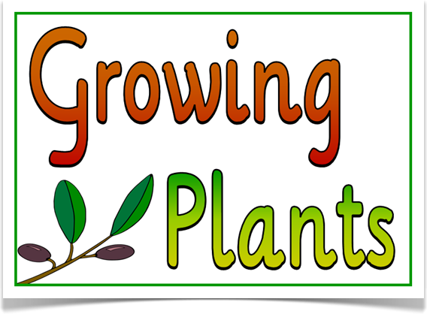
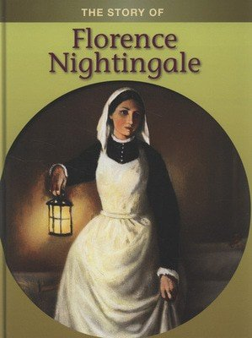
Summer Term

Dear Parents,

We hope you had a lovely Easter break and welcome you back for a new term.

Our topic for this term is Growing. In literacy we will be looking at different stories written by the same author. We will also look at significant people in History -Florence Nightingale and Mary Seacole. In DT we will design and make playground equipment and in art we will sketch pictures of flowers. Our science topic will also be Growing and we will look at growing plants.

If you have any related books/information or objects on our topic, please feel free to send these in.

PE will continue on Wednesdays and Zumba on Fridays.

Our weekly spelling test continues on Fridays. New spellings will be given each Friday. Please continue to encourage your child to learn these.

Phonics and comprehension sessions will begin on our first week back. Books will continue to be changed on Fridays. Please aim to read with your child at least four times a week and record this on the BoomRead App.

If you have any queries, please do not hesitate to contact either of us.

Thank you for your continued support.

Mrs Smith and Miss Halliwell

