Year 5/6 How do biomes shape life on Earth?
FPS GEOGRAPHY
Knowledge Organiser

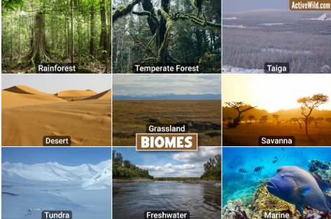
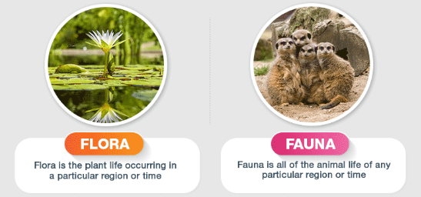
Key Question: What are biomes?
Biomes are areas of our planet with similar climates, landscapes, animals and plants. What lives in each biome depends on:
- how warm or cold it is
- how dry or wet it is
- how fertile the soil is

Types of biomes
- Deserts: hot and dry
- Savannah: hot with a long, dry season
- Tundra: the coldest biome
- Temperate grassland: vast and grass is the main type of vegetation
- Rainforest: warm, wet and dense
- Deciduous forest: a distinct winter season and year round rainfall
- Taiga: the driest and coldest of the three forest biomes.

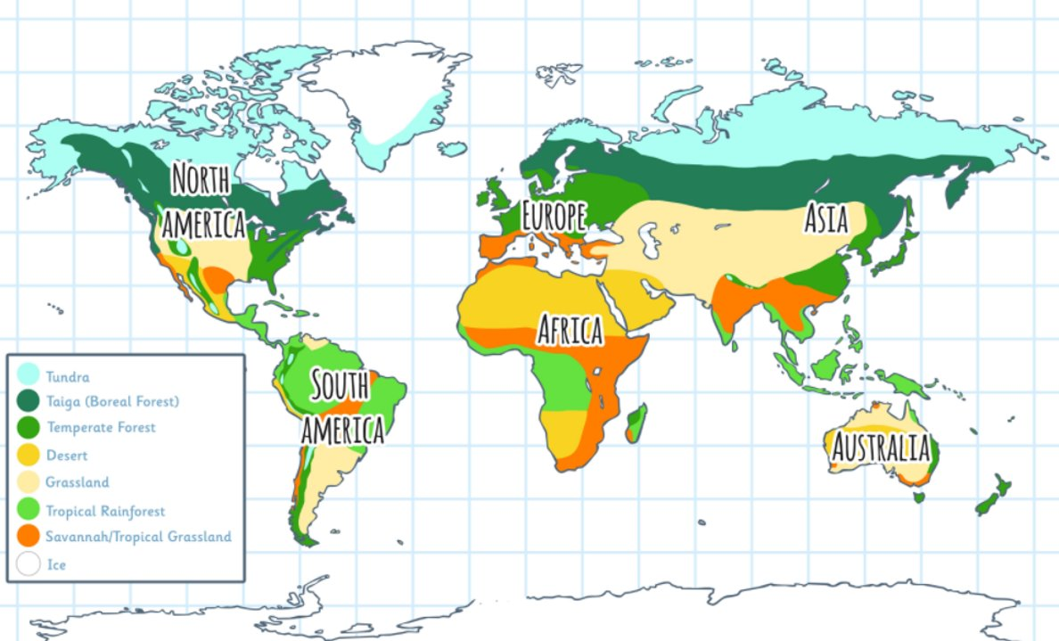

Key Question: How do humans impact biomes?
Humans change biomes in lots of ways. Some changes can be helpful, but many can harm the plants and animals that live there. This includes deforestation, pollution, farming and climate change

Key vocabulary
organism | A living thing, such as an animal or plant
Equator | An imaginary line around the centre of the Earth
climate | A description of the average weather conditions in a certain place
biome | Areas of our planet with similar climates, landscapes, animals and plants
vegetation | The plant life of a region
flora | Plant life in a specific region
fauna | Animal life in a specific region
ecosystem | A community of animals, plants and microorganisms together with their habitat
organism | an individual animal, plant, or single-celled life form.

Types of climate

• Polar
• Temperate
• Arid
• Wet tropical
• Mediterranean
• Tundra

