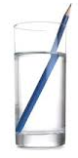
Key Question: What is refraction?
Why do pencils look bent in water?
Key Learning: The bending of light as
it passes from one substance to another
with the bending caused by the difference in
density between two substances.

FACTOID 2:
What colours is light made up from?
Light is made up of all the colours of the spectrum / rainbow. The colour of the light you see depends on its wavelength.

FACTOID 3:
How does a telescope work?
They have two lenses (one large and one small) which reflect light rather than bending it.

FACTOID 1:
Can you find out more?
How does a lens work? They bend rays of light as they pass through so they can change path or direction.

Key Question: How are shadows formed and what decides their shape and size?
Key Learning:
Shadows have the
same shape as the
objects that cast
them but they can
change size. As
light moves towards
the object, the
shadow becomes
larger.

Key Question: What is a spectrum?
Key Learning: A band of colours, as seen in rainbows, produced by separation of the components of light by their different degrees of refraction

Key Question: How does light travel?
Key Learning: Light travels in straight lines

Natural light sources: fireflies, the sun, volcanoes, electric eels, lightning
Man-made light sources: torches, televsion screens, phones, lamps

Key Question: How can objects be seen by the eye?
Key Learning: Objects are seen because they give out or reflect light into the eye
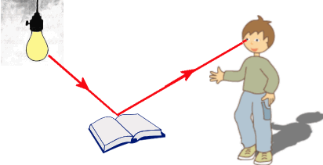

Key Question:
Can you explain the difference between transparent, translucent and opaque materials?
Key Learning:
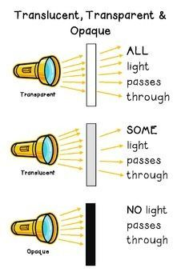

Key Vocabulary
translucent | A material which allows some light to pass through
refraction | The bending of light through a material
spectrum | Bands of colour
periscope | Device that uses mirrors to reflect light in order to see something obstructed from view.
prism | Transparent object that breaks up light into bands of colour.
opaque | Material that does not allow light to pass through it
angle of incidence | The angle made by a light ray as it strikes a mirror.
angle of reflection | The angle made by a light ray as it reflects off a mirror

FPS SCIENCE: Unit Light
KNOWLEDGE ORGANISER
Super Scientist Investigates:
How does the eye work?
Year 5/6 LIGHT
Previous Learning
- Light is needed in order to see.
- A light source is an object (torch/candle) or nature (sun/ firefly) which provides light
- A shadow is formed when the light source is blocked
- Opaque objects block light creating shadows
- Transparent objects allow light to pass through

Year 5/6 HOW CAN WE SEE THINGS?

Lesson Sequence

New Learning
- Light travels in straight lines
- Objects are seen because they give out or reflect light into the eye
- Shadows have the same shape as the objects that cast them but they can change size
- Translucent objects allow some light to pass through, but some of the light changes direction as it passes through the object; this means that something seen through a translucent object is not clearly defined
- When light travels from air to water it bends and causes objects in the water to look bent, this is called refraction.

