
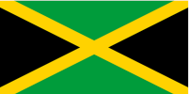
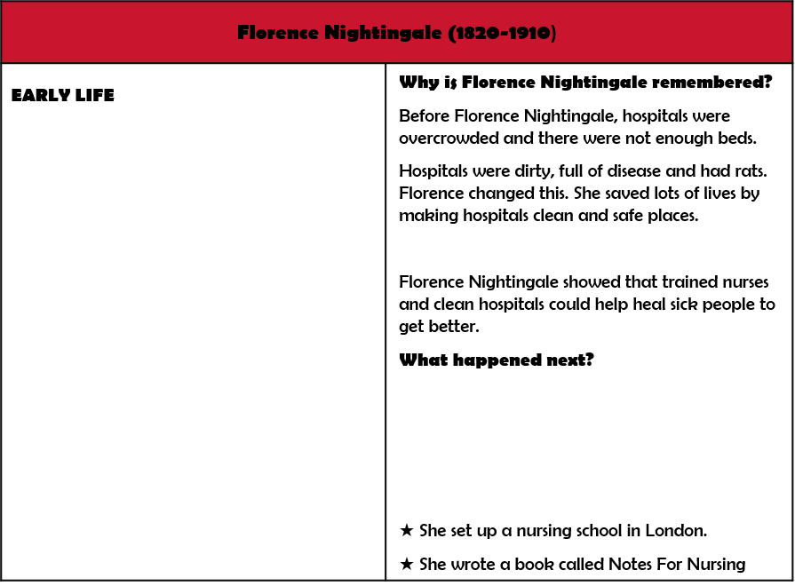
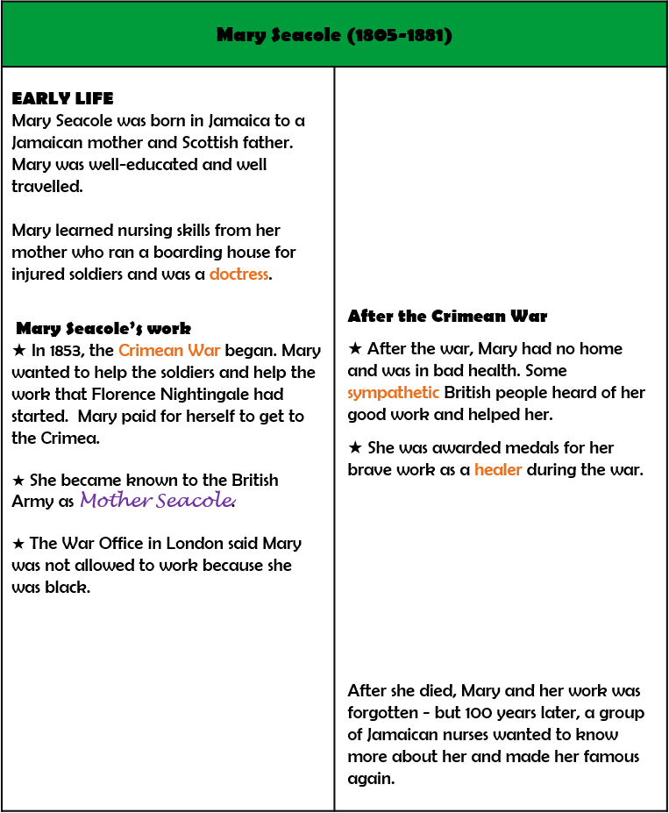
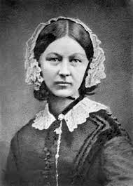
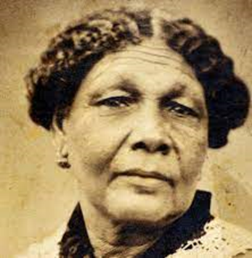
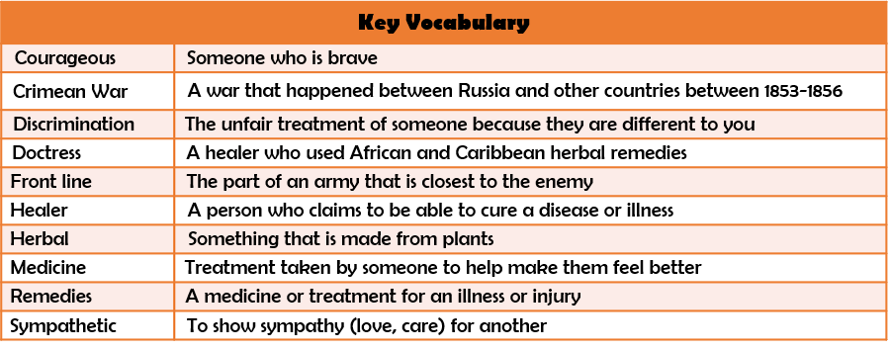
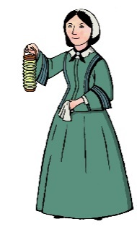
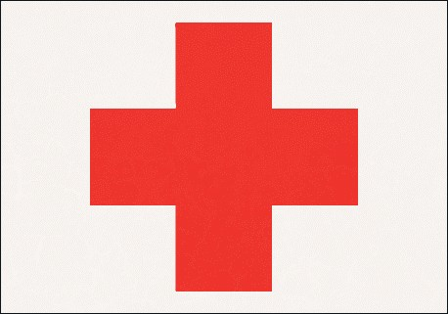
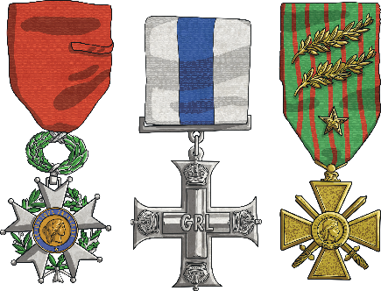

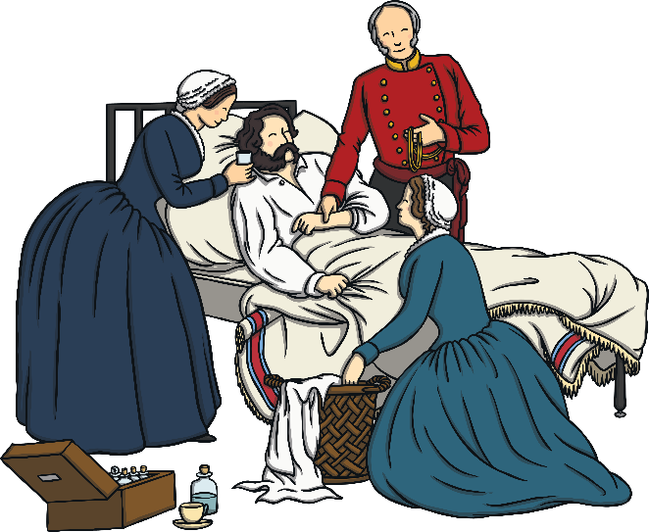
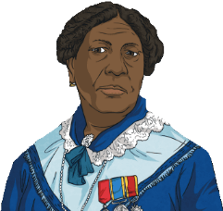
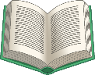
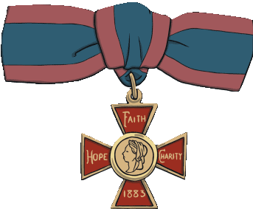




FLORENCE NIGHTINGALE AND MARY SEACOLE

FPS HISTORY
Knowledge Organiser

Year 1/2 Who was the ‘Lady with the Lamp’ and who was ‘Mother Seacole’?
History Detectives: How did these ladies change the future of nursing?
Florence Nightingale was born to a wealthy family in Florence, Italy but moved back to England when she was 11.
Both women were treated very differently. Florence was treated like a hero but Mary was discriminated against because she was black.
★ She became known as the Lady with the Lamp as she would work all night to make sure the soldiers were treated well with medicine, water and warm blankets.
★ On the front line, she cared for and treated soldiers with her herbal remedies. In some countries, remedies like this are still used.
★ In 1863, Florence met Queen Victoria who gave her the Royal
Red Cross Medal for her courageous work.
★ The Nightingale Fund was set up to reward all of Florence’s hard work.
She gave patients good food
★ A book was published about her life.
Florence Nightingale showed that trained nurses and clean hospitals could help sick people to get better.
Mother Seacole .

