What is friction? A force that acts between two surfaces or objects that are moving, or trying to move, across each other.
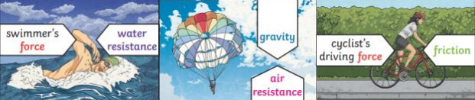

Key questions:: What is the best design for a parachute?
Key Learning: The shape and design of a parachute afffects the amount of air resistance that is needed to safely land.

Key questions:: What is gravity and how is Isaac Newton involved?
Newton described gravity as a pulling force that keeps people on the ground rather than floating off and which keeps the moon in orbit. He also told the story of seeing an apple fall to the ground from a tree which inspired him to wonder why it fell down, rather than up or across.

Forces can be categorised as pushes or pulls.
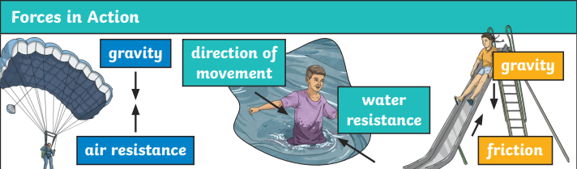
Vocabulary
air resistance | the frictional force air exerts against a moving object.
buoyancy | the ability of objects to float in water or air.
Force meter | a piece of equipment containing a spring, used to measure forces
friction | the resistance of motion when one object rubs against another
gravity | a pulling force that works across space
mass | the amount of matter or substance that makes up an object, measured in units called kilograms
Newton | a unit of force
Water resistance | A type of friction that happens when water (or any liquid) pushes against an object moving through it

Water resistance and air resistance are forms of friction. Friction is sometimes helpful and sometimes unhelpful. For example, air resistance is helpful as it stops the skydiver hitting the ground at high speed. Friction on a bike chain can make the bike harder to pedal so it is unhelpful
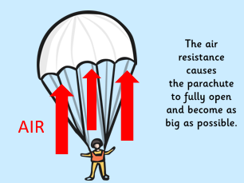
Year 5/6 How can we slow the descent of a parachute?
Super Scientist Investigates:
What it the best shape for the canopy of a parachute?
FPS SCIENCE
KNOWLEDGE ORGANISER

