**Key question: Can you explain why maps use scale and what it means? Maps are accurate plans of our land that have been reduced in size to fit onto paper. Some OSM maps are 1:50,000 which means that 1cm on a map represents 2km in real life.**

[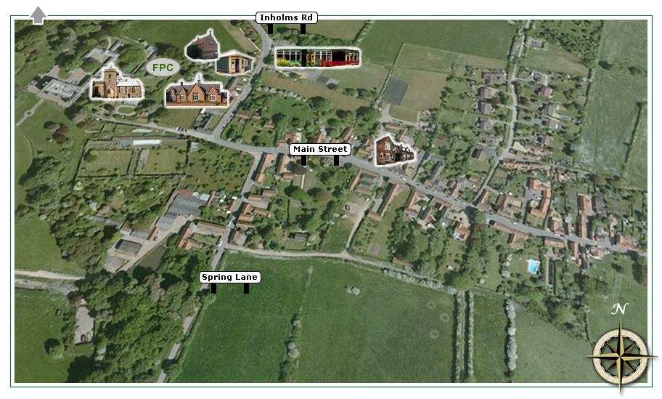](http://www.google.co.uk/url?sa=i&rct=j&q=&esrc=s&frm=1&source=images&cd=&cad=rja&docid=jdUC06KrcqleBM&tbnid=ZQoJ-NKowWt-MM:&ved=0CAUQjRw&url=http://www.flinthamvillage.co.uk/village-map/&ei=NH4vUp-uEqec0AWWvoG4BA&bvm=bv.51773540,d.ZG4&psig=AFQjCNG95uKZgEMsEoAW_nxnc4mD_KZHIw&ust=1378930596044058)

**Key question: What is an Ordanance Survey Map? It shows the physical and human features of the UK using symbols and a grid reference.**

**Key question: What**

**can you find at these**

**coordinates?**

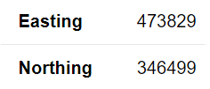

**Key question: What symbols would you include on a map of Flintham? Would these be on your map?**

|  |  |
| --- | --- |
| contours | an outline of a natural feature or area of land |
| dyke | a ditch or watercourse |
| grid  reference | a method where maps are divided by lines into grids and numbers to identify a location |
| human  features | things that are made or built by humans |
| ordnance  survey | government organisation that makes official maps (OSM) |
| physical features | natural things such as rivers, mountains, woods & coastline |
| rural | in or about the countryside |
| scale | the [relation](https://dictionary.cambridge.org/dictionary/english/relation)ship between the [real](https://dictionary.cambridge.org/dictionary/english/real) [size](https://dictionary.cambridge.org/dictionary/english/size) of something and [its](https://dictionary.cambridge.org/dictionary/english/its) [size](https://dictionary.cambridge.org/dictionary/english/size) on a [map](https://dictionary.cambridge.org/dictionary/english/map) for example |
| settlement | a place where people come to meet |
| urban | in or about a city/town |

**Vocabulary**

**Key question: Why did people settle in Flintham?**

**Key Learning: Flintham village predates the Roman times with early evidence of a settlement in fields off Spring Lane. Flintham was an ideal place to settle as it was close to the River Trent and there was excellent fertile land to grow crops and an ambundance of forest and wildlife.**

**Key question: What are the physical features of Flintham?**

**Key Learning: Flintham is a small village set in the Nottinghamshire countryside. It is surrounded mainly by farmland and is very close to the River Trent. It is 45m above sea-level and has the small Beck dyke running to the south.**

**Year 5/6 What Do I know about Flintham ?**

Geography Investigators: Where did the name Flintham come from?

**FPS Geography**

**KNOWLEDGE ORGANISER**