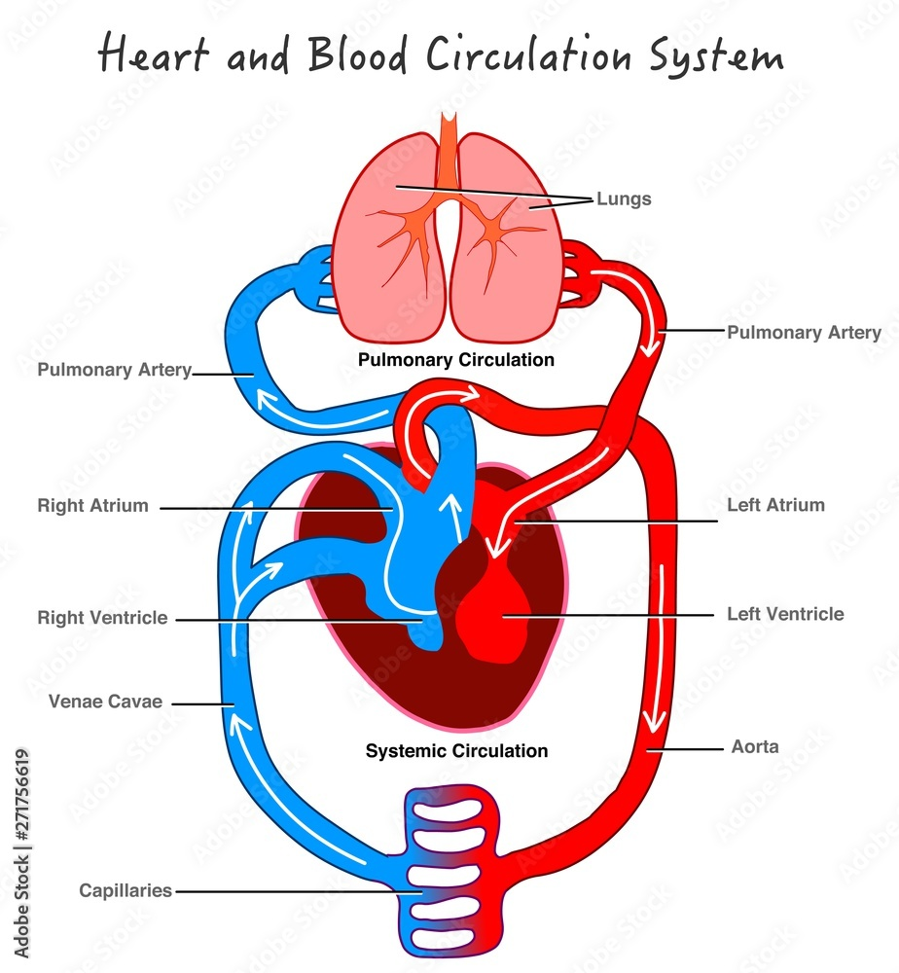

What does the blood do?

Blood is like a human river which flows through the body, transporting nutrients to help us grow, repair and stay helthy. These nutients have been absorbed into the blood stream from digestion.

What happens to the oxygen that we breathe?

When air has been drawn into the lungs, oxygen is absorbed into red blood cells that carry it to all the different parts of the body.

When the cells are depleted of oxygen, they return to the lungs carrying the waste product of carbon dioxide.

What factors make for a healthy lifestyle?

A healthy lifestyle is the result of a combination of lifestyle choices. A well-balanced diet, regular exercise, using drugs correctly and positive mental health.

**Vocabulary**

|  |  |
| --- | --- |
| artery | a blood vessel that carries blood away from the heart |
| blood vessels | any of the tubes (arteries, veins, capillaries) through which blood moves. |
| circulatory system | the system that carries blood around in the body |
| nutrients | chemical substances that people and animals need from food and plants need from soil including (protein, fats, vitamins) |
| pulse | the regular beating of the arteries that is caused by the beating of the heart |
| replenish | to make full again |
| respiration | the act of breathing |
| vein | a small vessel that carries blood to the heart |

**Key scientist: William Harvey**

**FPS SCIENCE**

**KNOWLEDGE ORGANISER**

**Year 5/6 How does our circulatory system keep us healthy?**

**The first physcian to recognise the full circulation of blood in the human body.**

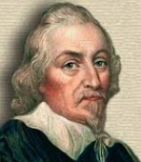

**Key questions**

How does the amount of exercise effect the circulatory system?

When we exercise, our heart beats more frequently to replenish the oxygen that has been used; the more exercise we do, the greater the amount of oxygen we need for our lungs! There are other effects of exercise including sweating, muscle ache and a raised temperature.

Super Scientist Investigates:

Who pioneered the transplant of the human heart?