**History Detectives:**

**How did life in Britain change from the Stone Age to the Iron Age? How do we know so much about the early Britains?**

**Year 3/4 Stone Age to Iron Age**

**FPS HISTORY**

**Knowledge Organiser**

**Key Question:** **When was the Stone Age? What does pre-historic mean? Why is it called the Stone Age?**

**Key Learning**:

|  |  |
| --- | --- |
| Palaeolithic (3,000,000 BC)  Early human developed |  |
| Mesolithic  (10,000 BC)  Hunter-gatherers |  |
| Neolithic  (4,500-2,400 BC)  Farmers |  |

|  |  |
| --- | --- |
| **Key Vocabulary** | |
| Prehistoric | The period of time before there were written records. |
| hunter-gatherers | A human who finds all or most of their food by foraging and hunting. |
| Stonehenge | A prehistoric monument made from a circle of large stones. |
| earthwork | A raised area of soil made in the past. |
| bronze | A yellowish- brown alloy of copper and tin. |
| alloy | A mix of 2 or more metals. |
| iron | A strong, hard, magnetic metal found on The Earth. |
| agriculture | The science or practice of farming. |
| hillforts | A fort and settlement built on a hill. |
| Beaker people | People of late Stone Age and early Bronze Age who made ditinctive earthenware vessels. |

**Key Question: How do we know so much about prehistoric humans? EVIDENCE!**

**Key Learning:**

**Archaeology, objects (stone, bone, antler tools), bones/skeletons, cave paintings, pottery, monuments.**

**Key Question: Who was the first in Brit? What was he like How did he live? Where did he live?**

**Key Learning:** **The importance** **of the Cheddar Man.**

**What have I learnt about the Stone Age to Iron Age?**



**When was the iron age and why did people use iron? What artefacts are made of iron?**

**Key Learning:**

**The Iron Age came after the Bronze Age. Finding information about the main artefacts discovered.**

**

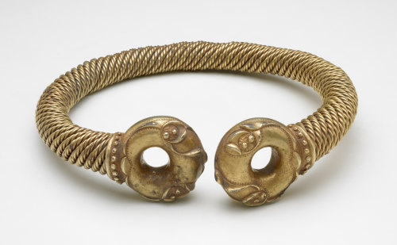

**Who were Britain’s first farmers?**

**Key Learning: How was it discovered? Who lived there and what did the houses look like?**

**Why is Stonehenge so intriguing and significant?**

**Key Learning: How Stonehenge was made and the mystery surrounding it.**

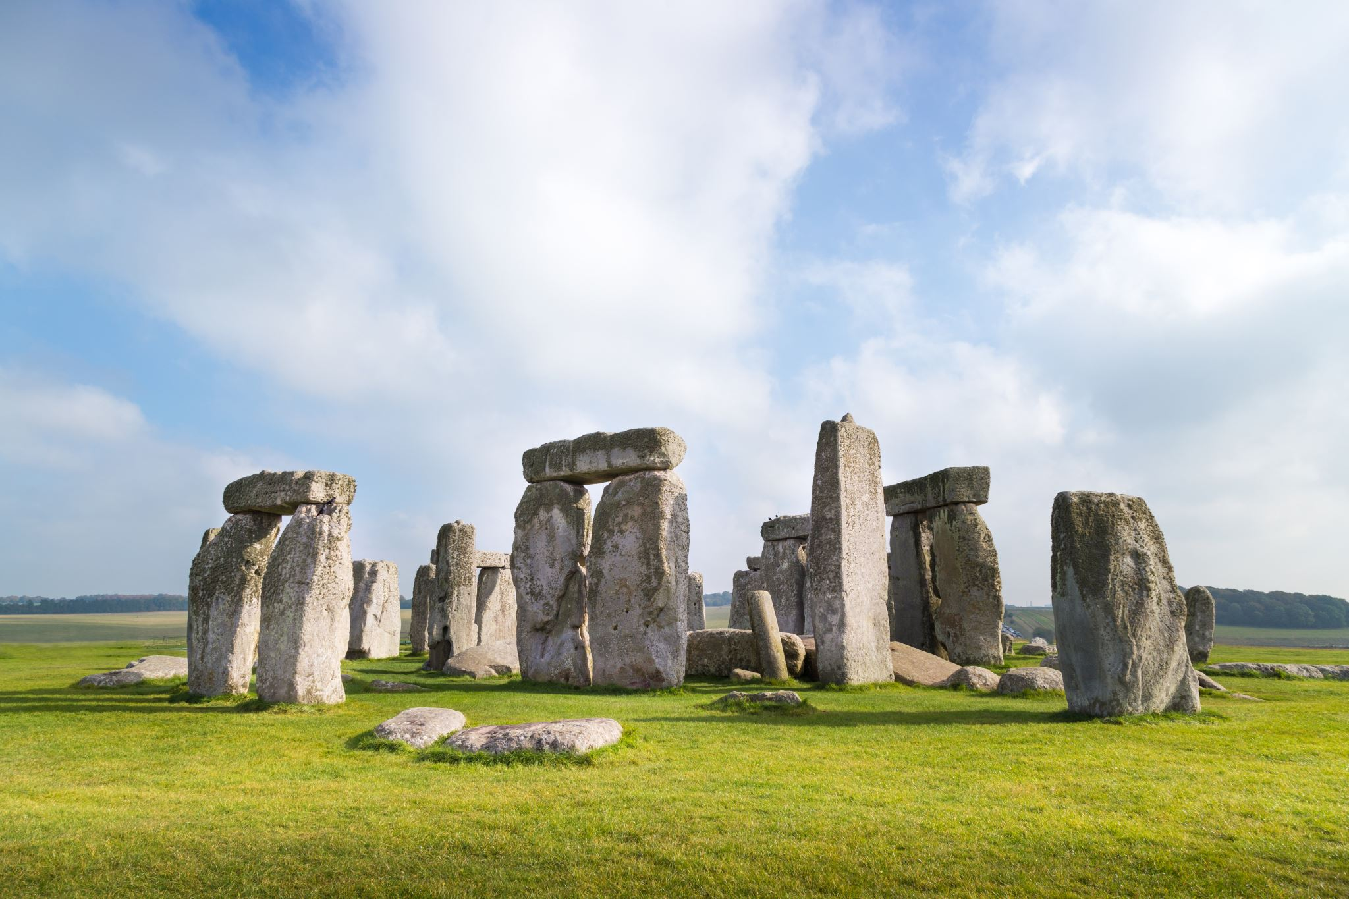

**Where did iron age people live? What are hillforts and roundhouses?**

**Key Learning:**

**The Iron Age people built hillforts and lived in round houses.**

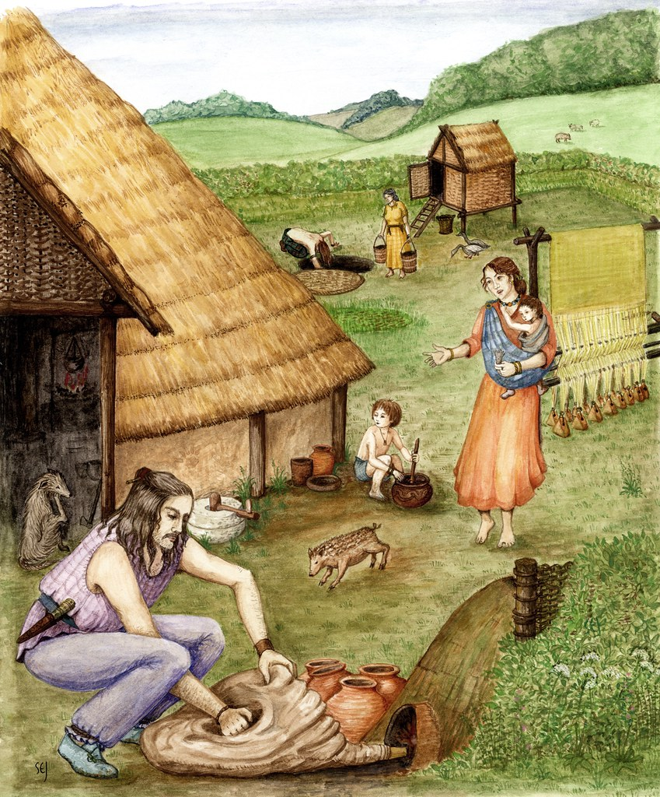

**Why did people stop using stone to make their tools and weapons?**

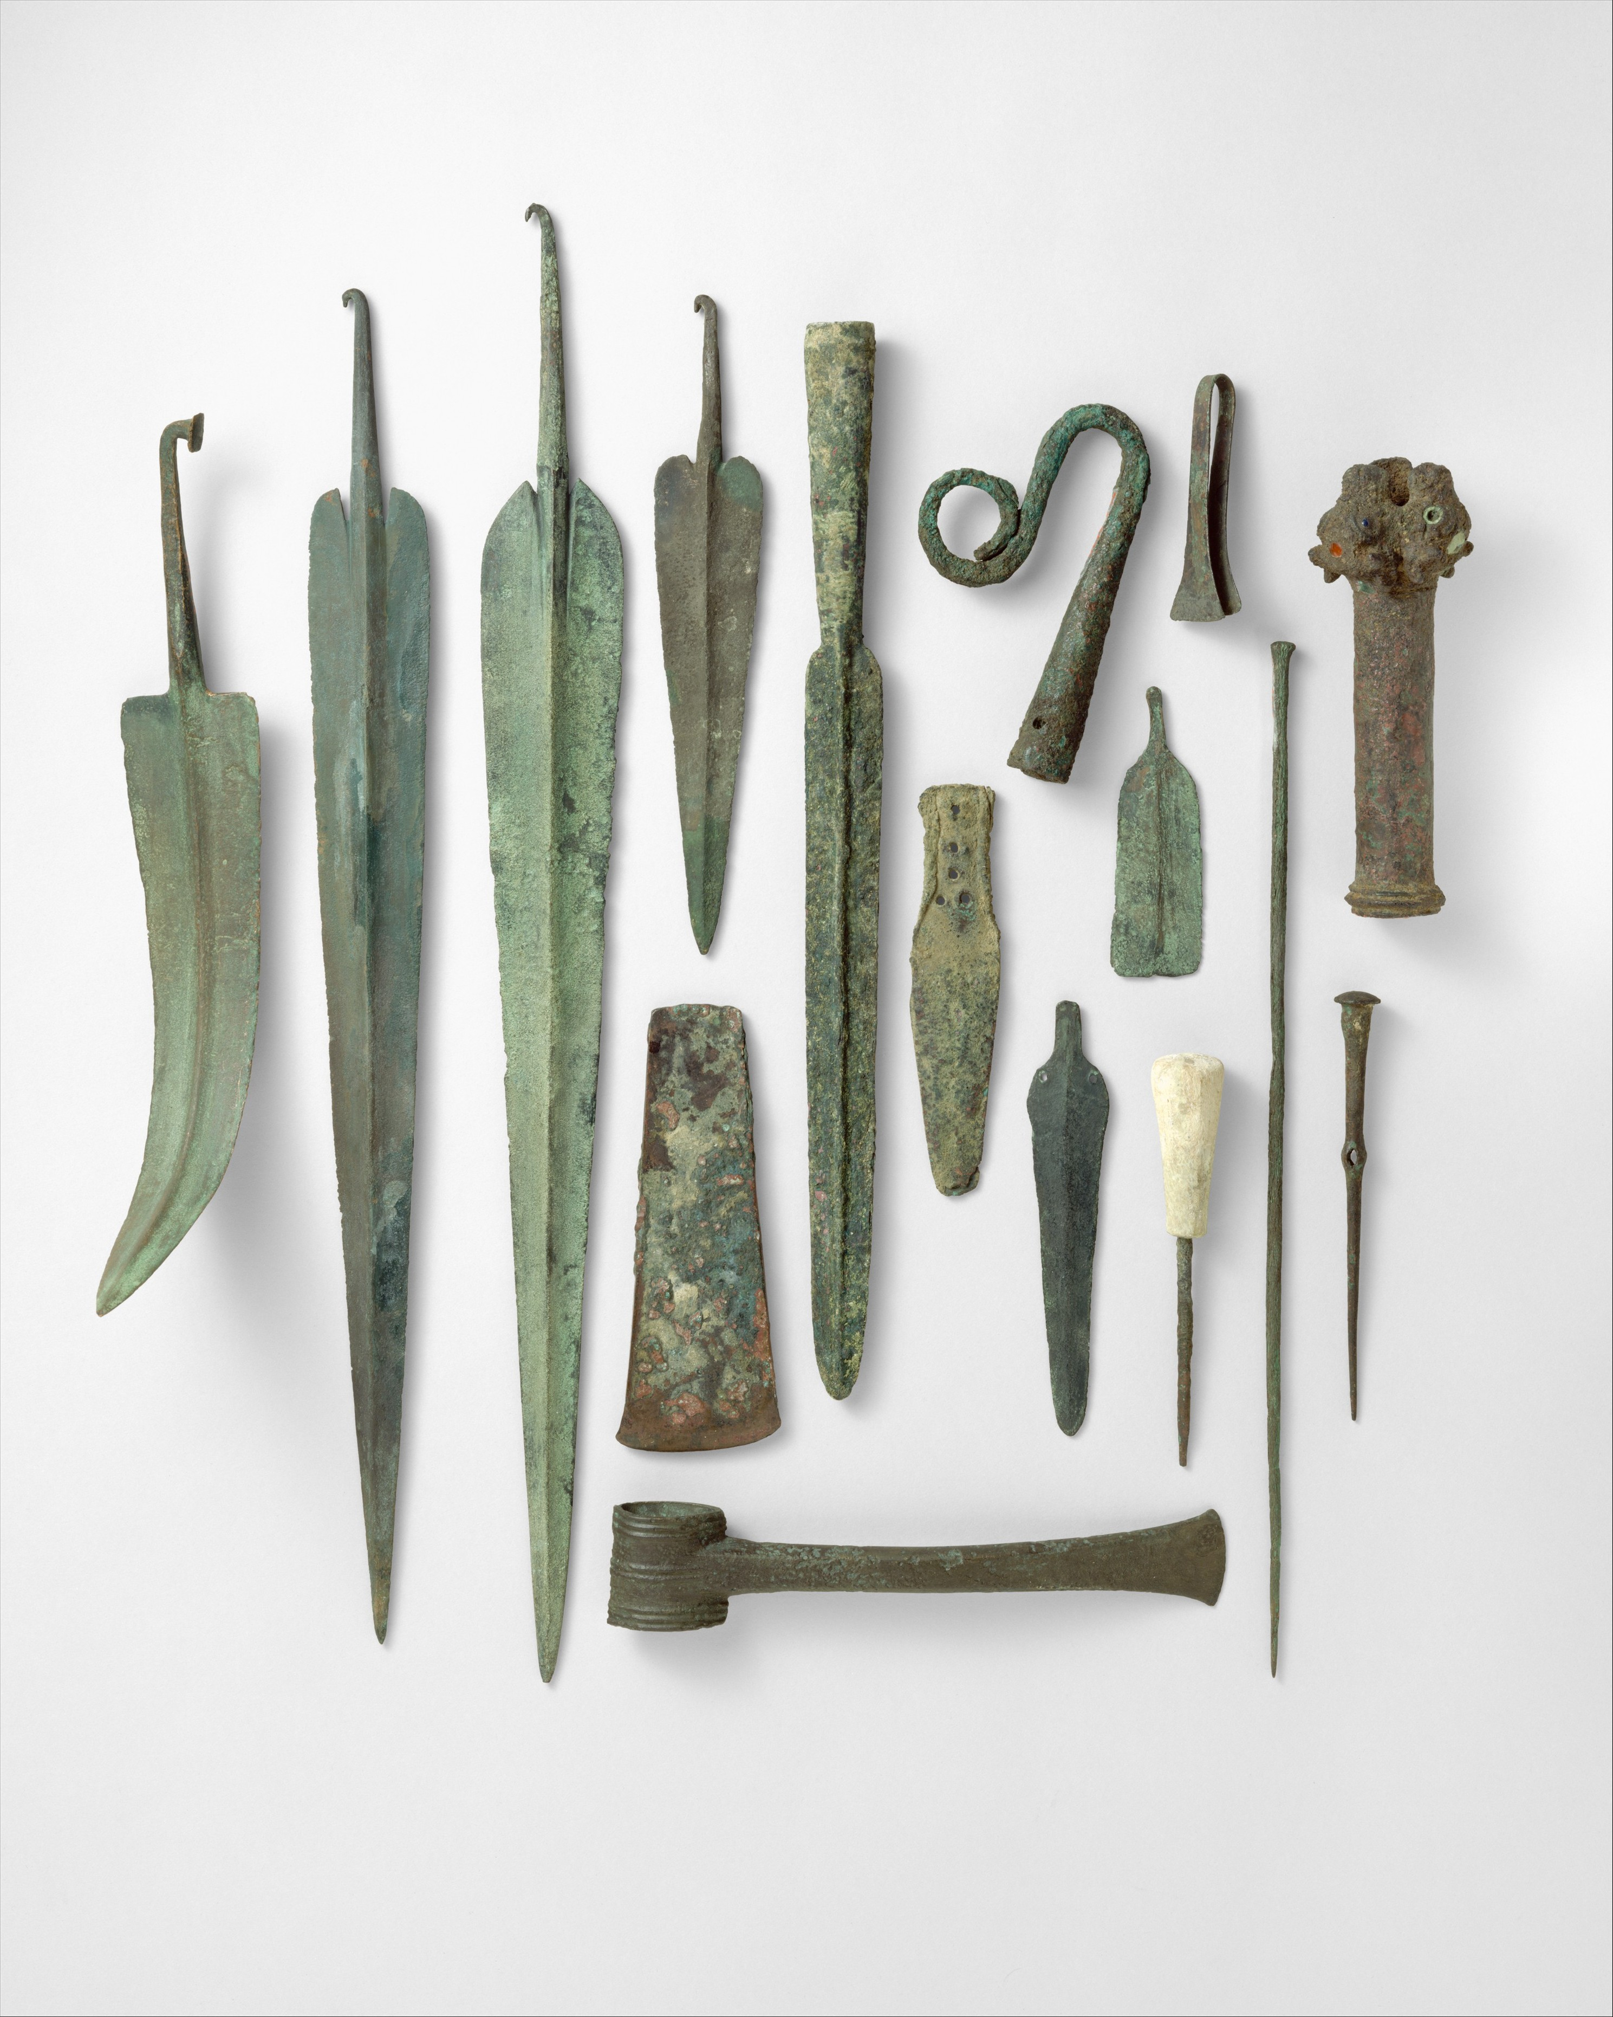

**Key Learning: Find out who the Beaker people were and why the Amesbury Archer discovery tells us so much about the Bronze Age.The discovery of metals!.**