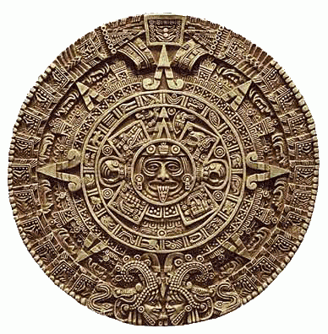
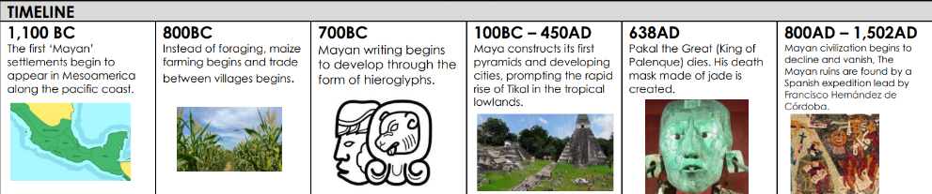
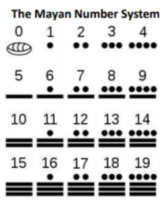
The Maya developed a complex number and counting system that was advanced for their time. They were one of only two cultures in the world to develop the concept of zero. The Maya people used just three symbols in their number system. These are thought to represent items that the Maya people might have first used to count with, such as pebbles, sticks and shells.
What was the Mayan number system?

Who were the Mayans?
The Mayans were people who lived from about 2000BC to 1500AD. They are well known for developing a complicated yet successful civilisation.

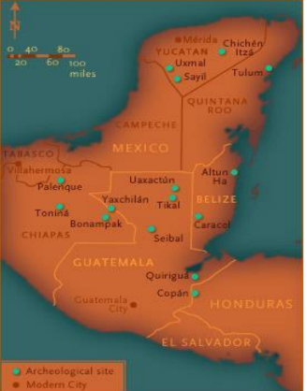
The Maya had a hierarchy, which means their society was organised in levels.
The king was the most powerful and therefore at the top. Slaves were at the bottom of the hierarchy.
Key Question: How was the Mayan society structured?
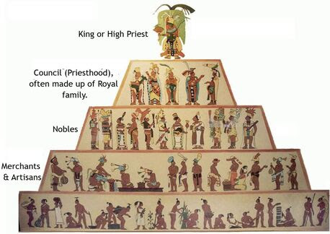
Vocabulary
Maya | The collective noun for the Mayan people.
Deity | A synonym for god.
Mesoamerica | The region in which the Maya lived, spanning  over Mexico and parts of Southern America.
Chichen Itza | One of the best-preserved examples of a  Mayan city.
Maize | Corn – a major resource of food for Mayan  people. Part of their religious culture too.
Hieroglyph | A symbol that has a worded meaning, read  like our graphemes.
Sacrifice | A slaughtering of an animal or human as an  offering to please the gods.

Year 5/6 Who were the Mayans and what have we learnt from them?
FPS HISTORY

