Knowledge Bank – Understanding the World
Reception – Spring 2
Habitats
A habitat is the home of an animal or a plant.
There are lots of different types of habitats in the world. There are many in the United Kingdom. These are some habitats you might find in and around Flintham.
A Woodland Habitat A Farmland Habitat

.

Key Questions
What is a habitat? What animals/plants/trees might we find in a woodland habitat? How are these animals suited to a woodland habitat? Where do they live?

.

Woodland Habitat (United Kingdom)
What might you see in a Woodland Habitat?
A woodland habitat has lots of trees and plants in it. It also has lots of animals.
Animals in a woodland habitat |  |  | Trees/bushes/plants in a woodland habitat
Fox | Owl | Deer | Oak tree | Bluebells | Pine tree

.

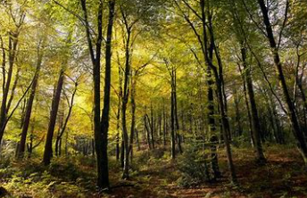
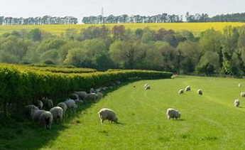

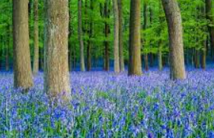
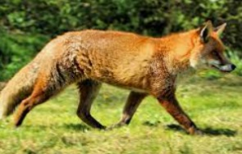
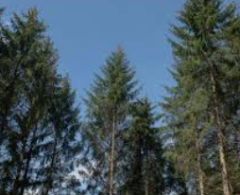
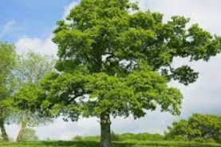
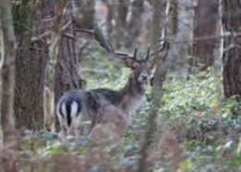
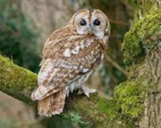

Seasonal Changes – Winter to Spring
Signs of Spring – What happens during springtime?
Winter is the season before spring. Summer is the season after spring. In Spring, the weather starts to turn warmer.
The flowers on a tree are called blossom. They begin to grow in spring. | Baby birds are often thought of as a sign of spring because they need to be warm before they hatch and so the warmer weather in spring is perfect for them. | Sheep give birth to lambs in spring when the cold weather has passed and the fresh grass is growing.
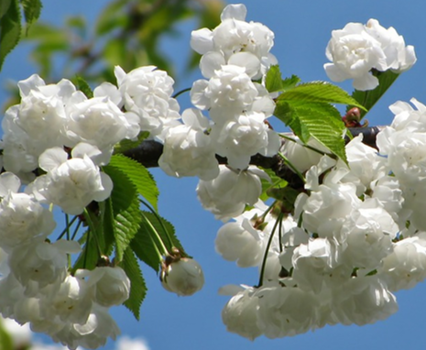 | 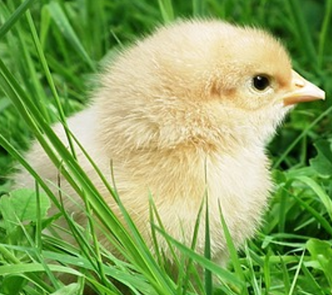 | 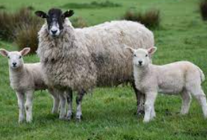

.

Key Questions?
What do you notice is happening outside? How is it changing? Why do you think this is? How is it the same/different as the season before?

.

Growing – What does a plant need to grow?
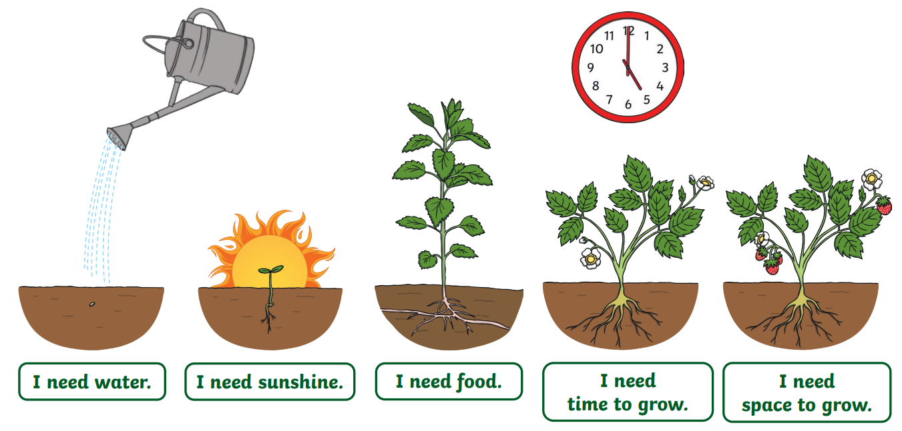

.

Key Questions
What do you think a plant needs to grow well? What can you see happening to the plant as it grows? Where does it grow? Why?

.

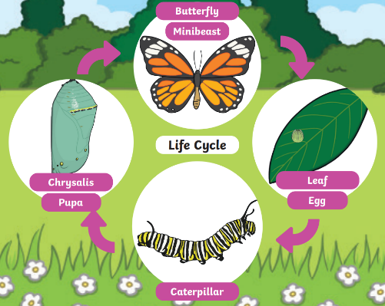
Where does our food that we eat come from?
Things that grow on trees
Apples | Pears | Plums
 | 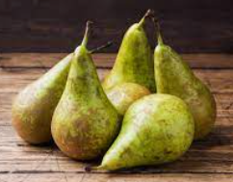 | 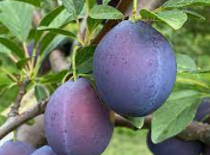
Things that grow on bushes
Blackberries
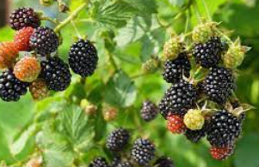
Things that grow in the soil
Potatoes | Carrots | Onions
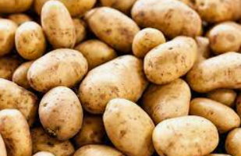 | 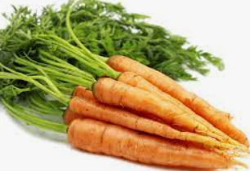 | 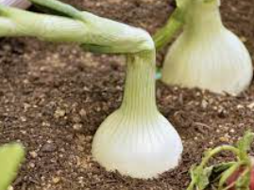

.

Lifecycle of a Butterfly
How does a caterpillar turn into a butterfly?
The butterfly lays an egg on a leaf, the egg hatches and a caterpillar grows, the caterpillar turns into a chrysalis and then the chrysalis opens and a butterfly comes out.

.

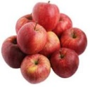

Key Questions Can you tell me how banana’s get to our country? How do they arrive?

.

The Journey of a Banana
Some foods, such as banana’s, do not grow where we live because it is not hot enough for them to grow. They are grown in hotter countries like Brazil or Equador. Here is how they get to our country;
The bananas are harvested (cut from the tree) | Bananas are shipped from a hot country (mainly by boat) | Bananas arrive in the shops in the UK
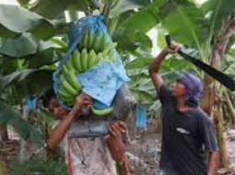 |  | 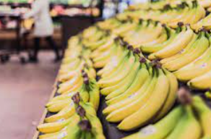

.

Key Questions
Can you tell me which fruits and vegetables grow on trees, bushes or in the soil?

.

Key Questions
How does a caterpillar changes as it grows? Can you talk me through the stages of the Butterfly lifecycle?

.

