Knowledge Bank – Understanding the World
Reception – Summer 1 2026
Farms
Flintham has farms surrounding the village. Some which have animals, some which grow crops (plants) and some which do both.
A crop is a living plant grown by farmers. Farmers in the UK grow wheat, corn and potatoes and lots of other plants.
Wheat | Corn | Potatoes
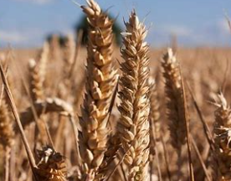 | 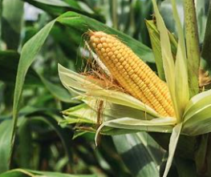 | 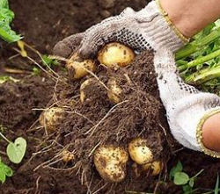

Farmers that have animals on their farm, use them in different ways. Some animals are used for more than one thing.
Type of animal | What do the farmers use the animals for?
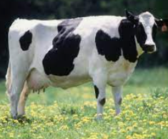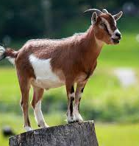 | 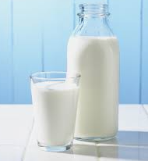
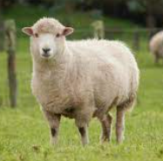 | 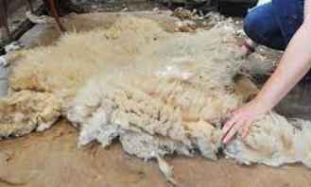
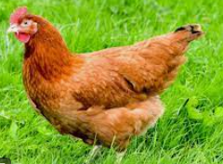 | 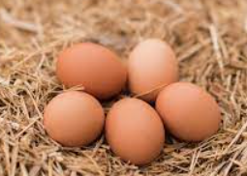

.

Milk
goat
cow

Sheep wool for making clothes.
sheep

Eggs
hens

Key Questions?
What do farmers have on a farm? What is a crop? Can you name some different types of crop that farmers grow? How do farmers use animals on a farm?

.

Farm Animals and their young
Here are some animals you might see on a farm and some photographs and names of their babies.
Cow | Sheep | Chicken | Goat | Pig
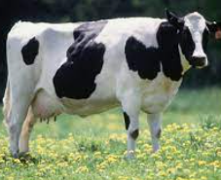 | 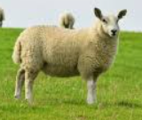 | 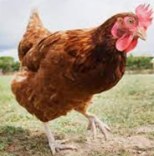 | 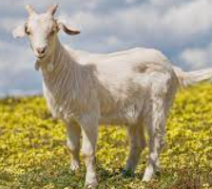 | 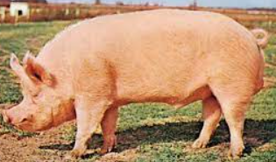
Calf/calves | Lamb | Chick | Kid | Piglet
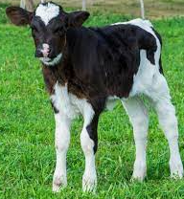 | 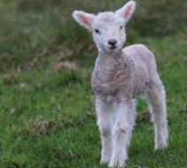 | 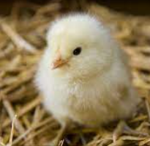 | 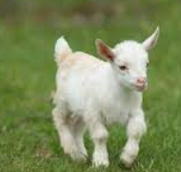 | 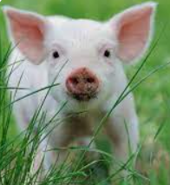

.

Key Questions
What animals might you find on a farm? What are the animal’s babies/young called?

.

Farm animals and their houses
Animals live in different buildings on a farm. Here are some of the places you might find the animals…
Cows | Pigs | Chickens | Sheep
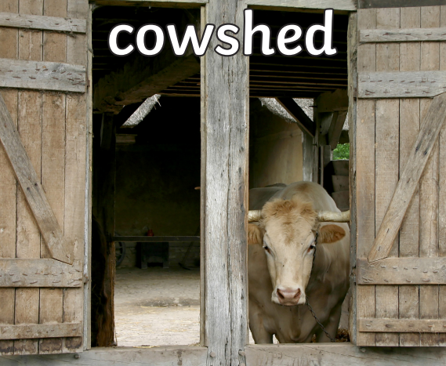 | 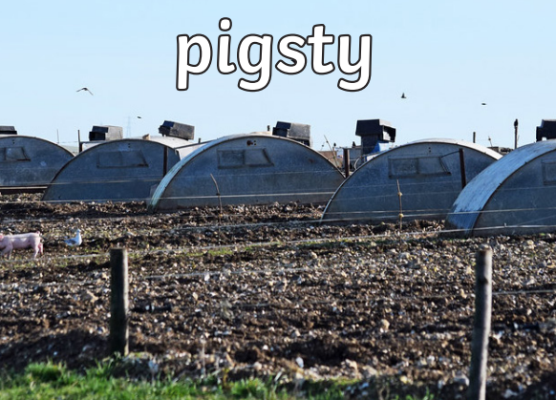 | 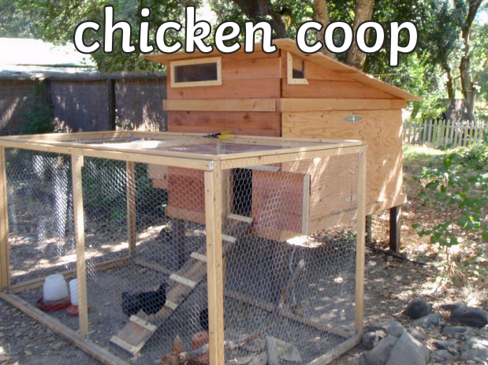 | 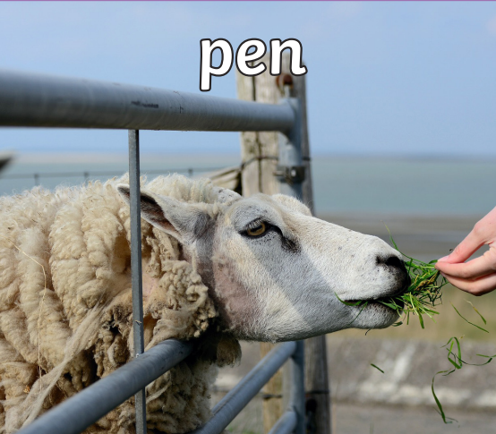

.

Key Questions?
What buildings might you see on a farm? What are the buildings used for? Where are the farm animals usually kept?

.

Lifecycle of a Chicken
How does an egg turn into a chicken?

.

Animal Groups
A chicken is a bird because…
- Birds have a beak
- Birds have wings
- Birds have feathers
- Birds have two legs
- Birds lay eggs

+

.

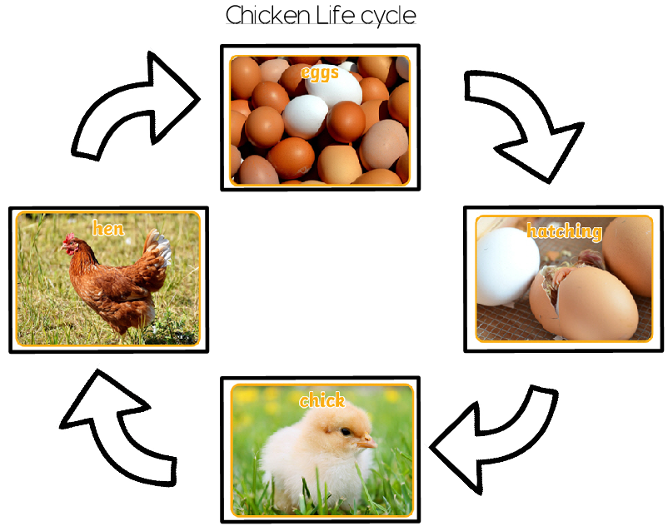
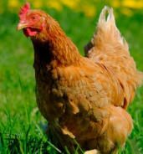

Key Questions How do you know that a chicken is a bird? Can you name some other birds?

.

Key Questions Can you tell me how banana’s get to our country? How do they arrive?

.

The Sun, Moon and Earth
Sun | Moon | Earth
The Sun is a giant star. Planet Earth and the other planets in our solar system travel around the sun. | The Moon is made of rock and moves around the Earth. | Our planet is called Earth. It is made of land and water.
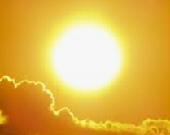 | 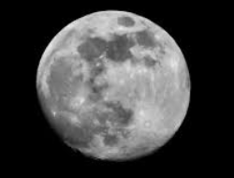 | 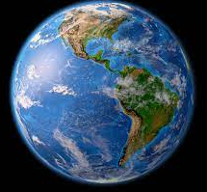
The Sun is much bigger than the Earth and the Moon. The Earth is bigger than the Moon.
.

Key Questions What happens when an egg hatches? How does the chick grow over time? Talk me through the stages of a chicken lifecycle.

.

Staying Safe Near Water
Water can be very dangerous. Staying safe around water is very important. You might see these signs or flags around water. It is important to know what they mean.
No Diving | Life jackets must be worm | There is a steep drop | It is not safe to swim
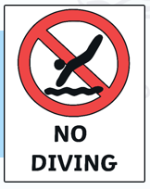 | 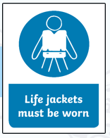 | 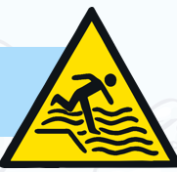 | 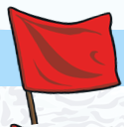

Key Questions What can you tell me about the Sun, Moon or Earth?

.

Key Questions What does each of these signs mean? How can we stay safe when we are near water?

.

History of Farming
Farming has changed over time. Look how machines and equipment have changed.
Old | New
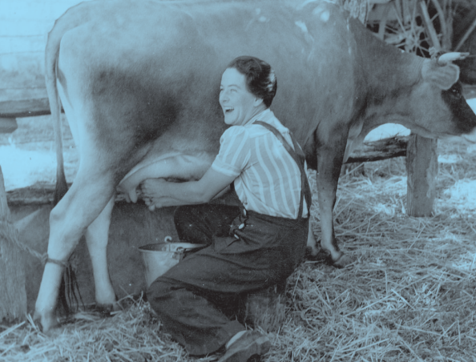 | 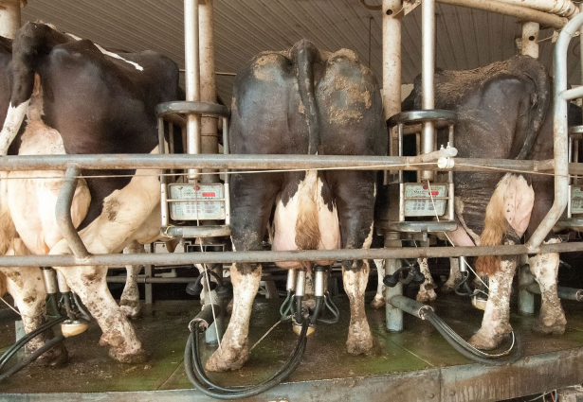
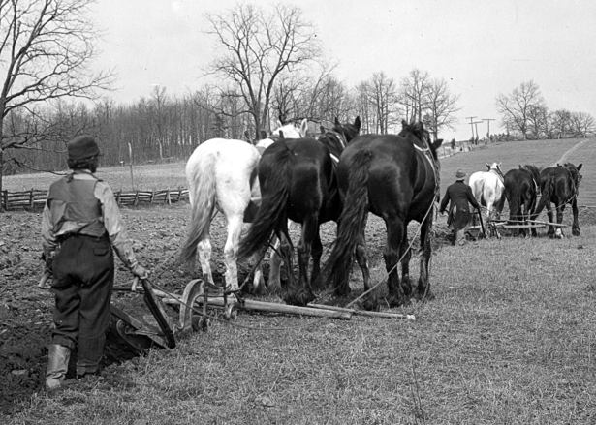 | 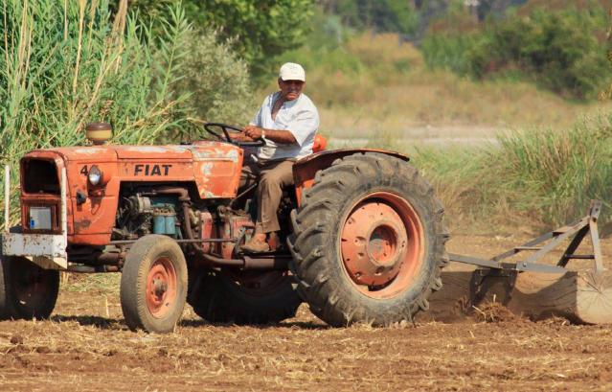
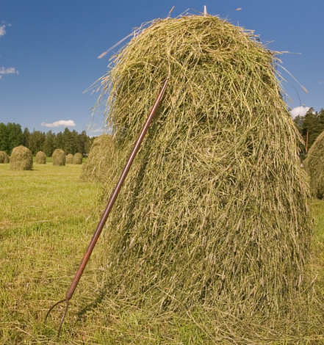 | 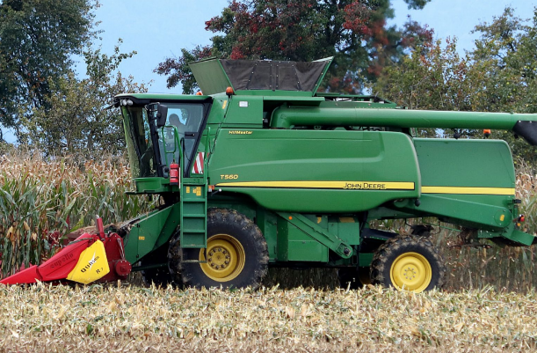

.

Key Questions
How has farming changed? What do farmers have now that they didn’t have in the past? What equipment does a farmer use to do his job?

.

