PE Funding

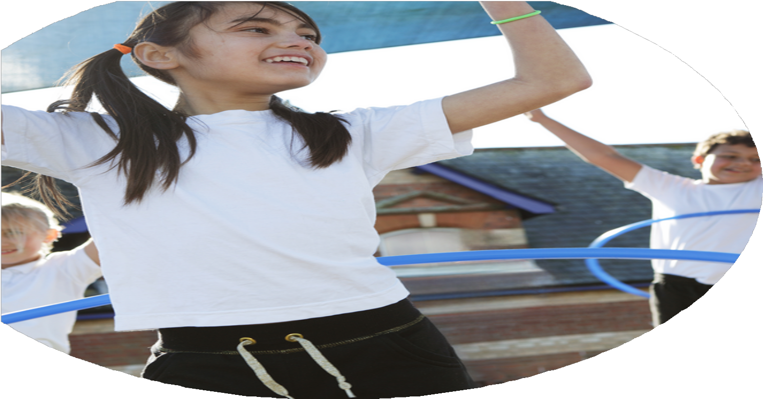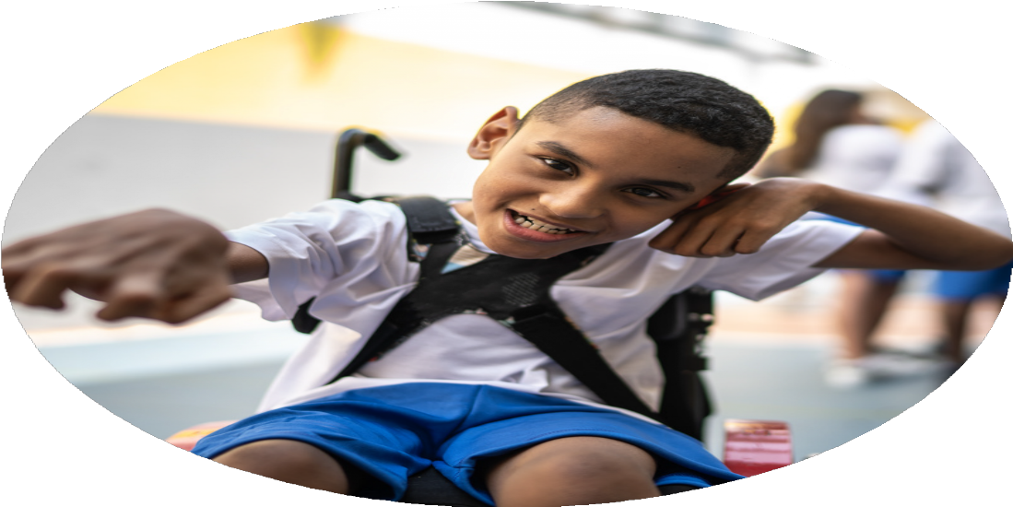

Evaluation Form

**Commissioned by**

**Created by**

Images courtesy of Youth Sport Trust

**PE Funding Evaluation Form**

 It is intended that this template should be used as preparation for the completion of the statutory digital reporting tool being introduced this academic year. You can upload data (including swimming) from this template onto this platform once it becomes accessible.

 Before you decide how you are going to use the funding for this academic year you should reflect and evaluate the impact of your use of the funding in 2023/24.

 All spending of the funding must conform with the terms outlined in the Conditions of Grant document.  The template is a working document that you can amend/update during the year.

 Based on your evaluation of last year’s funding you should decide what you intend to do this academic year, how you will do it, and what impact you expect it to have.

It is important that the funding is used effectively and based on your school’s needs.

 You must use the funding to make additional and sustainable improvements to the PE and sport in your school.  You must develop and add to the PESSPA activities that your school already offers.

*Summative digital reporting from June 2025 will continue to include swimming and water safety information therefore funding can be used to provide top-up lessons where necessary to ensure pupils meet national curriculum swimming requirements.*



**Evidence of the Impact of Primary**

**PE and Sports Premium**

**2024-25**

1. Deliver forest school lessons within the EYFS class on a weekly basis. Staff member to be trained in forest school.
2. Children to have access to a wider range of activities at playtimes and lunchtimes.
3. Support children in accessing residentials and experiences beyond local and school.
4. Replenish equipment for delivery of ABC curriculum.
5. Wider range of children take part in team events.
6. School to offer new sports.
7. Participate in virtual competition based on ABC’s with trust schools.
8. Forest school sessions are planned within the EYFS curriculum (Forest Fridays). Staff member has almost completed their training. Will be complete by Dec 2024.
9. New playtime rota was introduced using the children’s choices of activities. All children engaged at playtimes/lunchtimes. Reduction in first aid and behaviour incidents.
10. Uptake for residentials was 95%. Children talked about the experience as being one of the best they had experienced.
11. Equipment was bought when requested to ensure the curriculum could be taught.
12. When choosing teams, staff took into consideration those who had already represented the school, meaning more children were able to take part in the team events.
13. New events from trust available and taken part in. Sports were brought back to school with participants teaching others how to play.
14. All children took part in all the competitions available.
15. Children were only trained in the summer term, so the impact was reduced. Need to implement sooner and get children to train next year group.
16. Minimal resources were bought for the EYFS outdoor provision this year. Best use was made of the equipment the school already had.
17. Increase sports leadership by children.
18. Wider range of continuous provision in EYFS.

What are your plans for 2024/25?

Intent

How are you going to action and achieve these plans?

Implementation

1. House captains, school council , sports leaders and staff will help plan, organise and run sporting events and playground games alongside the school council and staff. Sports coach/SSP will train the children and staff.
2. Staff to plan forest school sessions with the trained member of staff for one term per class to ensure children are more active during these sessions.
3. Sports and activities on offer at playtimes/lunchtimes is reviewed and equipment replenished as required.
4. Opportunities for all children to try new physical activities during residentials that cannot be accessed in school. A program is in place for a two year cycle of residentials with a range of activities on offer.
5. The equipment required to deliver the ABC based PE curriculum will be checked and new equipment purchased when required.
6. Teams to be made up of children who have not had opportunities before. School to try to participate in as many events as possible.
7. All children to participate in new sports. Older children to lead on some new sports as sports leaders.
8. Quality of sports delivery is good as have specialist coach.
9. New staff attend CPD sessions with the trust and local sports partnership.
10. Training is provided for a member of staff and selected Year 5 children in Peer Mentoring by NHS mental Health and Wellbeing Team.
11. Increase leadership by children in and out of PE lessons.
12. To deliver forest school lessons across the school on a termly basis to ensure children are more active throughout the day. Staff member to be trained in forest schools.
13. Children to have access to a wider range of activities at playtimes and lunchtimes.
14. Support children in accessing residentials and experiences beyond local and school. Residentials to include activities which are beyond those available at school and physical.
15. Replenish equipment for delivery of the ABC based PE curriculum.
16. A wider range of children will take part in team events e.g. as part of the sports partnership, Trust and other opportunities.
17. School to offer some new sports either as part of competitions, playtime equipment, extra curricular clubs or PE lessons. External coaches to deliver new sports during sports week.
18. Specialist sports coaching for KS2 children’s PE lessons.
19. New PE leads in place. This will be shared between two members of staff.
20. Year 5 children trained as Peer Mentors to support other children in the school at playtimes and lunchtimes.

What impact/intended impact/sustainability are you

expecting?

How will you know? What **evidence** do you have or

expect to have?

1. Number of children physically active during playtimes/lunchtimes. In PE lessons children are engaged in their lessons. The number of hours children are physically active increases.
2. Planning will show forest school activities which develop physical development across the school for one term per class. Children’s feedback on outdoor learning.
3. Number of children involved in activities/games at playtimes/lunchtimes will be increased. The number of incidents occurring at playtimes/lunchtimes will be reduced.
4. Children’s uptake for residentials is increased/maintains high. Children’s feedback from previous experiences, sharing these with younger year groups.
5. PE curriculum is planned over two year cycle to ensure coverage of the national curriculum whilst still providing a wide range activities.
6. List of activities and teams that the school have taken part in during the year. Range of children in the teams.
7. List of sports available as part of PE curriculum, competitions, sports clubs and playtimes/lunchtimes increases
8. PE curriculum is wide and varied. Competition’s entered vary and the school perform well, with good knowledge of the sport and it’s rules.
9. Curriculum reviewed. Improvements made where necessary.
10. Peer Mentors are identified in school so children know who to speak to if they have an issue. There are reduced incidents reported at playtimes and lunchtimes.
11. Children take on role as sports leaders to encourage more children to participate in sport. More children are meeting their daily physical activity goal.
12. Staff will be confident in delivering a wide range of activities in forest school sessions. More children will be physically active through accessing outdoor learning.
13. More children will be physically active during playtimes and lunchtimes through a wide range of activities and sports. Children are involved in selecting the activities on offer to help with participation.
14. Children will grow in confidence through these wider experiences. Children are inspired to try new activities which challenge children physically. Opportunities for all children to try new activities that cannot be accessed in school.
15. Children will be able to have access to a wider range of sports through the planned curriculum.
16. Staff used their experience of events to coach the sports in school. Children can share their experiences with others in the school to inspire them.
17. Range of sports on offer increases and children take responsibility to lead on some of these.
18. Children are skilled in a range of sports. As a result if children are entered for competitions they do well, knowing the rules and how to play the sport.
19. New staff review the curriculum, competitions and sports available and make changes as required.
20. The Peer mentoring scheme supports children’s relationships and issues at playtimes and lunchtimes, supporting by a trained member of staff.

What **impact/sustainability** have you seen?

What **evidence** do you have?

1. Children have taken on role as sports leaders in some lessons and at playtimes, supporting each other in pairs and refereeing/scoring. This helped children who were injured still to be involved in PE lessons. More children are meeting their daily physical activity goal.
2. Staff are more confident in delivering a wide range of activities in forest school sessions which include being physical while outside. More children are physically active through accessing outdoor learning. This is currently just Early Years and Reception children, with the odd lesson for other year groups.
3. More children are physically active during playtimes and lunchtimes through a rota of activities and sports, which vary across the week. Children are involved in selecting the activities on offer to help with participation.
4. Children have grown in confidence through wider experiences and activities they have experienced on residentials. All children in Key Stage Two have the opportunity to attend the residentials annually. The activities planned inspire children to try new activities which challenge them physically. Opportunities accessed are not available in school.
5. Children’s curriculum includes ABC activities. The two year curriculum has a wide range of sports, ensuring children have a varied diet of activities which encourage all children, including those who do not like physical activity.
6. Staff used their experience of events to coach the sports in school, including boccia and ultimate frisbee. Children shared their experiences in assembly with others to inspire them.
7. Range of sports in competition has included boccia, cricket, tag rugby, football, street hockey, tri-golf and indoor sports hall athletics. The curriculum and playground rota include some of these sports and others, such at table tennis and archery.
8. More children choose physically active games and activities during playtimes and lunchtimes. In PE lessons, all children are engaged in their lessons, including those who are injured. The number of hours children are physically active increased.
9. Planning shows clear forest school activities which develop physical development in the Early Years and Reception class and the odd lesson in the KS2 classes. The school’s Forest School handbook state that there needs to be times were the children are physical active, not just engaged in activities with an adult.
10. The number of children involved in activities/games at playtimes/lunchtimes is increased. The number of injuries and incidents occurring at playtimes/lunchtimes is reduced.
11. Children’s uptake for residentials has maintained high, despite some parents reservation. Children’s feedback from previous experiences is shared with younger year groups. All children have stated that residentials have been the best thing they have done. These came up in most of the Year 6 leavers assembly.
12. PE curriculum is planned over two year cycle to ensure coverage of the national curriculum. This enables the school to provide a wide range of activities.
13. A list of activities and teams that the school have taken part in during the year has been compiled. The teams were made up of a wide range of children, including SEND, disadvantaged and distinct groups.
14. List of sports available as part of PE curriculum, competitions, sports clubs and playtimes/lunchtimes has increased with many of the children in the school being offered the opportunity to represent the school.
15. The two year PE curriculum is wide and varied. Competitions entered vary and the school has perform well in all competitions, showing good knowledge of the sports, their rules and sportsmanship, representing the school well.
16. The curriculum has been reviewed over this year. Improvements have been made where necessary. Sports week was excellent, with new sports being included and many parents and children commenting on how much they enjoyed sports day this year, with thanks to the new PE lead.
17. Peer Mentors have been identified in school and know their role in September. They have selected their group’s name and will deliver an assembly so all children know who to speak to if they have an issue or need help at playtimes and lunchtimes.
18. Children are skilled in a range of sports and staff are upskilled to deliver the range of sports for future years. Due to specialist coaching, when the school enters teams into inter-competitions either within the sports partnership or the trust, they know the rules, how to play the sport and have a positive experience and outcome.
19. New PE leadership staff have review the curriculum, competitions and sports available and introduced some new sports, including street hockey and a well planned sports week, including sports day.
20. The Peer mentoring scheme training has been delivered and the Year 5 children are ready to start supporting children in September. As well as supporting children’s relationships and issues at playtimes and lunchtimes, they will be encouraging children to take part in some of the sports and/or work with others to keep active.